Source Server Rehost from Production

Schindler CRD Applications

Exported on 2025-08-19 06:27:50

Table of Contents

1 3

2 Prerequisites 5

3 Copy Vault from Production to Development Server 6

3.1 Copy main Vault on Application server 6

3.2 Copy Replica Vault on Replica server 7

4 Take Backup of existing GUID 9

5 Import database from Production to Development server 11

6 Copy PTC folder from Production to Dev server 13

7 Execute Rehost Utility 17

8 Update Server specific folders from backup 22

9 Update Database Tables 26

10 Update ActiveMQ Configurations from DS 31

11 Update properties of Development server as per QA Server 34

12 Replica Configuration 38

12.1 Update Replica Site URLs 38

12.2 Update IND Replica Master Security Key 42

13 JMS Service Update 45

14 Update Distribution Target 47

15 Vault Configuration 51

16 Update GUID for WPA 56

17 Remove unreferenced files 59

18 Issues and Resolution 62

18.1 Method server is not getting started due to com.ptc.wvs.server.cadagent.CadAgentServer.stop error 62

18.1.1 Issue 62

18.1.2 Resolution 62

18.2 INDWSR0109 replica server is not starting 63

18.2.1 Issue 63

19 Send ActiveMQ Certificate to SAP – PI Team 65

20 References 67

20.1 PTC Articles 67

20.2 SQL Queries 67

# 

* Overview Prerequisites Copy Vault from Production to Development Server Copy main Vault on Application server Copy Replica Vault on Replica server Take Backup of existing GUID Import database from Production to Development server Copy PTC folder from Production to Dev server Execute Rehost Utility Update Server specific folders from backup Update Database Tables Update ActiveMQ Configurations from DS Update properties of Development server as per QA Server Replica Configuration Update Replica Site URLs Update IND Replica Master Security Key JMS Service Update Update Distribution Target Vault Configuration Update GUID for WPA Remove unreferenced files Issues and Resolution Method server is not getting started due to com.ptc.wvs.server.cadagent.CadAgentServer.stop error Issue Resolution INDWSR0109 replica server is not starting Issue Send ActiveMQ Certificate to SAP – PI Team References PTC Articles SQL Queries Overview
* Prerequisites
* Copy Vault from Production to Development Server
  + Copy main Vault on Application server
  + Copy Replica Vault on Replica server
* Take Backup of existing GUID
* Import database from Production to Development server
* Copy PTC folder from Production to Dev server
* Execute Rehost Utility
* Update Server specific folders from backup
* Update Database Tables
* Update ActiveMQ Configurations from DS
* Update properties of Development server as per QA Server
* Replica Configuration
  + Update Replica Site URLs
  + Update IND Replica Master Security Key
* JMS Service Update
* Update Distribution Target
* Vault Configuration
* Update GUID for WPA
* Remove unreferenced files
* Issues and Resolution
  + Method server is not getting started due to com.ptc.wvs.server.cadagent.CadAgentServer.stop error
    - Issue
    - Resolution
  + INDWSR0109 replica server is not starting
    - Issue
* Send ActiveMQ Certificate to SAP – PI Team
* References
  + PTC Articles
  + SQL Queries

Overview

* Existing Windchill 12 Development Server **CRDWSR0245**is used as source server for Upgrade Rehearsal 2
* Windchill 12 Development Server **CRDWSR0245**is connected to **QA SAP PI**.
* Development server word is used is this document as we are using existing development server as QA source server

# Prerequisites

* Stop all services Windchill/Apache/WDS/Solr/ActiveMQ of target system, change it to manual startup

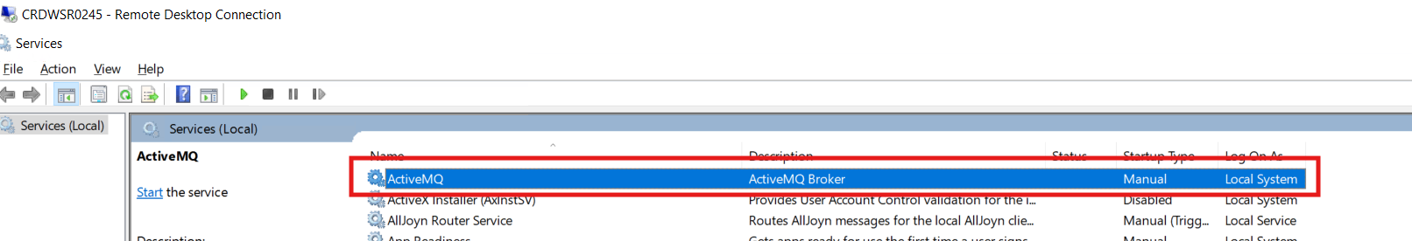

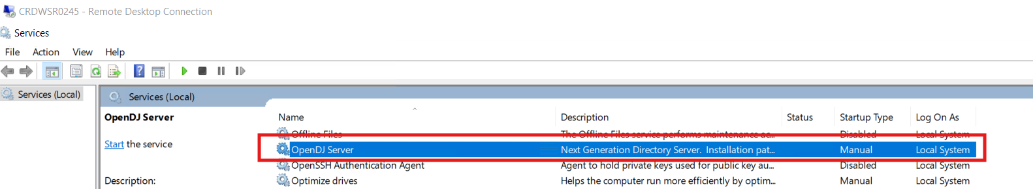

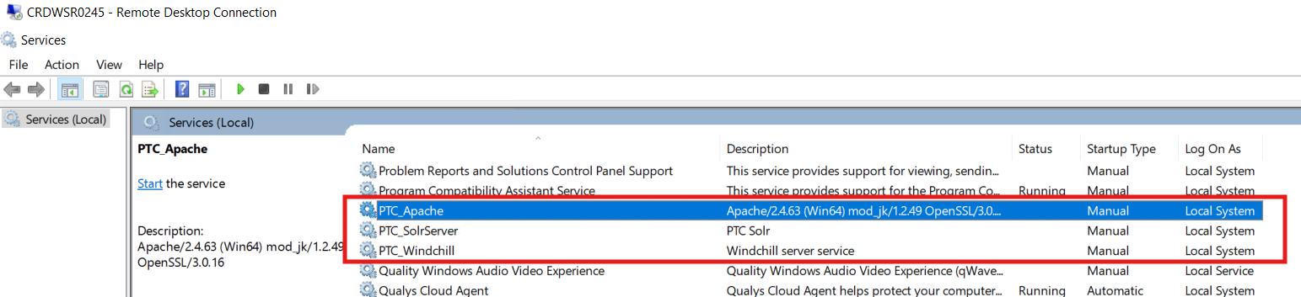

# Copy Vault from Production to Development Server

## Copy main Vault on Application server

* Connect to **CRDWSR0245**
* Open cmd in Administrator mode and run below command

robocopy \\CRDWSR0254\d$\PDMLVault D:\PDMLVault /MIR /MT:8

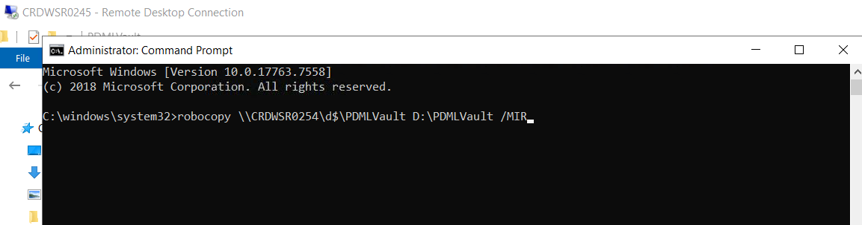

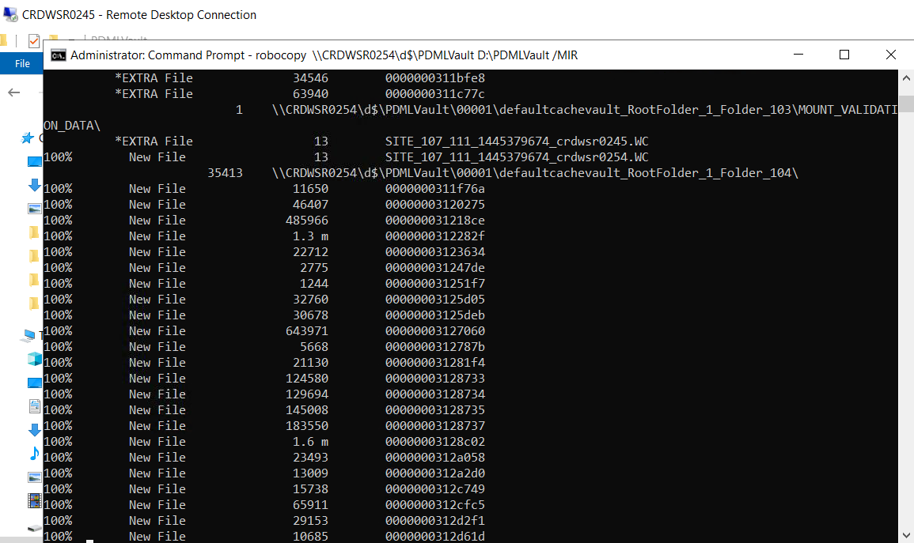

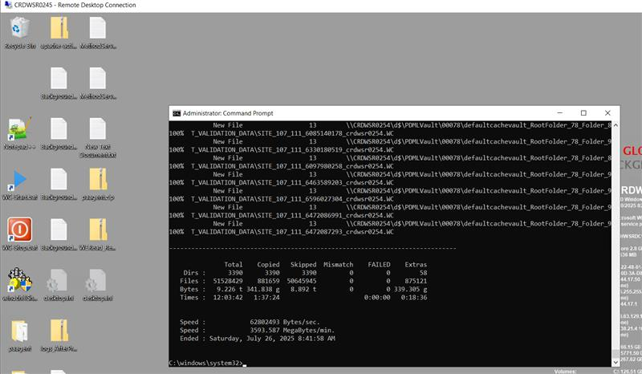

## Copy Replica Vault on Replica server

* **INDWSR0111** is Production - India Replica Server
* **INDWSR0109** is QA - India Replica Server
* Connect to **INDWSR0109** server and run below command to copy replica vault

robocopy \\indwsr0111\d$\ptc\ReplicaVault D:\PTC\ReplicaVault /MIR /MT:8

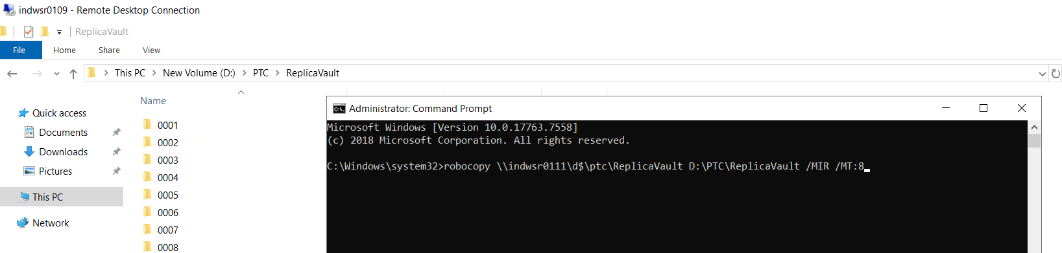

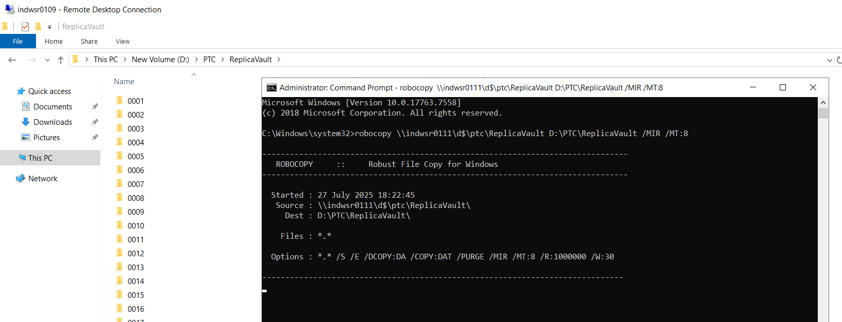

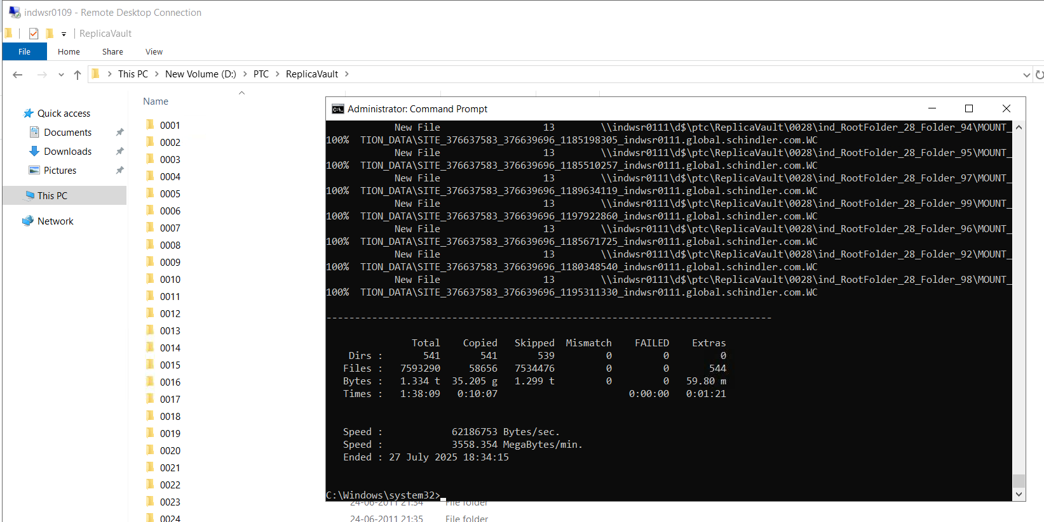

# Take Backup of existing GUID

* Connect to server **SHHWSR2444** and launch SSMS
* Connect to pdmlink database on **SHHWSR2604** server

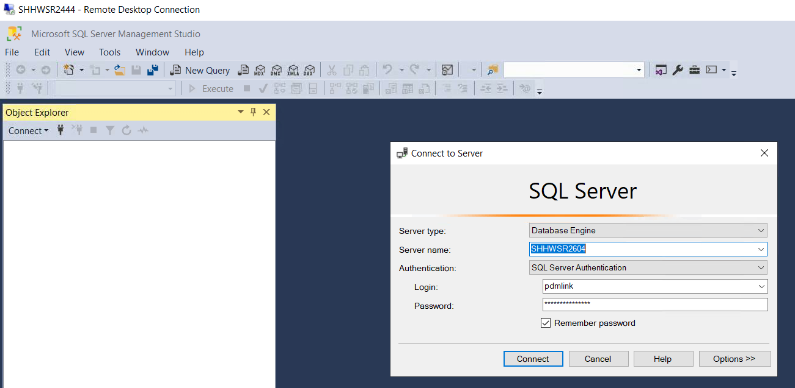

* Run below query and validate connected to correct database

select * from Site;

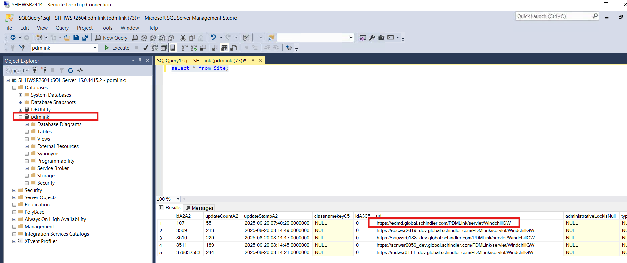

* Run below query to check GUID and copy guid column value of PTC_WCN_INTERNAL row from displayName column

select * from Repository;

**642486821-1744628908415-668729626-50-17-44-10**

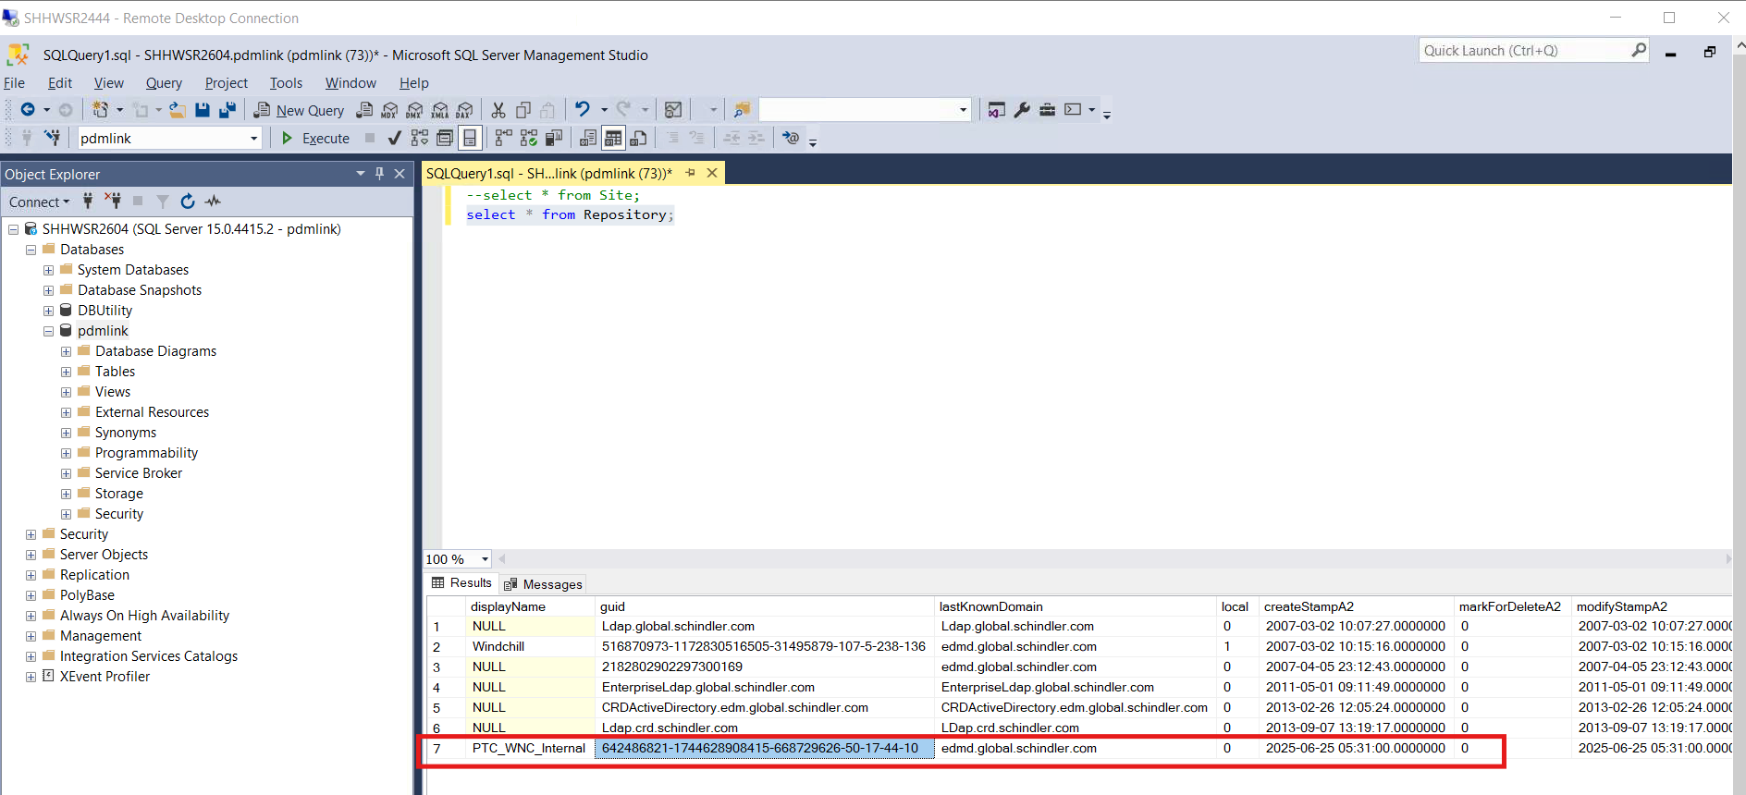

* GUID from Site > Utilities > Windchill Performance Advisor tab

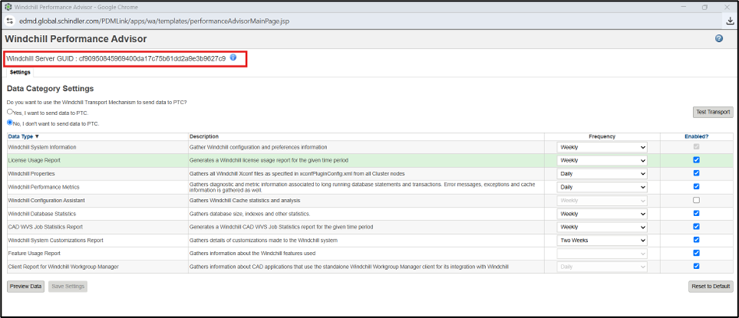

* Disconnect from pdmlnk database and server

# Import database from Production to Development server

* Create service now ticket using below link to import production pdmlink database to development server

[Create Incident - Service Portal](https://serviceportal.schindler.com/sp?id=sc_cat_item&sys_id=3f1dd0320a0a0b99000a53f7604a2ef9)

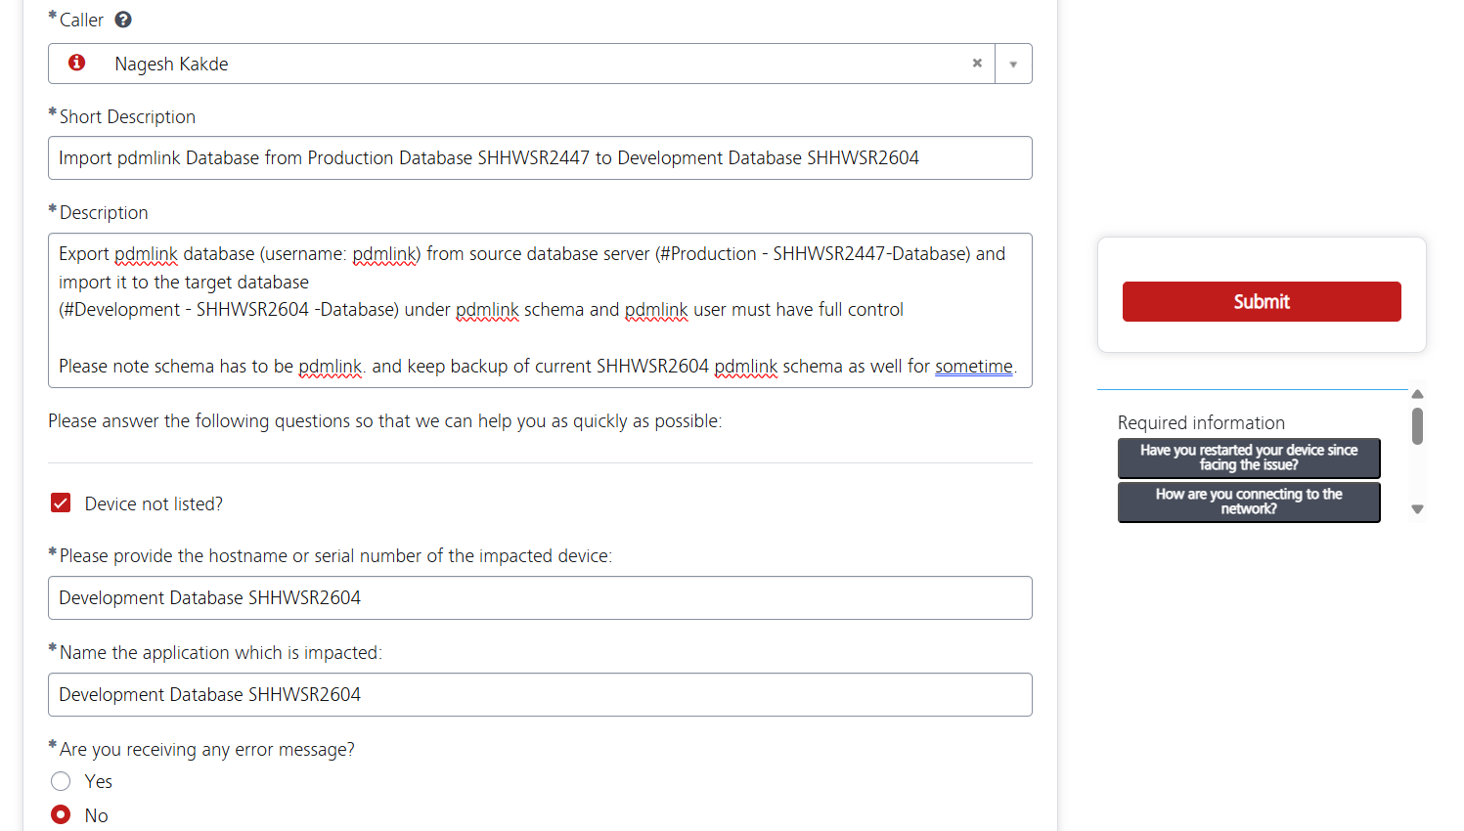

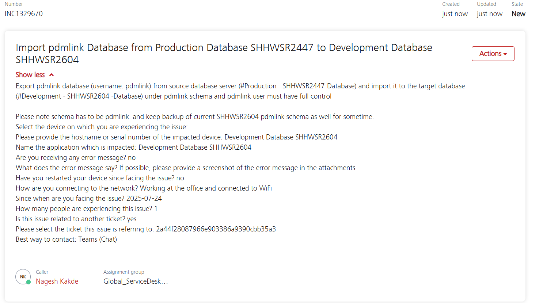

* ticket needs to be assign to Global_WebAppAndDB_AS so mentioned this group in comment to

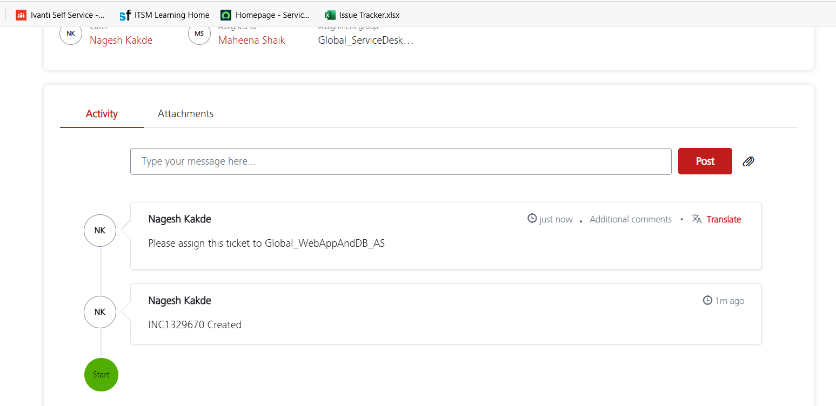

* Connect to database and validate database is imported correctly and pdmlink user login is successful.

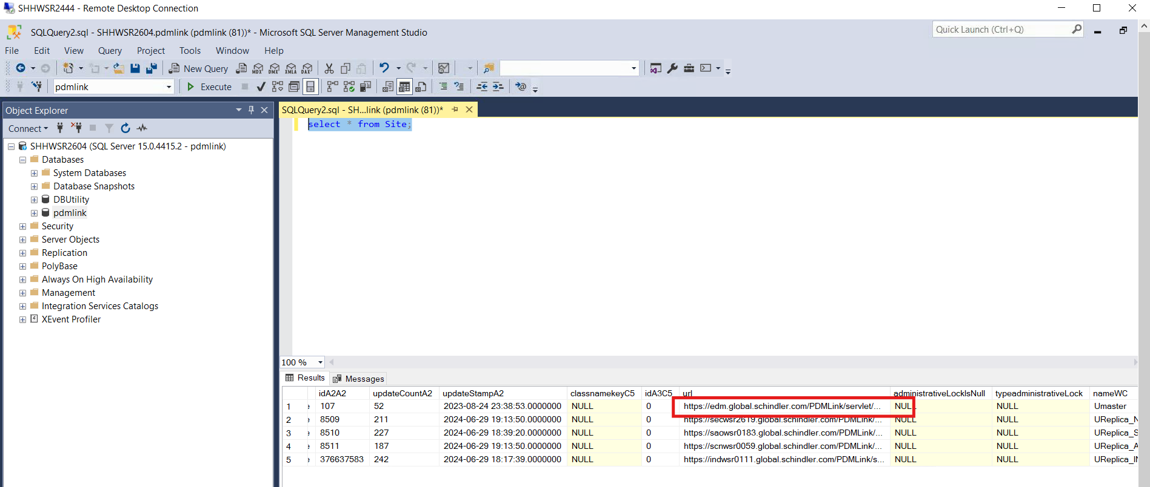

# Copy PTC folder from Production to Dev server

* Rename existing D:\ptc to D:\ptc_bkp_26072025

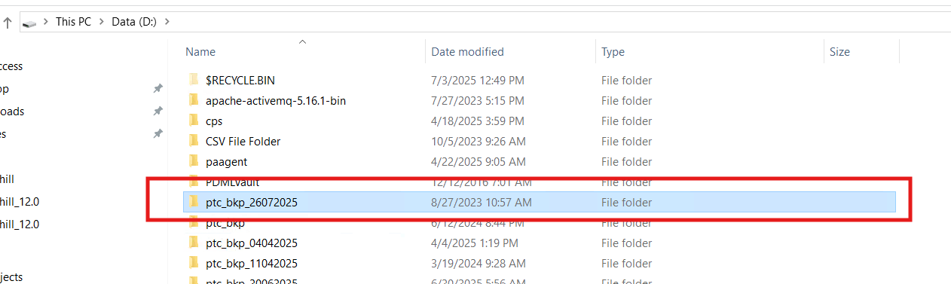

* Create D:\ptc folder
* Copy ptc folder from production server using below robocopy command

robocopy \\CRDWSR0254\d$\ptc D:\ptc /MIR

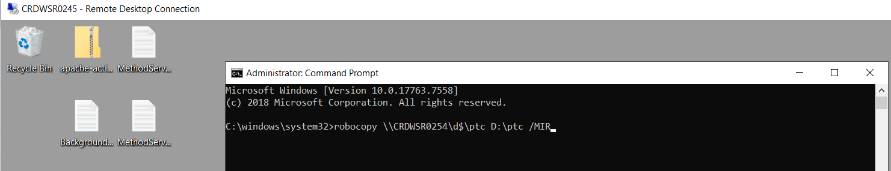

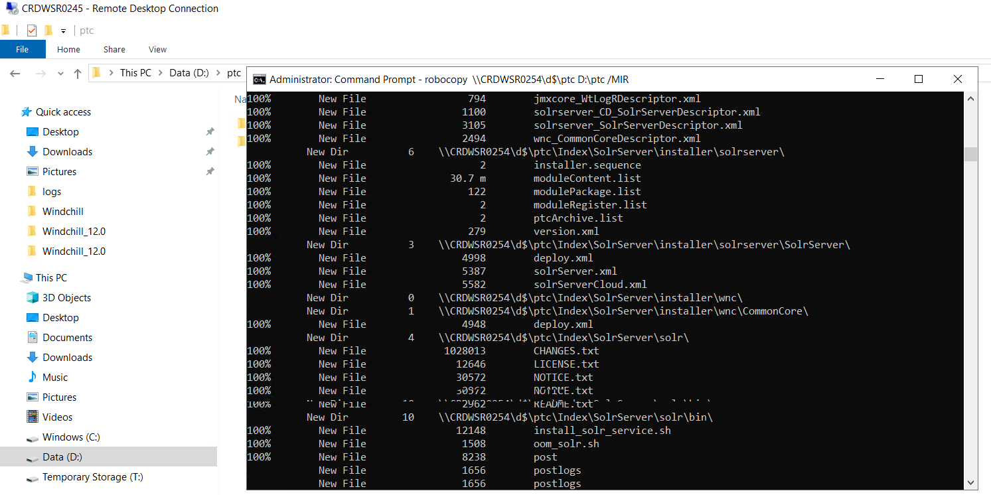

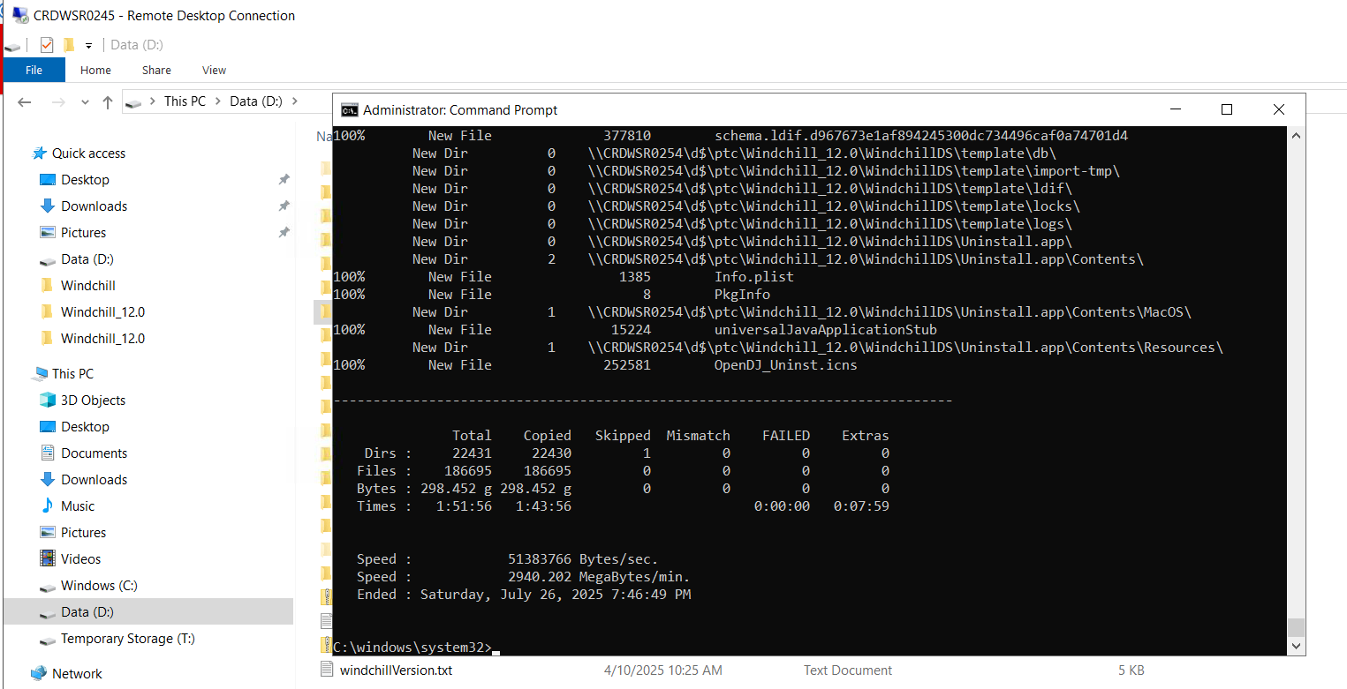

* Copy QA WindchilDS to dev server using below command

robocopy \\crdwsr0249\D$\ptc\Windchill_12.0\WindchillDS D:\ptc\Windchill_12.0\WindchillDS /MIR

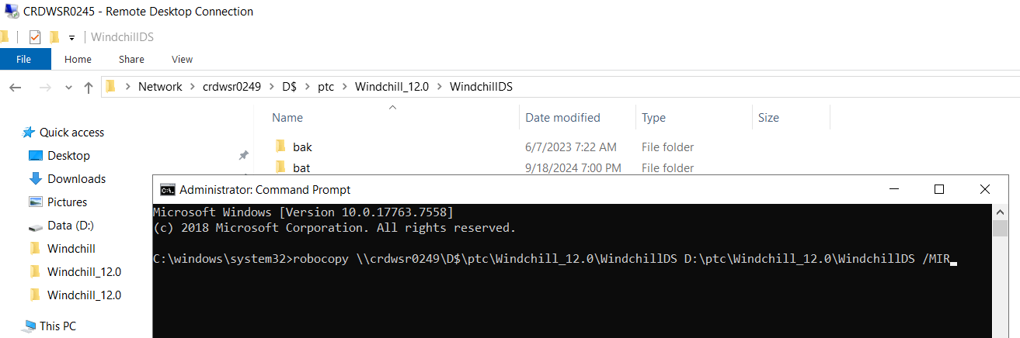

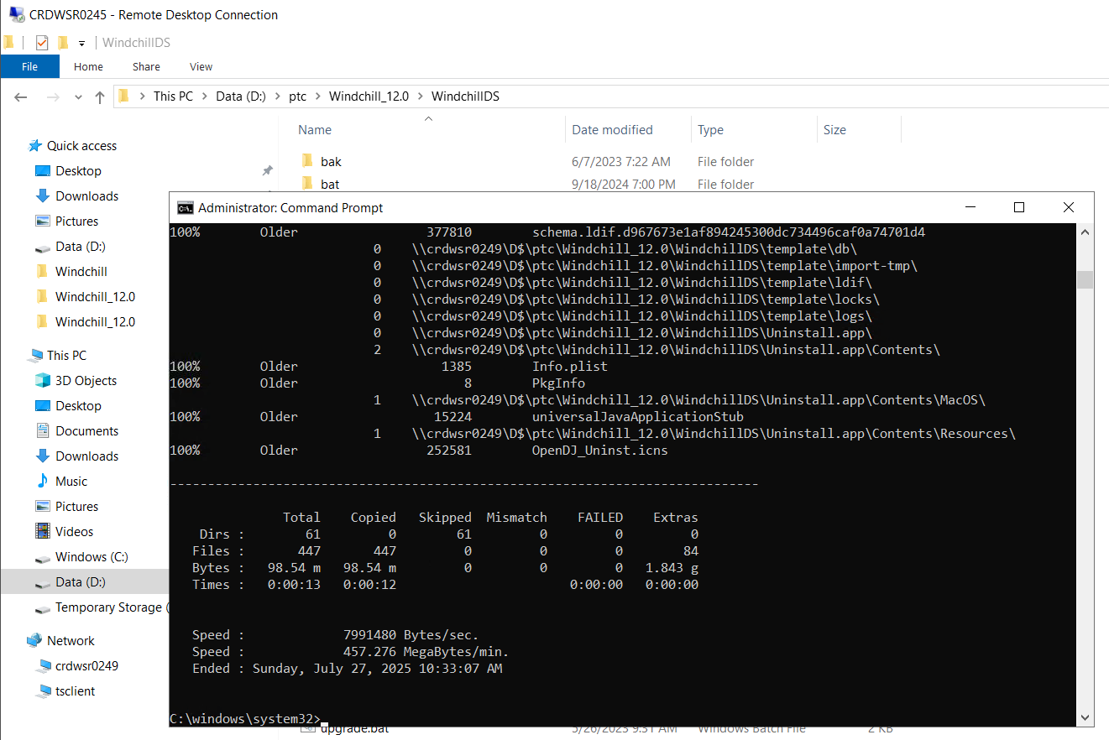

* Run control-panel.bat in administrator

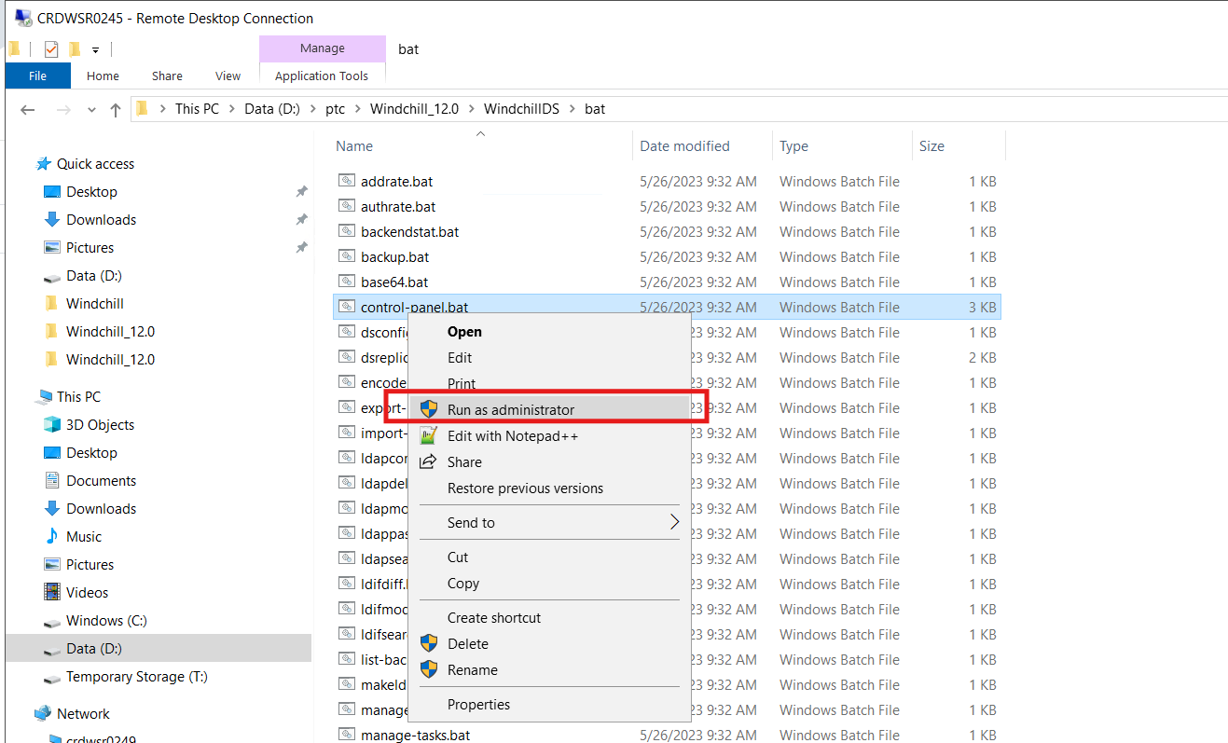

* Click start

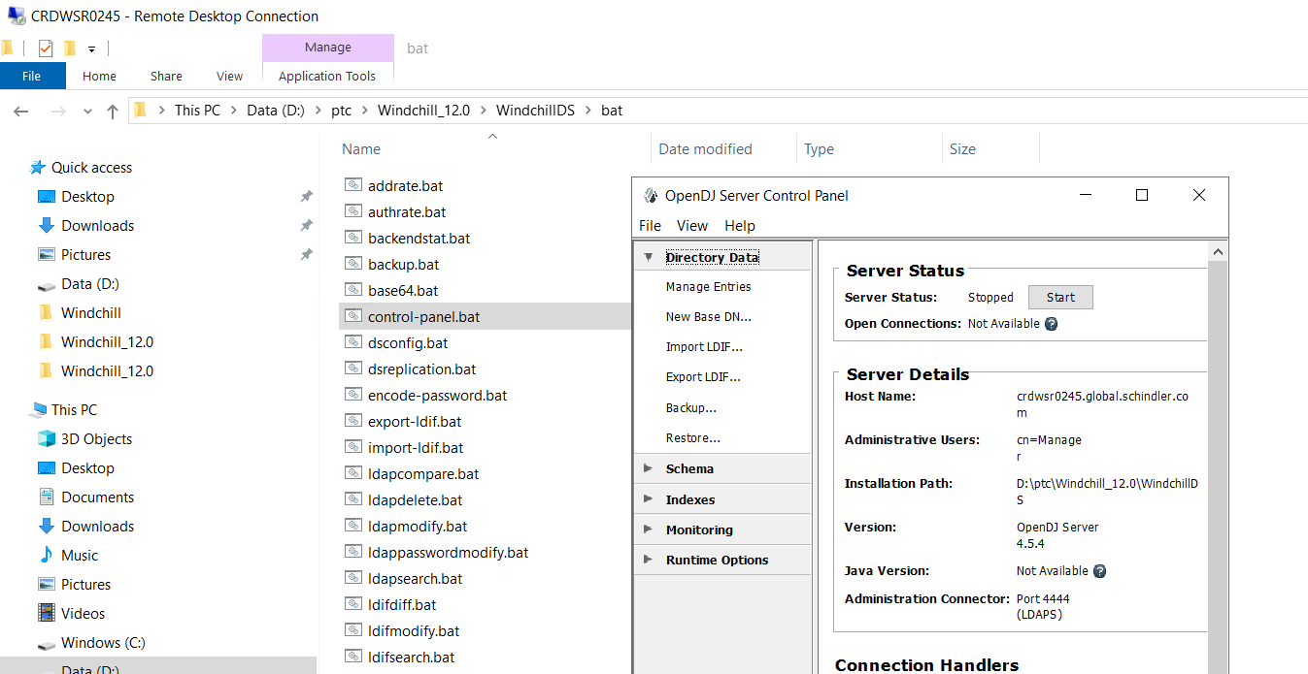

* Enter ldap password

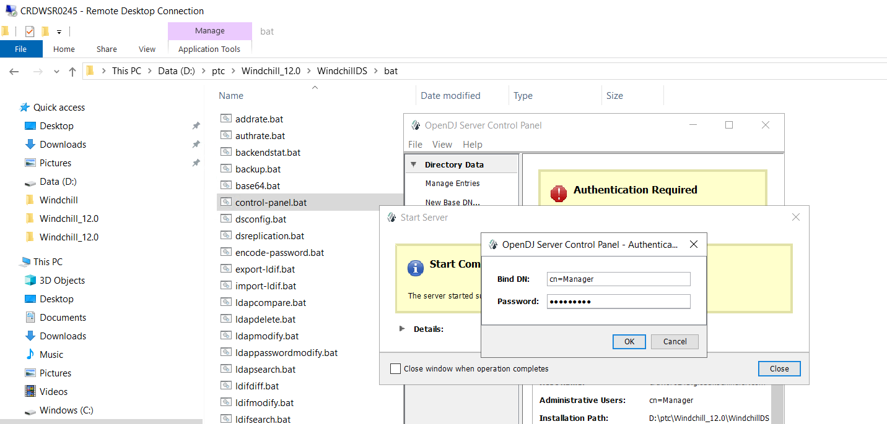

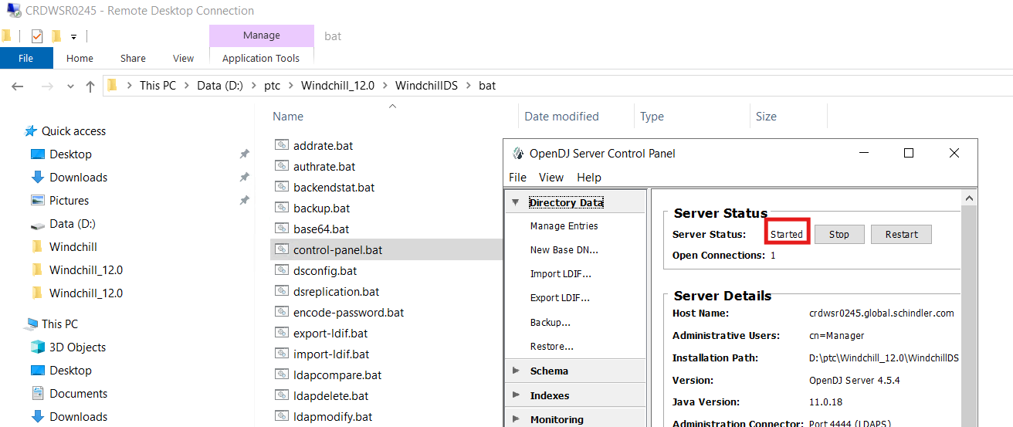

# Execute Rehost Utility

* Copy rehost.properties file & Projects.properties from D:\ptc_bkp_26072025\Windchill_12.0\Windchill\utilities\wcRehost\conf to D:\ptc\Windchill_12.0\Windchill\utilities\wcRehost\conf

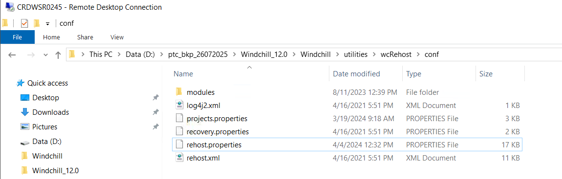

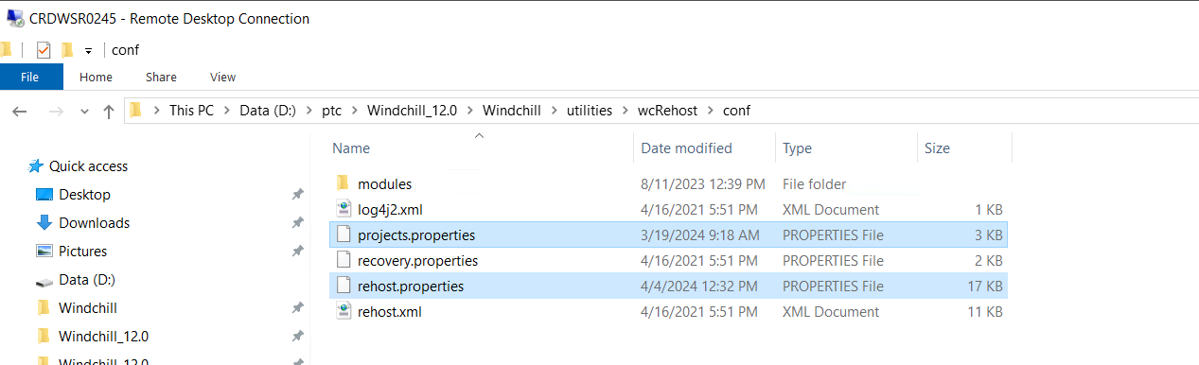

* Open projects.properties make sure its updated as per below snapshot

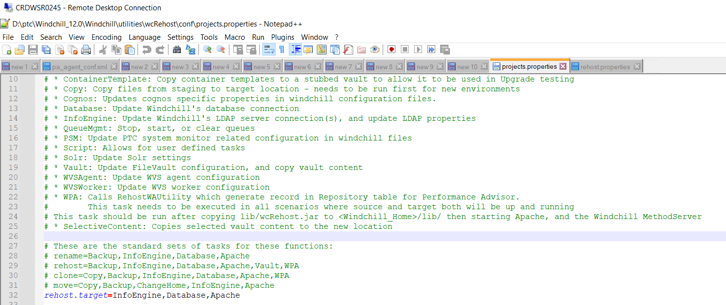

* Open rehost.properties make sure its updated as per below snapshot

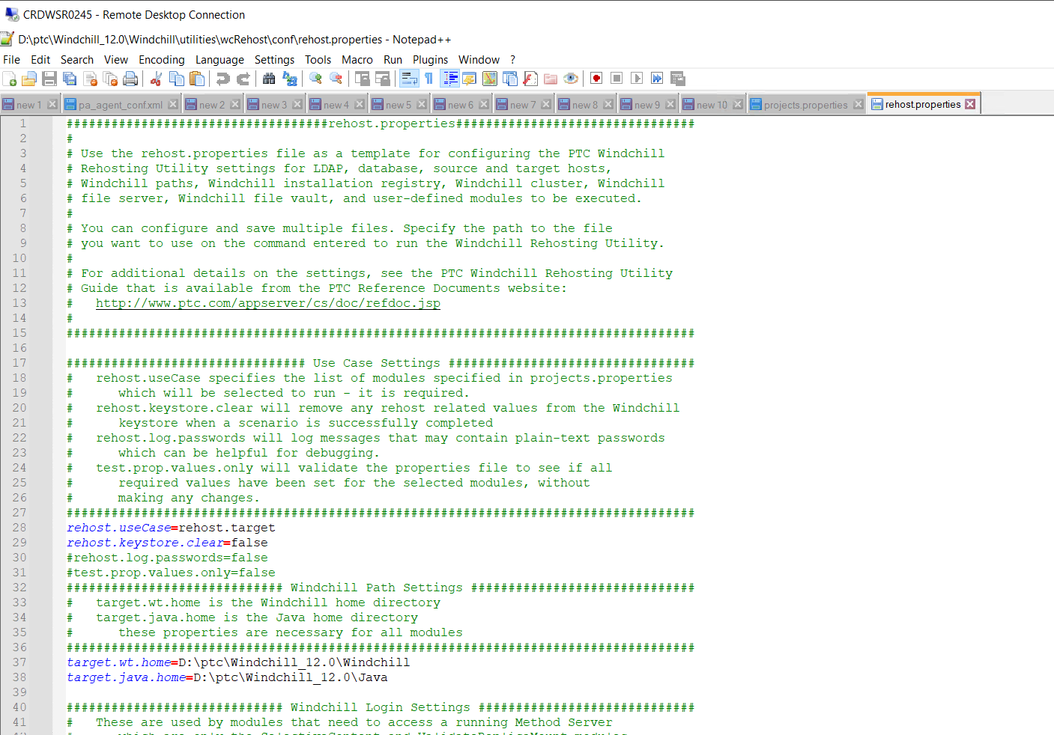

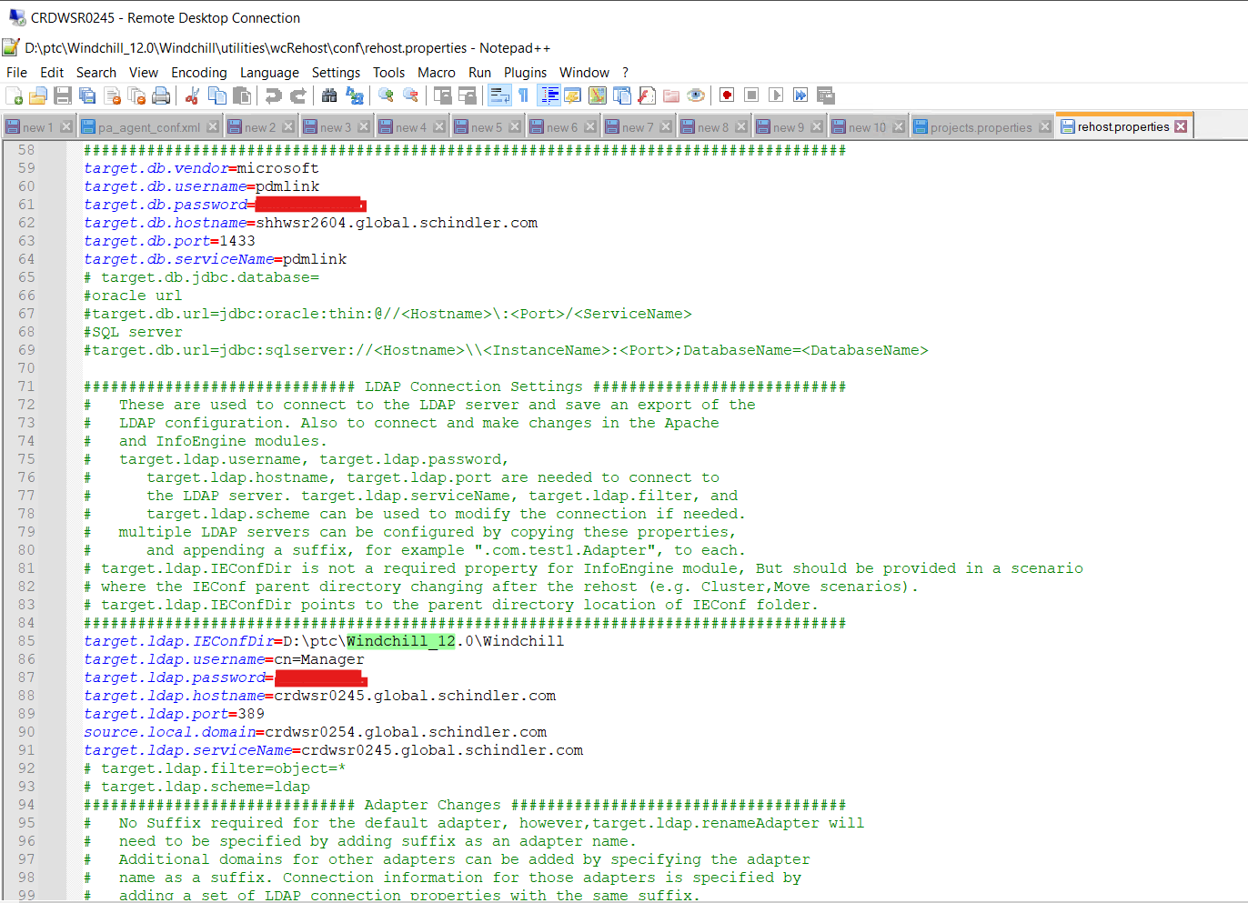

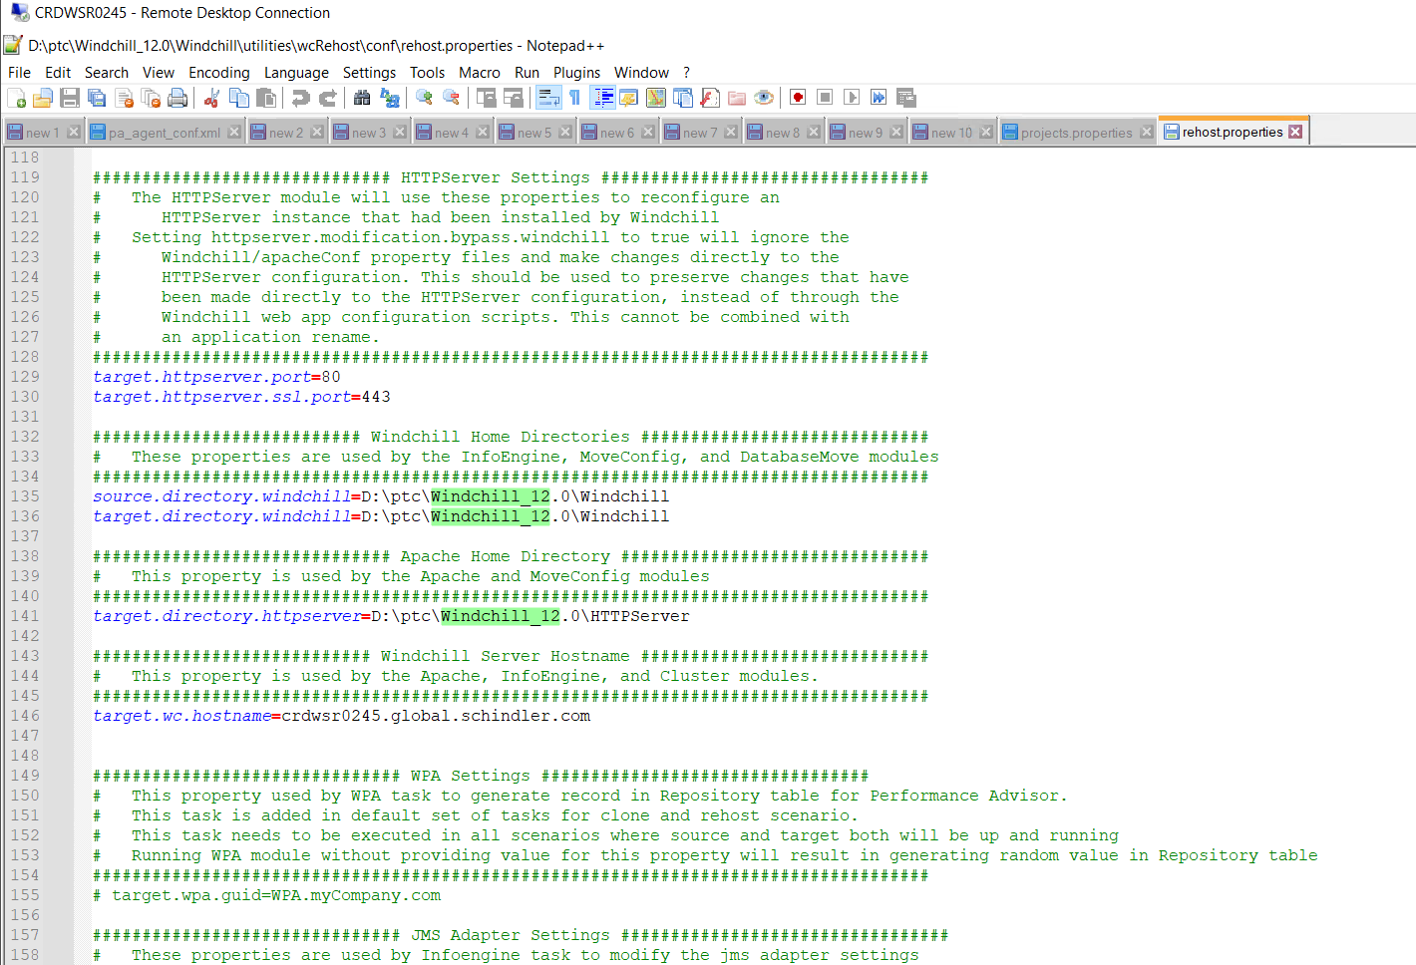

* Open Windchill shell and navigate to D:\ptc\Windchill_12.0\Windchill\utilities\wcRehost
* Run below command

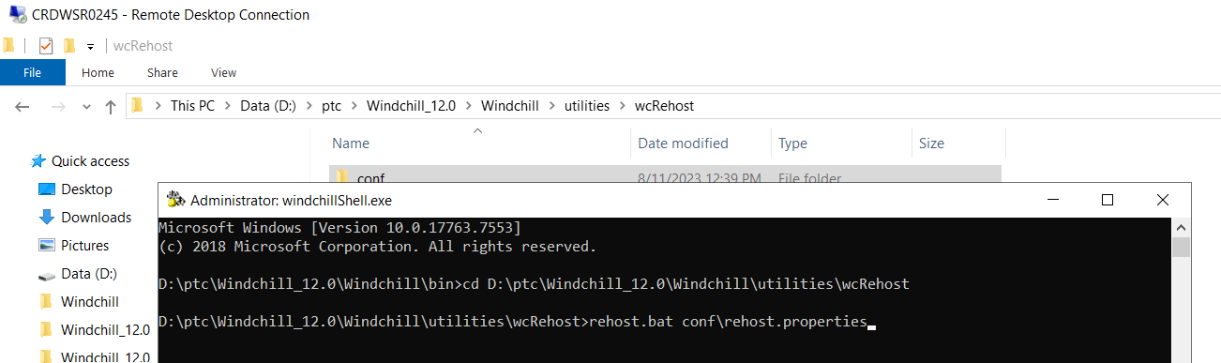

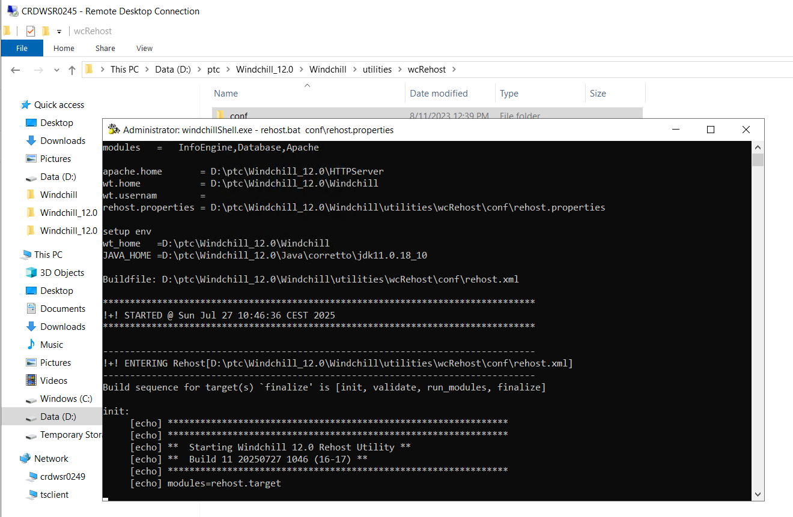

* Make sure BUILD SUCCESSFUL once command is executed.

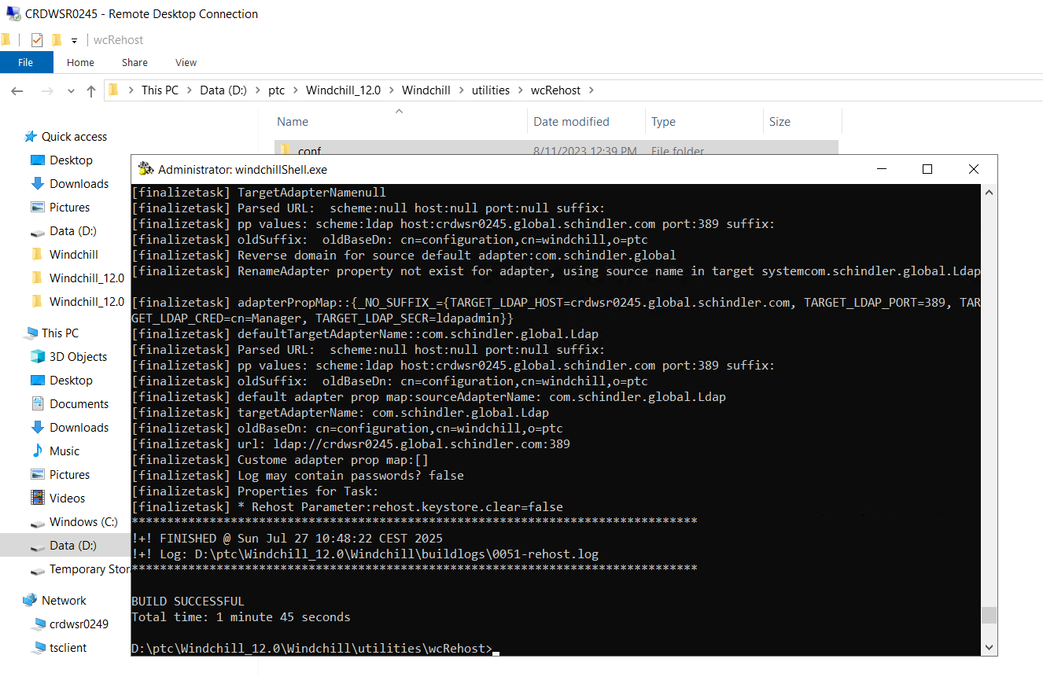

* Stop DS and take restart of server/machine so that no service will be running.

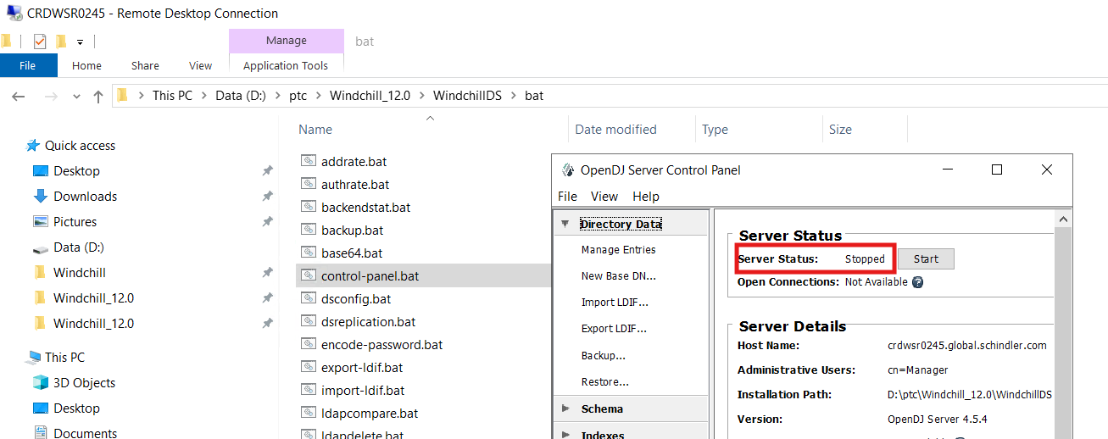

# Update Server specific folders from backup

* Copy **Java** and **HTTPServer** from from  **D:\ptc_bkp_26072025\Windchill_12.0** to **D:\ptc\Windchill_12.0**

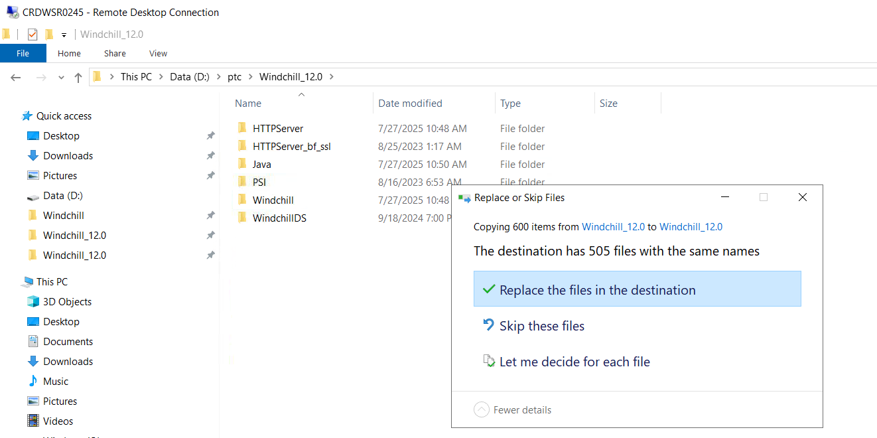

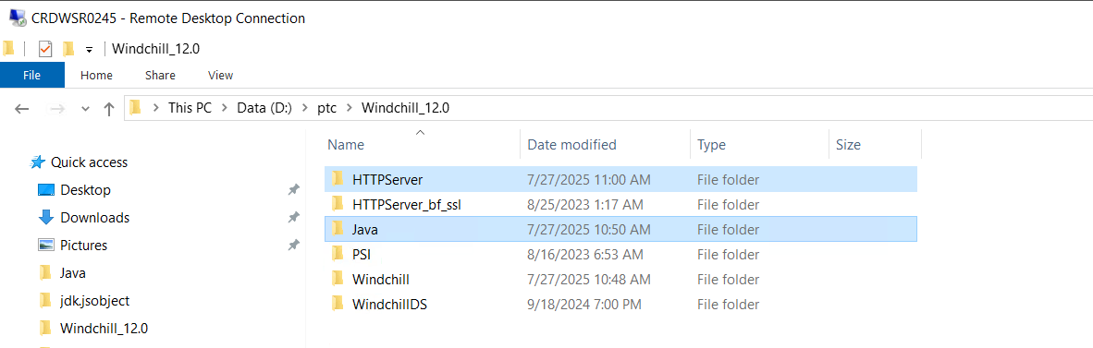

* Copy **Index** ,**distribution**, **WC-startup-scripts** from **D:\ptc_bkp_26072025** to **D:\ptc**

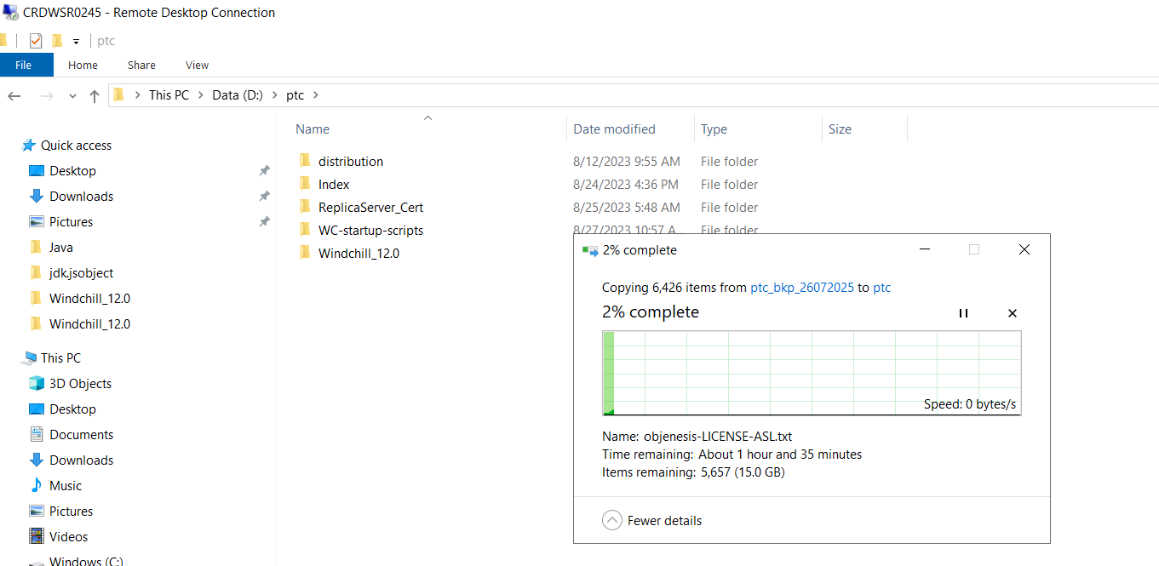

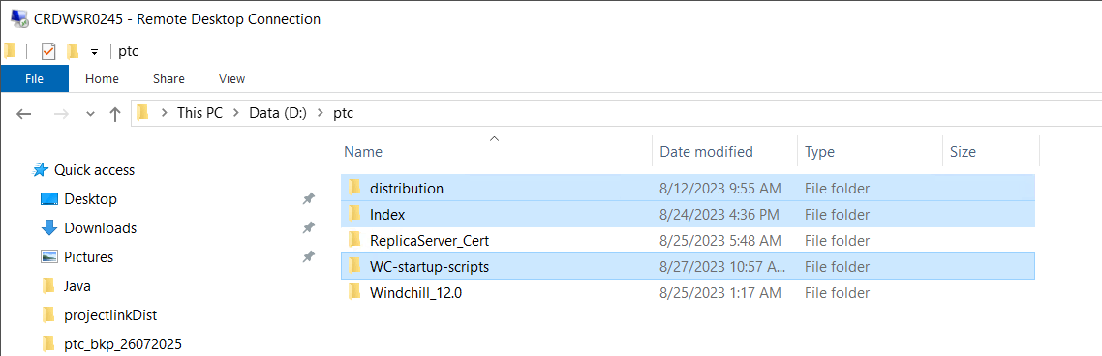

* Copy **IEConf** folder from **D:\ptc_bkp_26072025\Windchill_12.0\Windchill** to **D:\ptc\Windchill_12.0\Windchill**

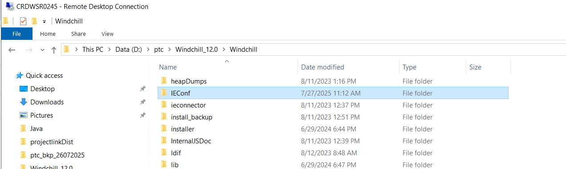

* Copy **ext** folder from **D:\ptc_bkp_26072025\Windchill_12.0\Windchill\codebase** to **D:\ptc\Windchill_12.0\Windchill\codebase**

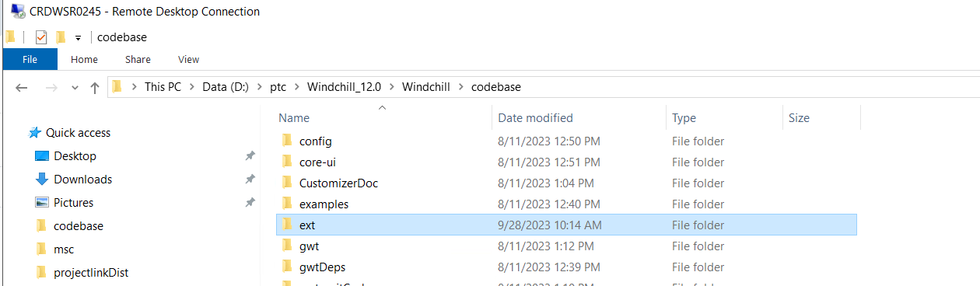

* Copy **site.xconf** and **performance.xconf** from **D:\ptc_bkp_26072025\Windchill_12.0\Windchill to D:\ptc\Windchill_12.0\Windchill**

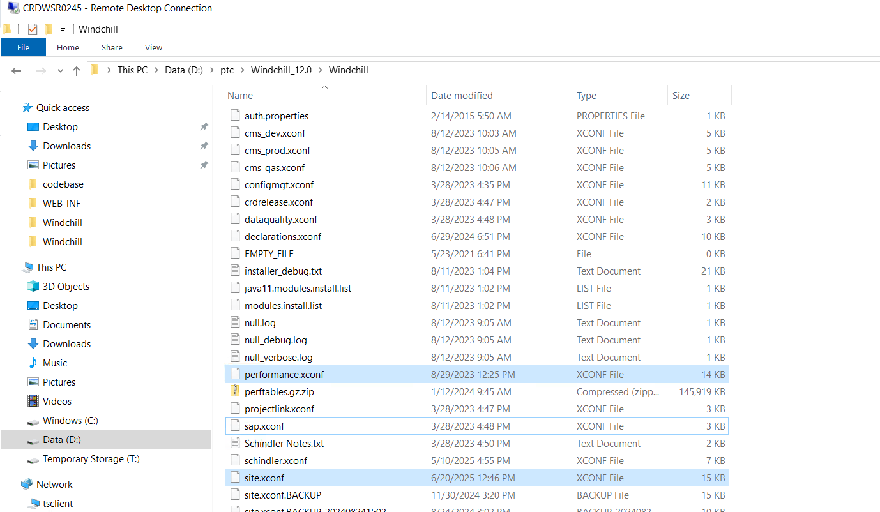

* Copy **web.xml** from **D:\ptc_bkp_26072025\Windchill_12.0\Windchill\codebase\WEB-INF** to **D:\ptc\Windchill_12.0\Windchill\codebase\WEB-INF**

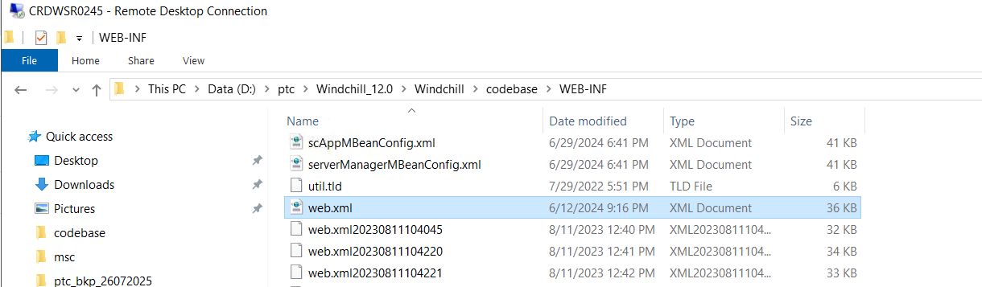

* Copy **sip** folder from **D:\ptc_bkp_26072025\Windchill_12.0\Windchill\bin\adminTools** to **D:\ptc\Windchill_12.0\Windchill\bin\adminTools**

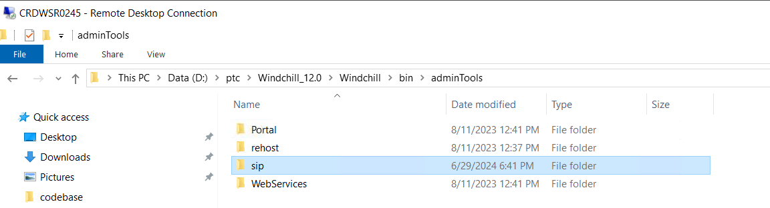

* Copy **ext** folder from **D:\ptc_bkp_26072025\Windchill_12.0\Windchill\tasks** to **D:\ptc\Windchill_12.0\Windchill\tasks**

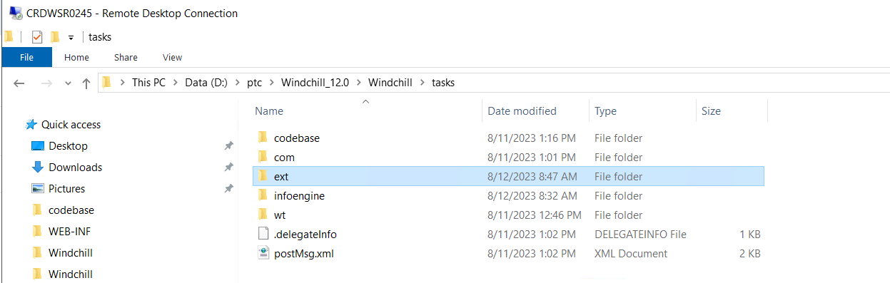

* Copy **agent.ini** file from **D:\ptc_bkp_26072025\Windchill_12.0\Windchill\conf\wvs** to **D:\ptc\Windchill_12.0\Windchill\conf\wvs**

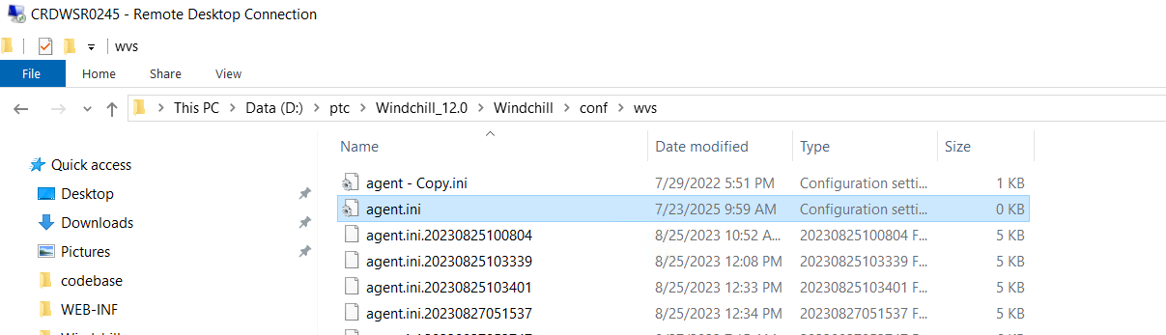

# Update Database Tables

* Connect to database

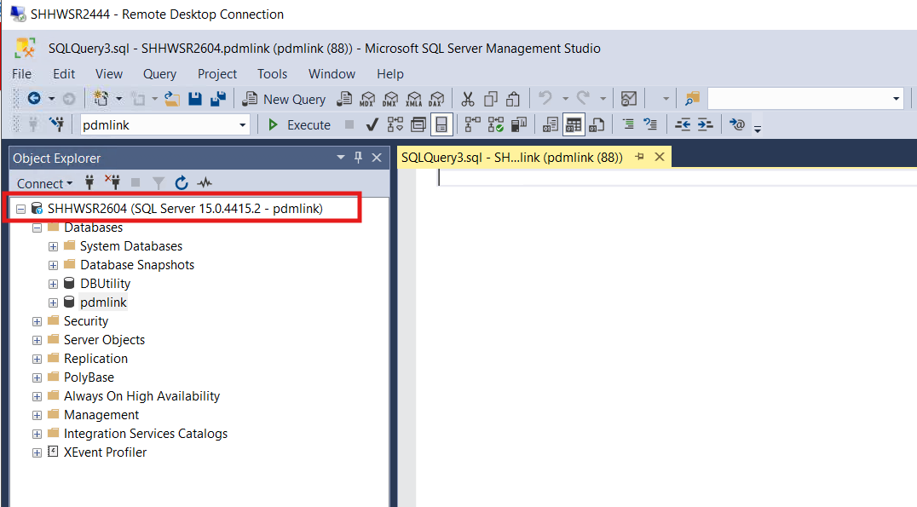

* Run below query to take backup of FvHost table

select * into FvHost_bkp27072025 from FvHost;

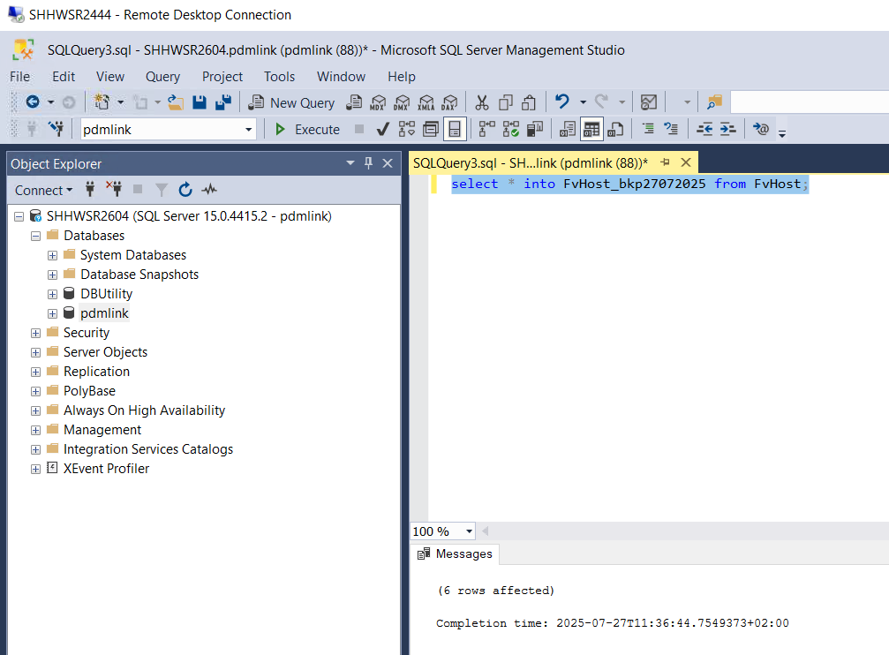

* Update replica server host name to dummy host name using below queries except indwsr0111. Get idA2A2 value by running below query

select * from select * from FvHost;

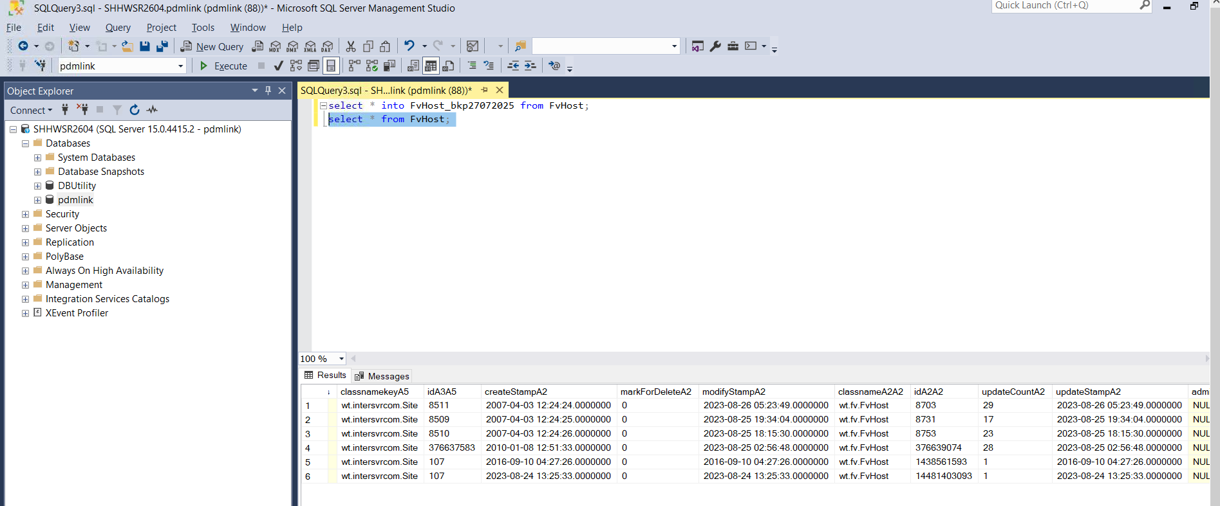

update FvHost set hostName='[scnwsr0059_qas.global.schindler.com](http://scnwsr0059_dev.global.schindler.com)' where idA2A2='8703';

update FvHost set hostName='[secwsr2619_qas.global.schindler.com](http://secwsr2619_dev.global.schindler.com)' where idA2A2='8731';

update FvHost set hostName='[saowsr0183_qas.global.schindler.com](http://saowsr0183_dev.global.schindler.com)' where idA2A2='8753';

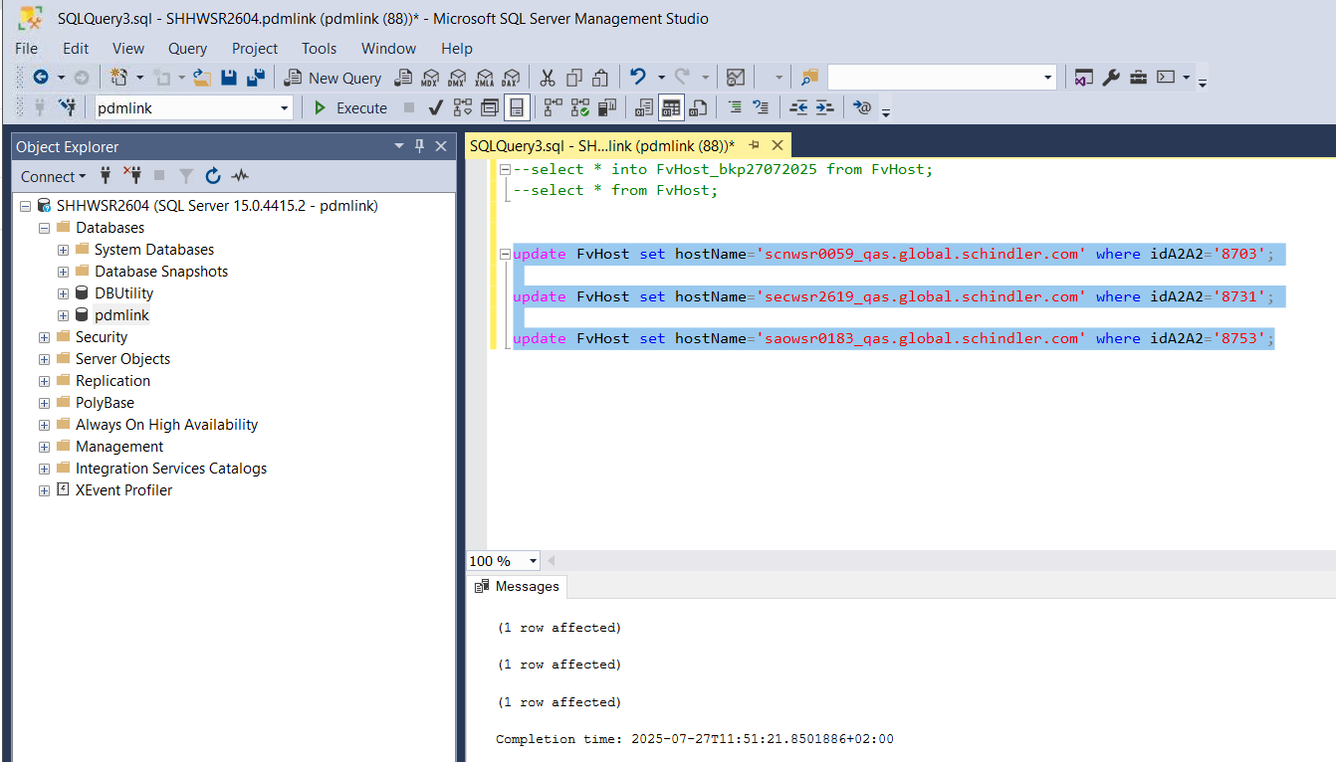

* update host name indwsr0111 toindwsr0109 using below query

update FvHost set hostName='[indwsr0109.global.schindler.com](http://indwsr0109.global.schindler.com)' where idA2A2='376639074';

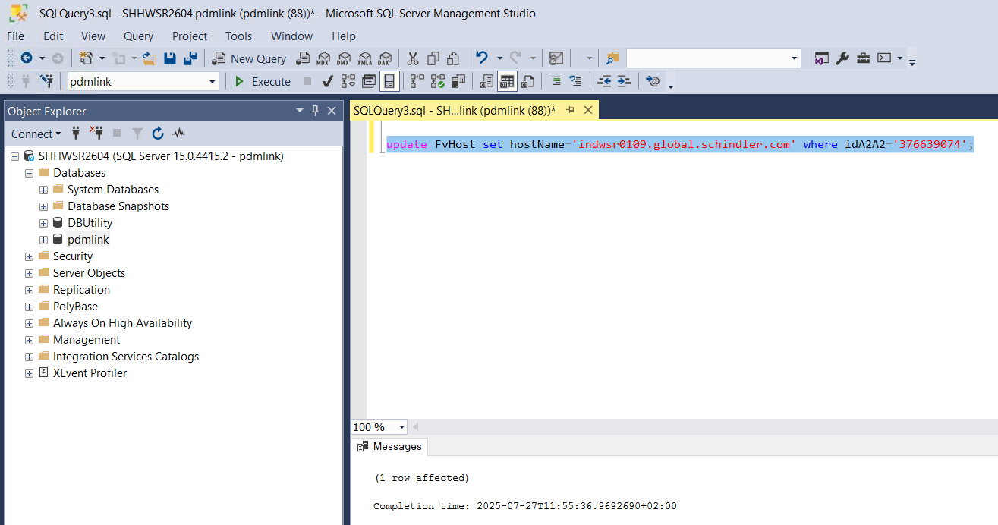

* validate host names for replica are updated successfully by running below query

select * from FvHost;

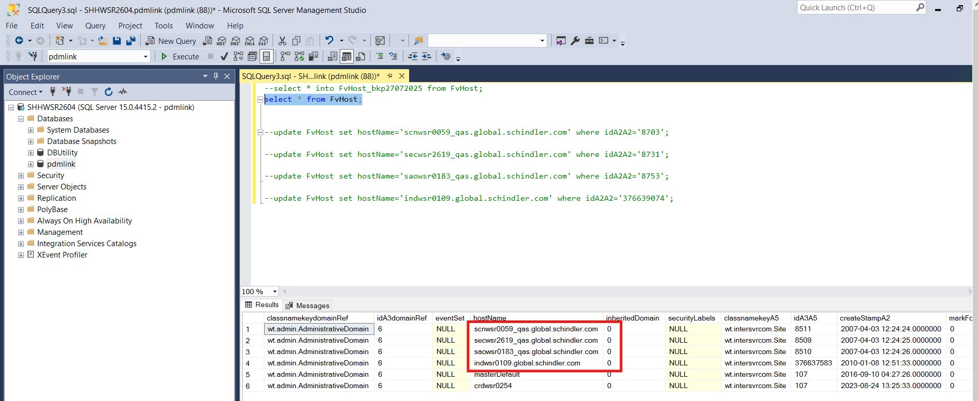

* Take backup of RMIStubs using below query

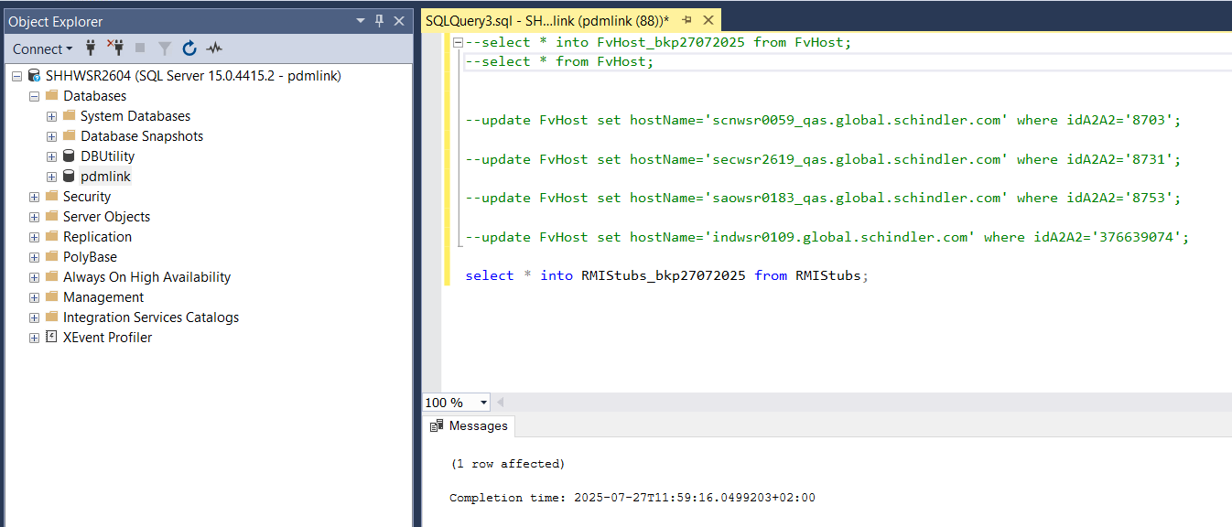

* Clear RMIStubs table using below query

Delete from RMIStubs;

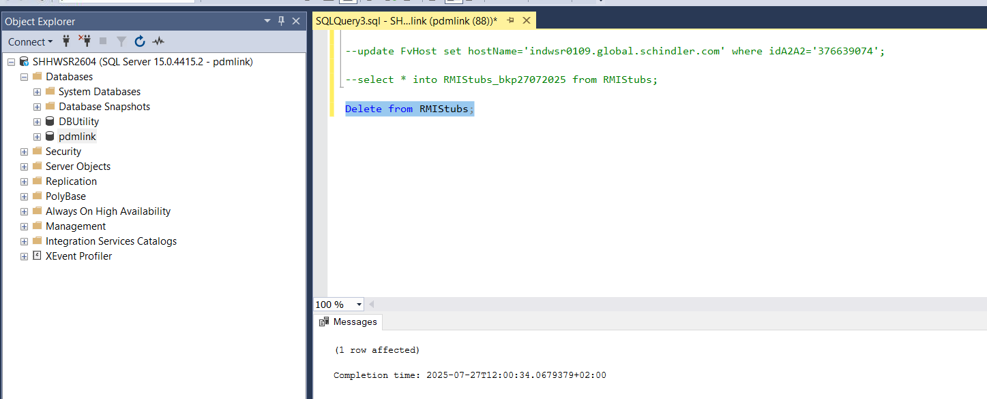

* Take backup of Repository using below query

select * into Repository_bkp27072025 from Repository;



* Update last known Domain using ida2a2 from Repository table using below query

Run query to get ida2a2 : select * from Repository;

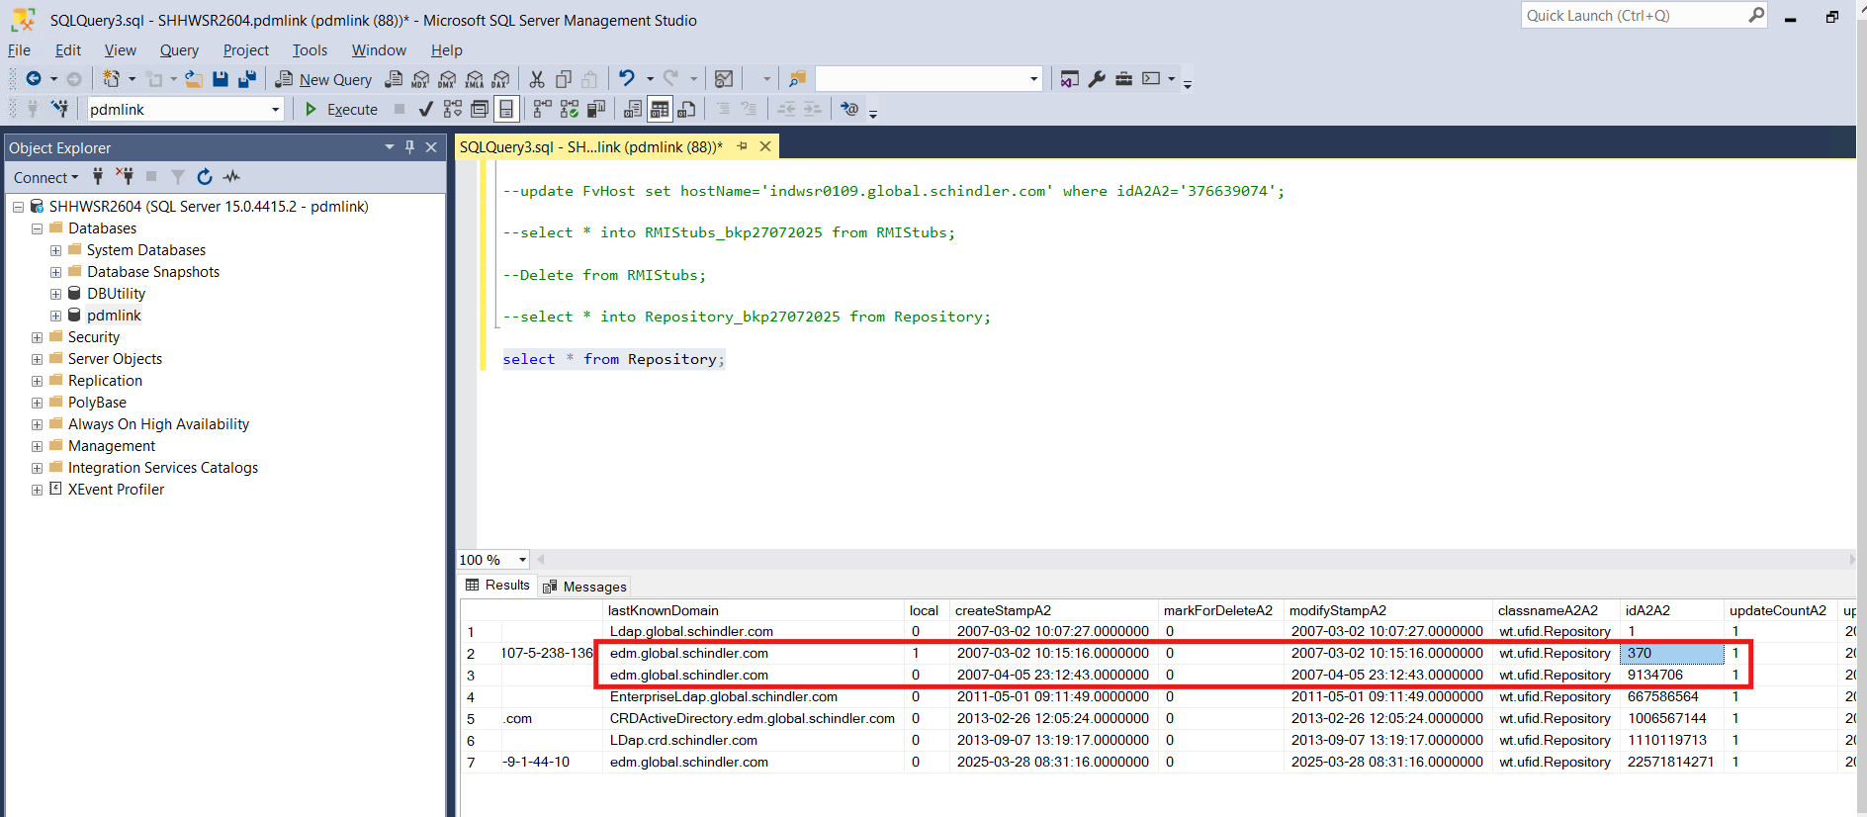

* Run below queries as per ida2a2 values

update Repository set lastKnownDomain='[edmd.global.schindler.com](http://edmd.global.schindler.com)' where idA2A2='370';  
update Repository set lastKnownDomain='[edmd.global.schindler.com](http://edmd.global.schindler.com)' where idA2A2='9134706';

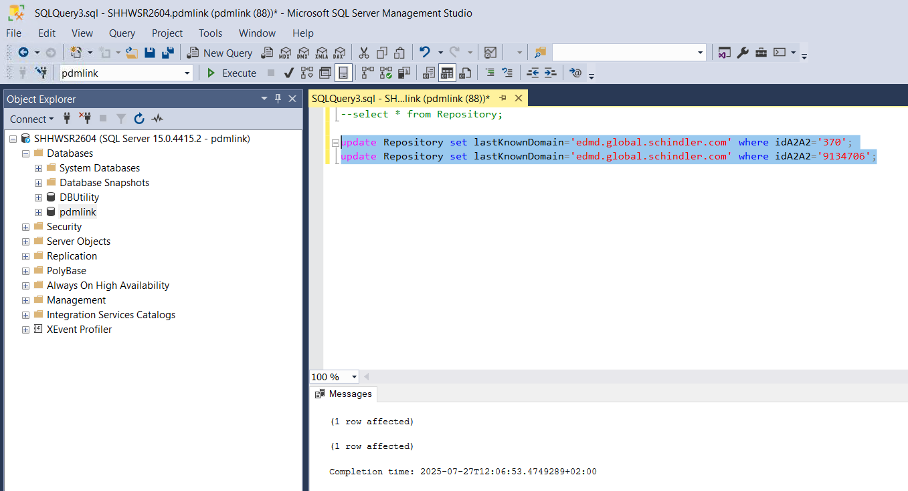

* Validate lastKnownDomain is updated correctly using below query

select * from Repository;

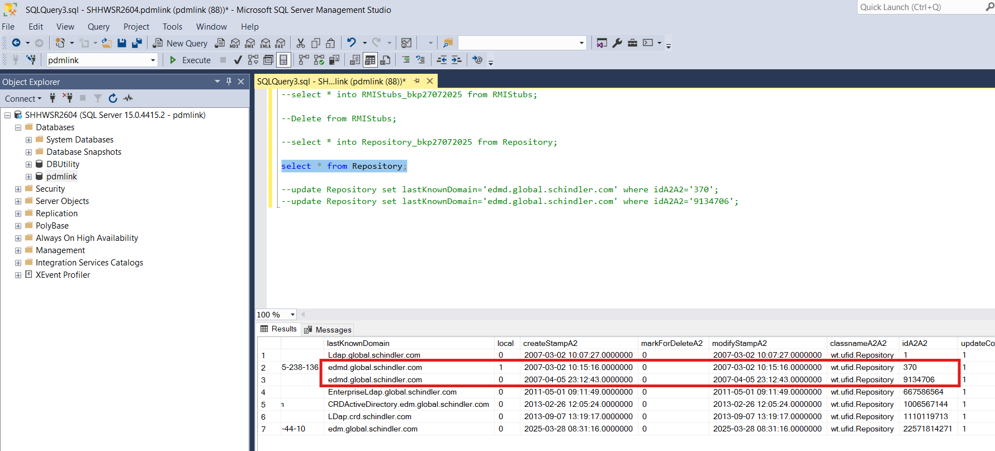

# Update ActiveMQ Configurations from DS

* Launch DS and Navigate to manage entries

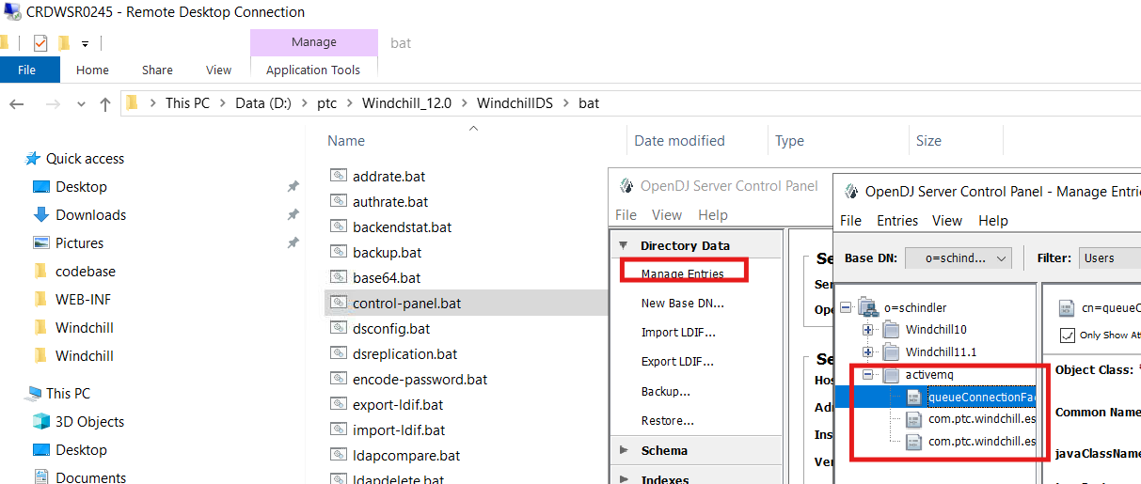

* Update hostname to crdwsr0245 in queueConnectionFactory

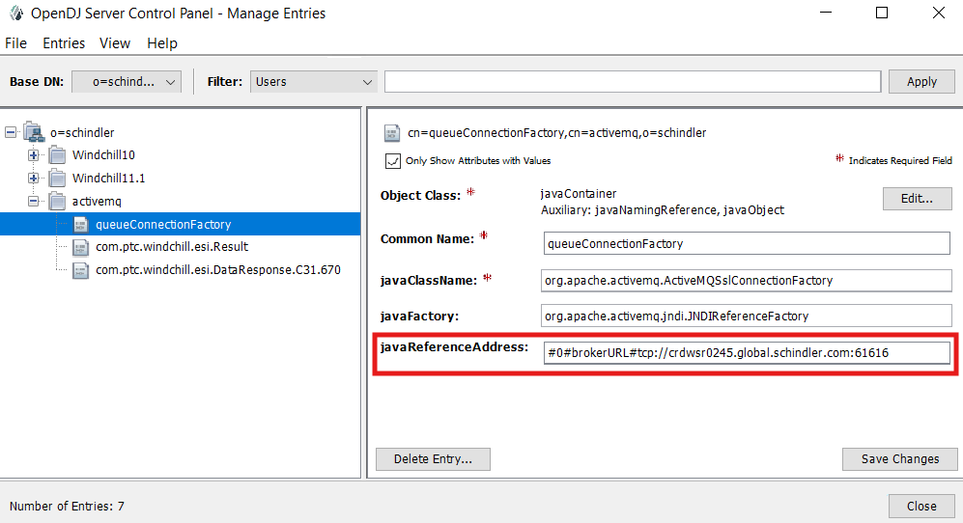

* Click on Save Changes

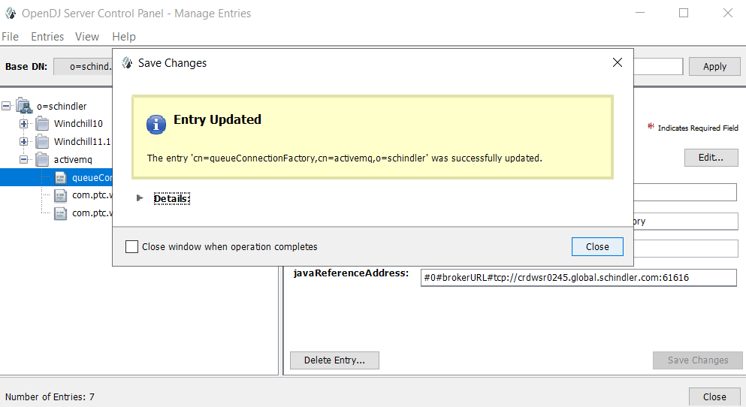

* Validate com.ptc.windchill.esi.Result is as per below snapshot

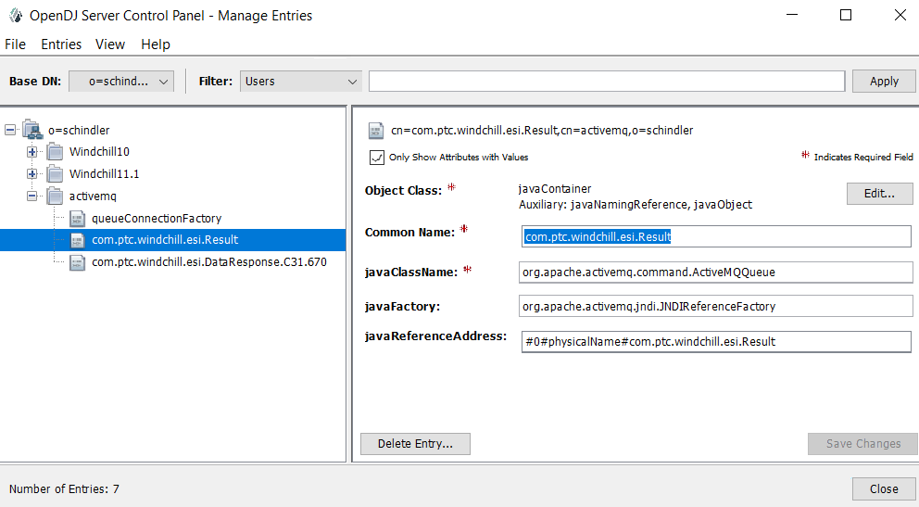

* com.ptc.windchill.esi.DataResponse as per below snapshot

**C31.670** is the QA Server distribution target

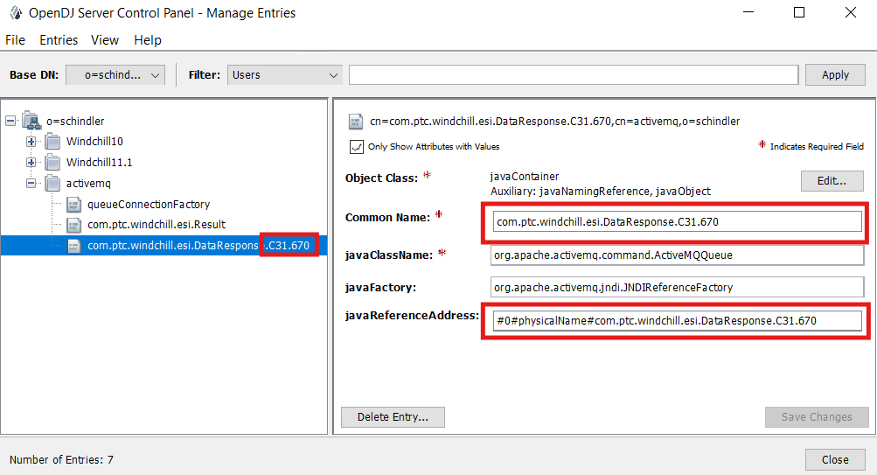

* Click on Close

# Update properties of Development server as per QA Server

* As Development server will be used as QA server for Upgrade RH2, We will update few properties on development server so that data can be created on source server before importing database export on target server for upgrade.
* Update below .xconf entries in site.xconf to use QAS properties

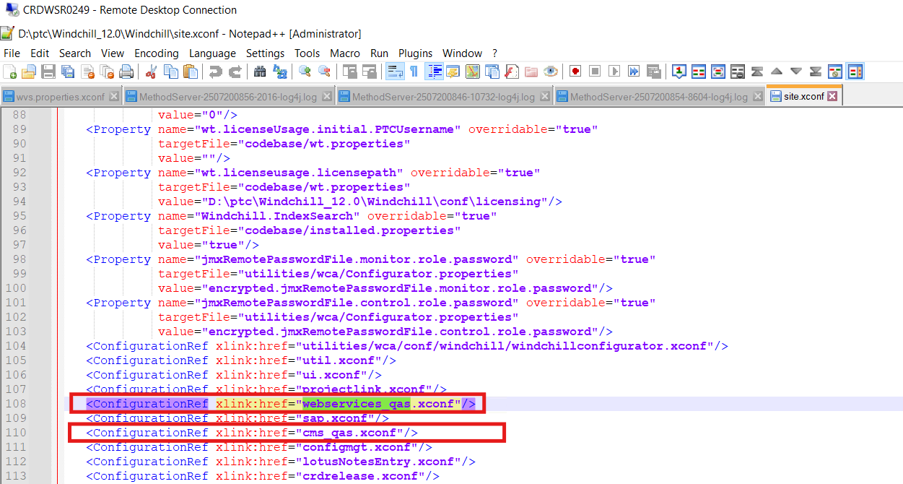

* Open D:\ptc\Windchill_12.0\Windchill\codebase\ext\schindler\cms\translation\jms\jms.xconf and update properties as per below snapshot. [Password is hidden due to security. Get in touch with windchill admin for password]

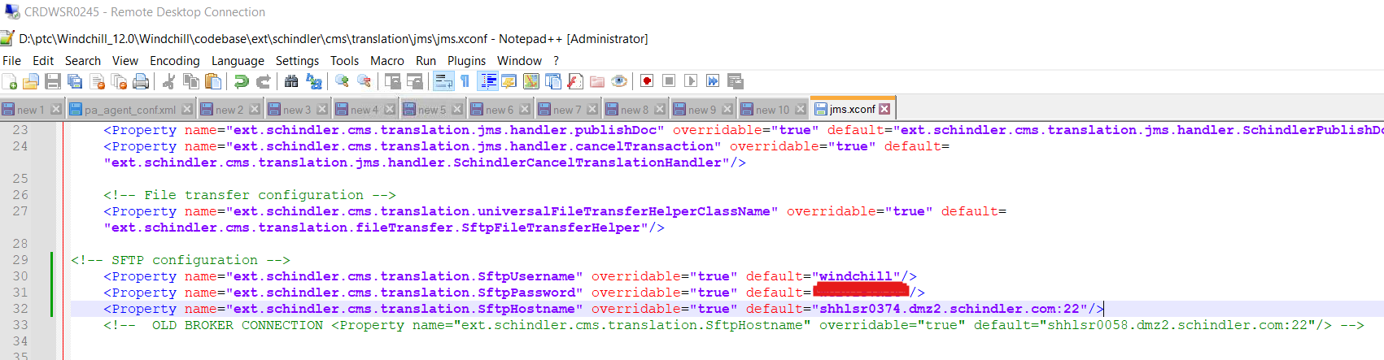

* Open D:\ptc\Windchill_12.0\Windchill\codebase\ext\schindler\cms\translation\jms\jms.xconf and update properties as per below snapshot. [Password is hidden due to security. Get in touch with windchill admin for password]

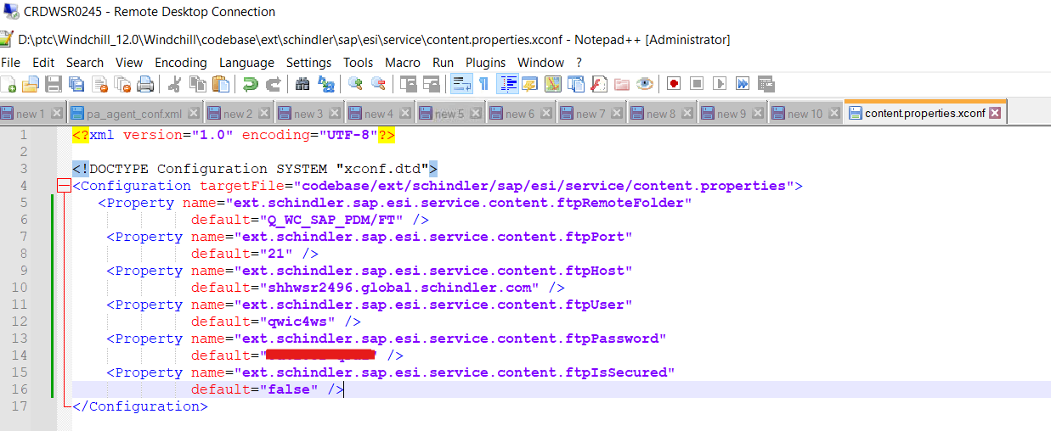

* Open D:\ptc\Windchill_12.0\Windchill\codebase\ext\schindler\cms\schindler_cms.properties and update properties as per below snapshot. [Password is hidden due to security. Get in touch with windchill admin for password]

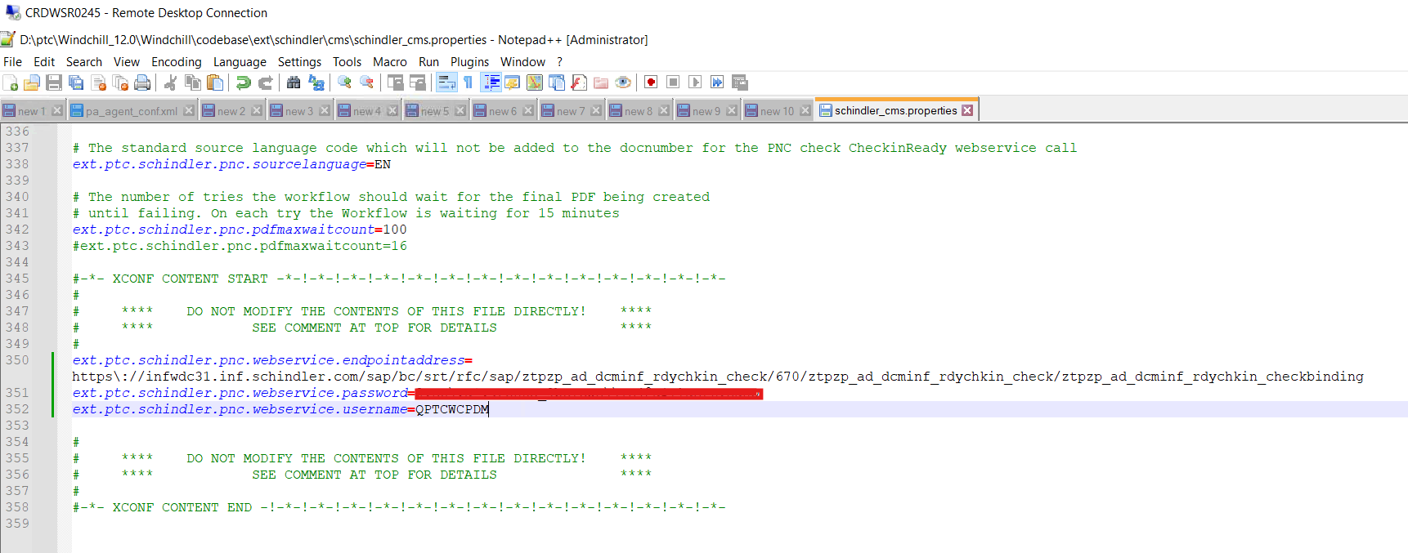

* Validate D:\ptc\Windchill_12.0\Windchill\tasks\ext\schindler\cms\translation\jms\sendJmsMessage.xml content is as per below snapshot

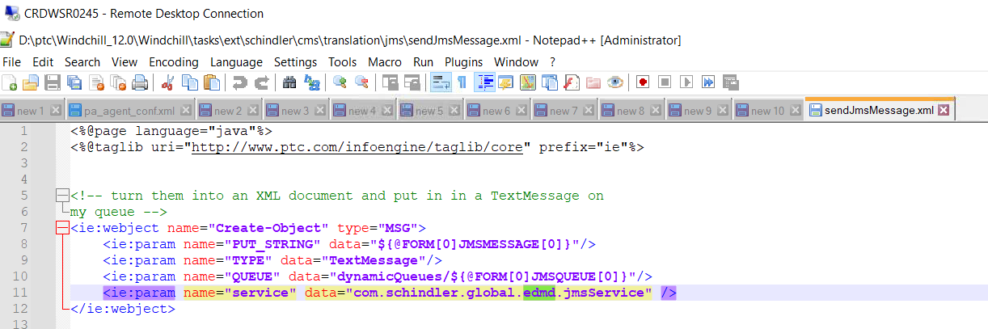

* Validate D:\ptc\Windchill_12.0\Windchill\tasks\ext\schindler\cms\translation\jms\subscribeQueue.xml content is as per below snapshot

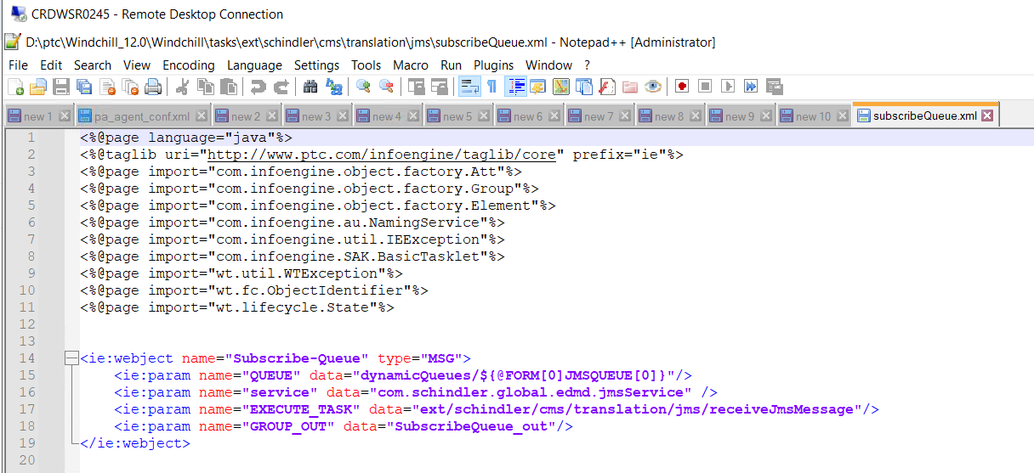

* Run below command from windchill shell

**ant -f D:\ptc\Windchill_13.0\Windchill\bin\adminTools\sip\EncryptPasswords.xml encryptPw -DpropertyName=ext.schindler.webservices.inventio.auth.password -Dpassword=”PASSWORD”**

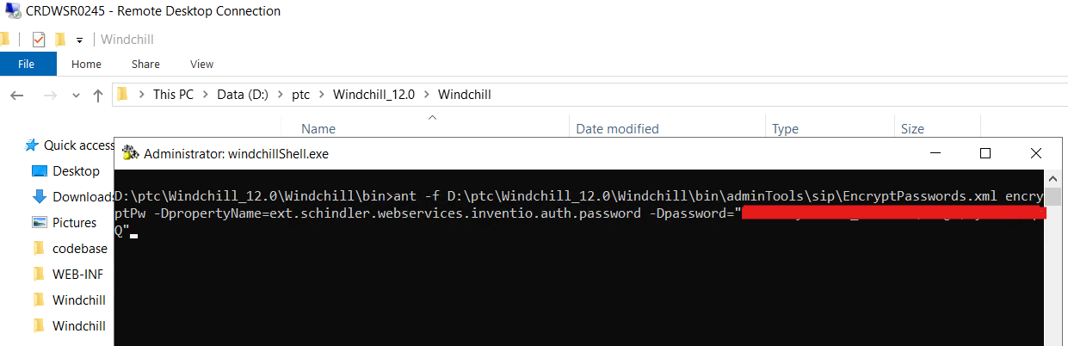

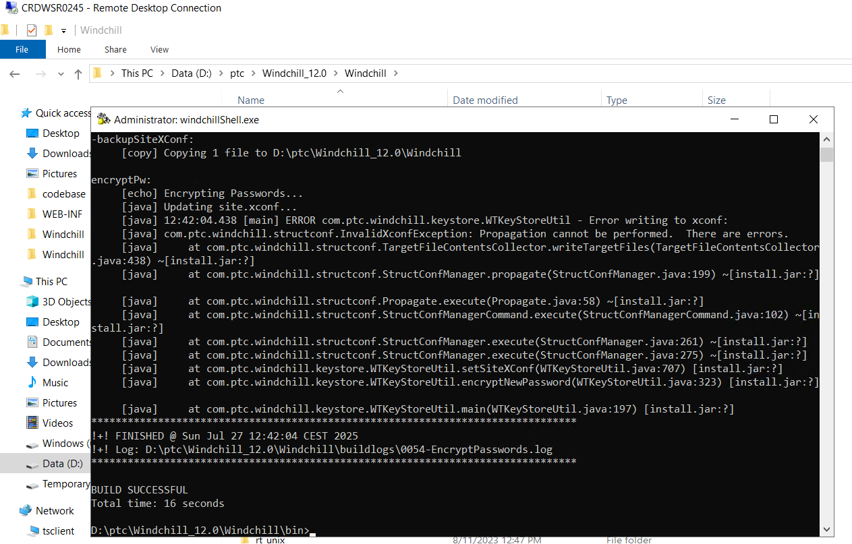

* Copy **lotusNotesEntry.xconf** from D:\ptc_bkp_26072025\Windchill_12.0\Windchill to D:\ptc\Windchill_12.0\Windchill

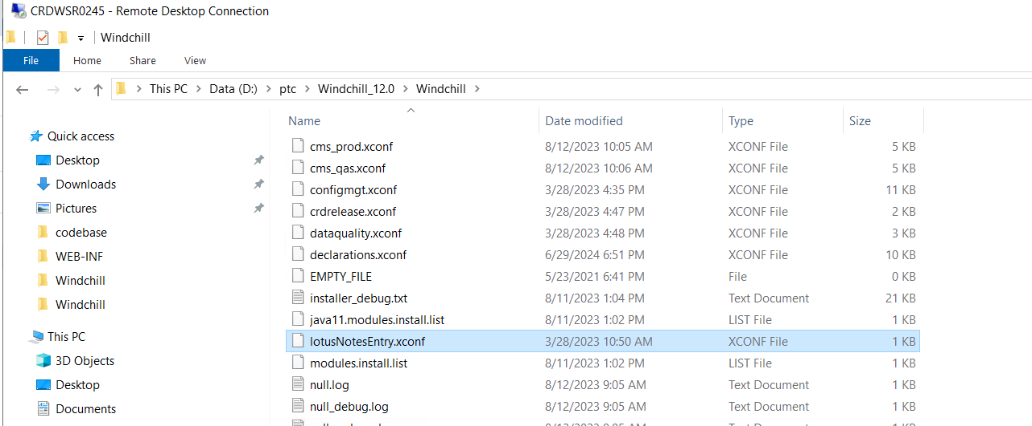

* Run xconfmanager -p

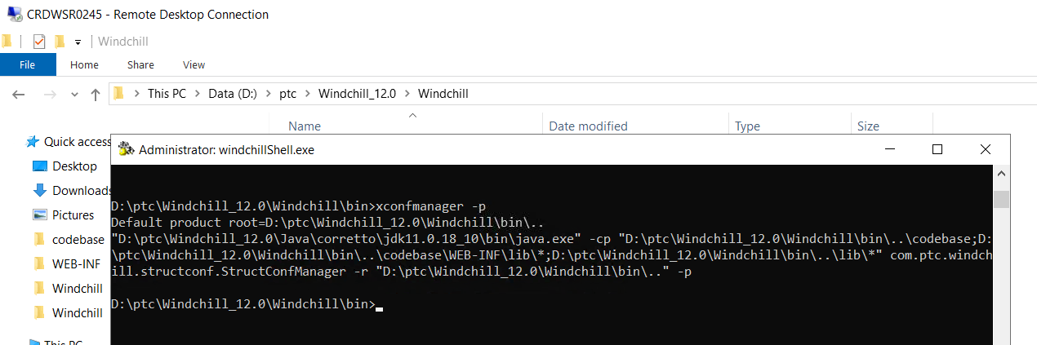

* Clear windchill cache and start DS, HTTP, Windchill and Solr from windows service

# Replica Configuration

## Update Replica Site URLs

* Navigate to Site > Utilities > File Server Administration

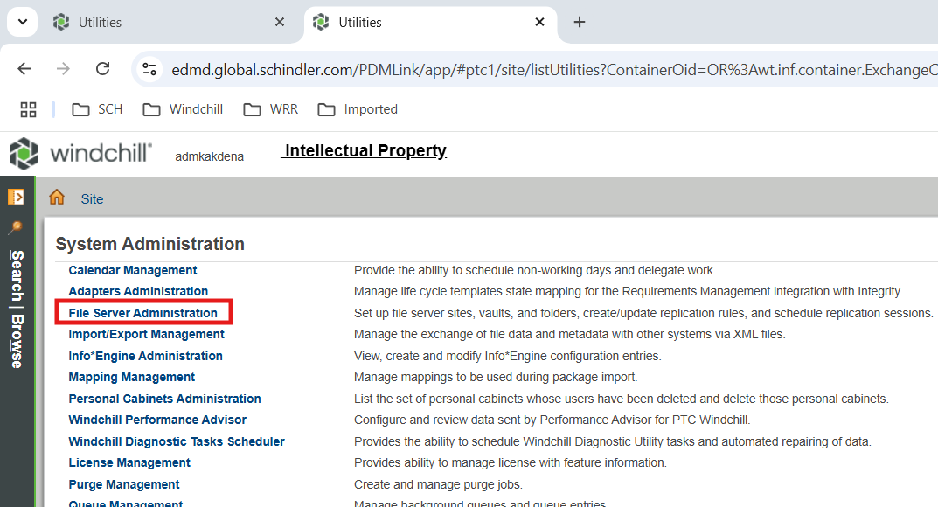

* Click on File Server Management

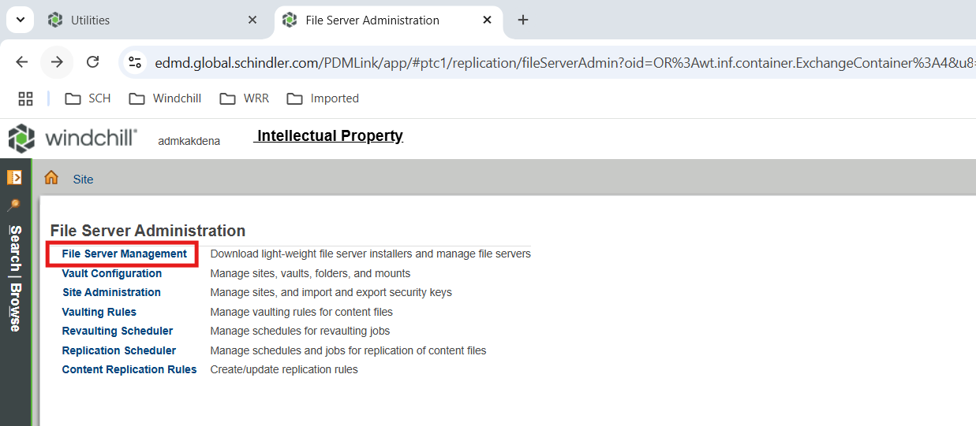

* Edit Replica_NA

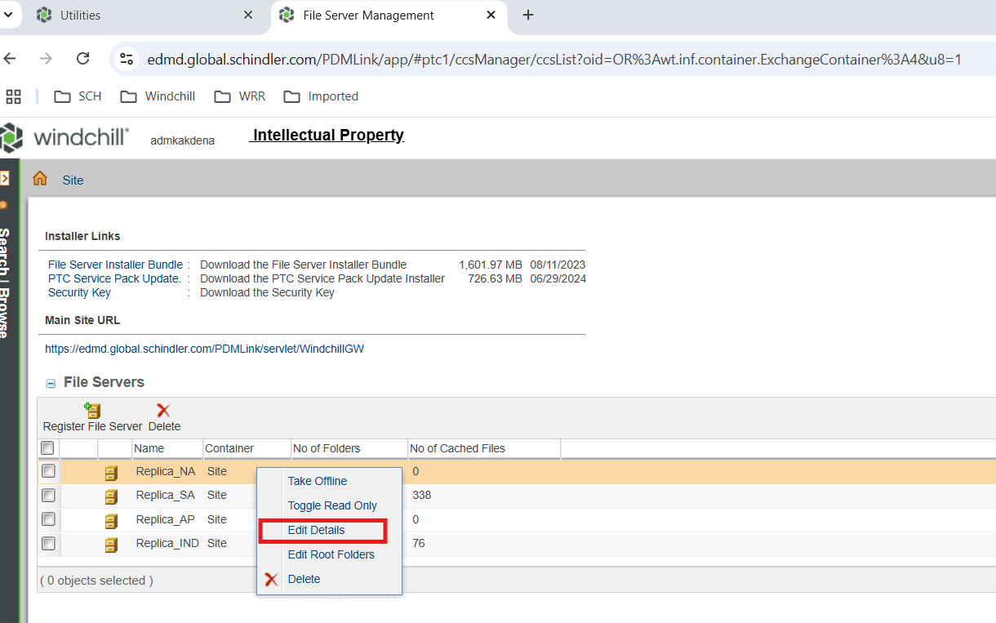

* Update file server url as per below snapshot and click Ok

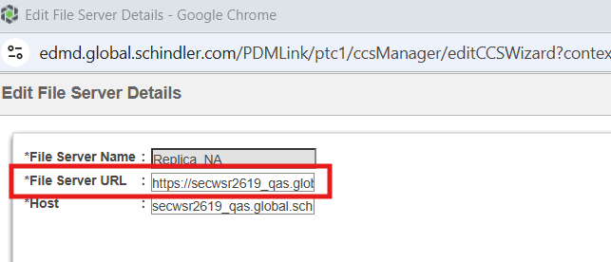

* Edit Replica_SA

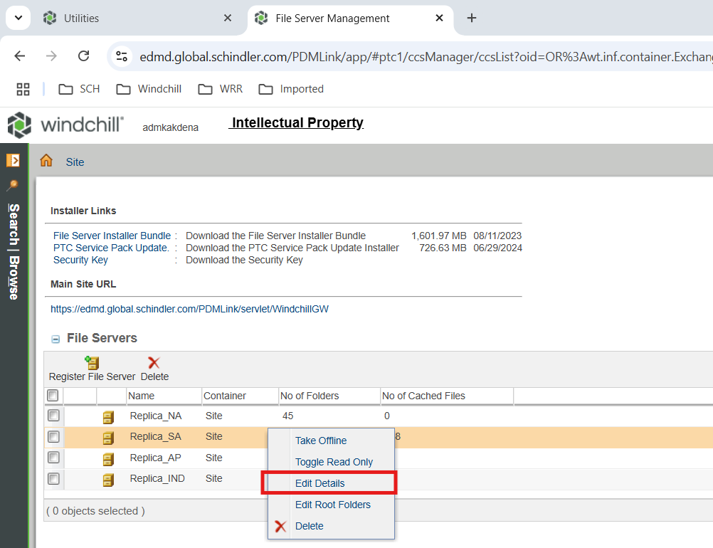

* Update file server url as per below snapshot and click Ok

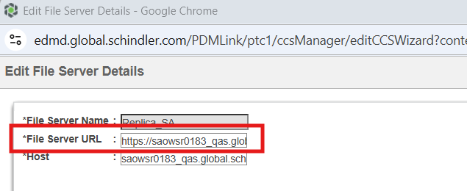

* Edit Replica_AP

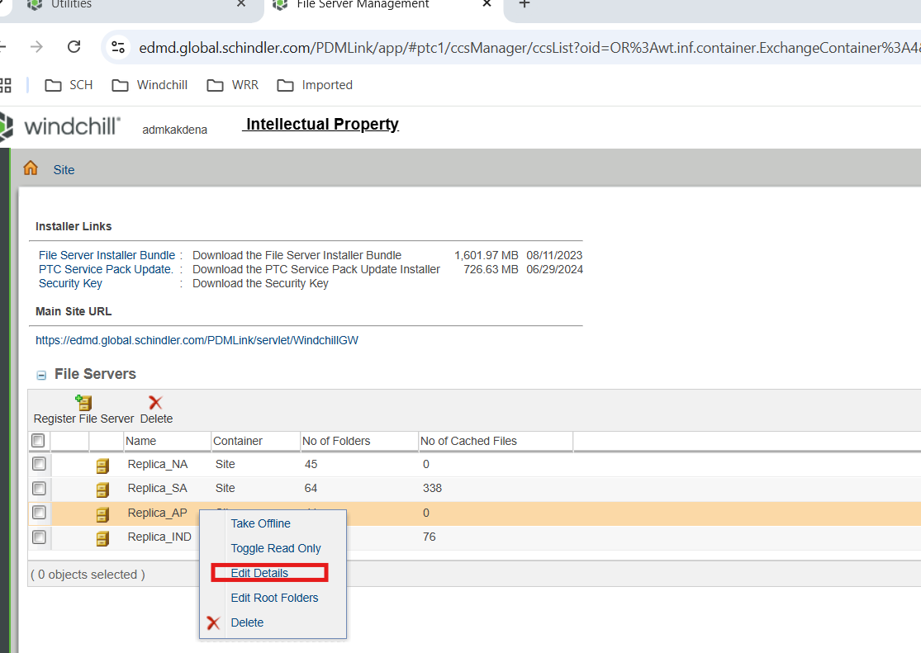

* Update file server url as per below snapshot and click Ok

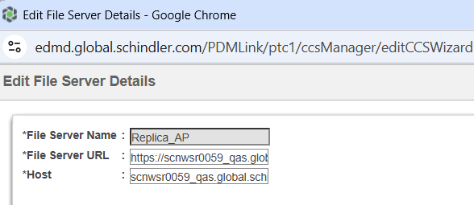

* Edit Replica_IND

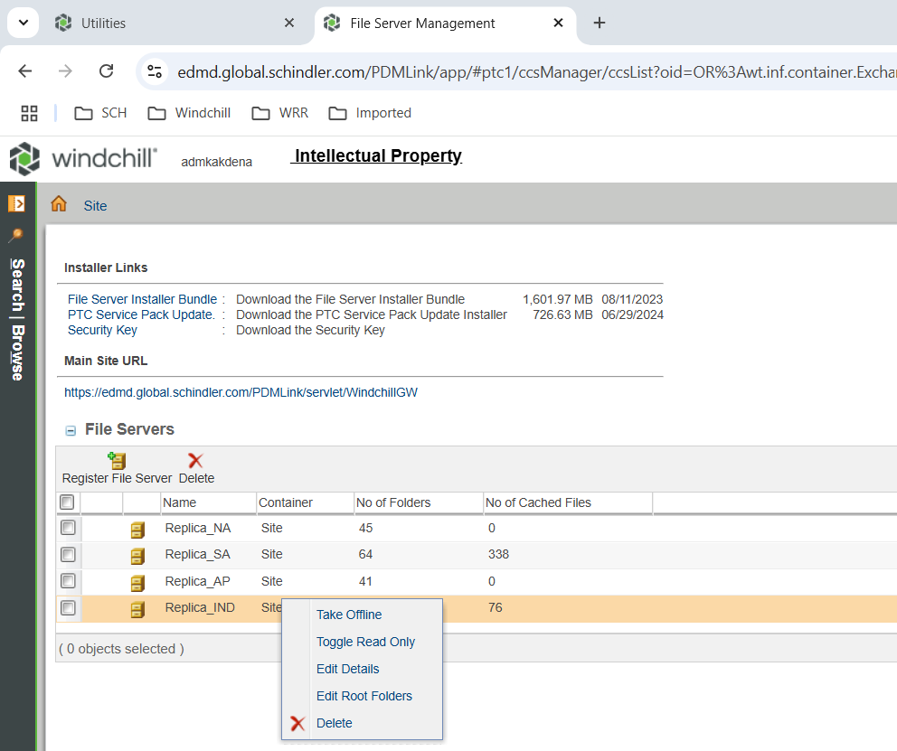

* Update file server url as per below snapshot and click Ok

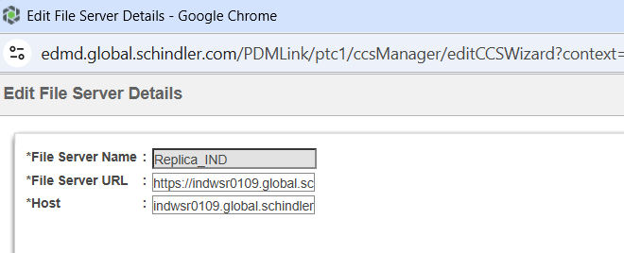

## Update IND Replica Master Security Key

* Navigate to Site > Utilities > Site Administration

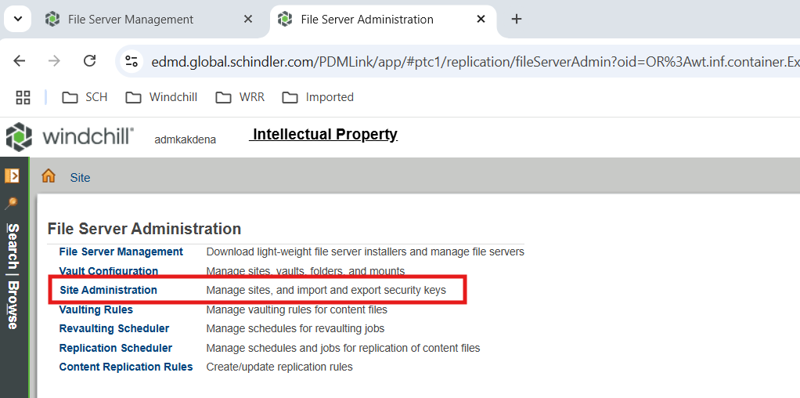

* Select Master and Export Key

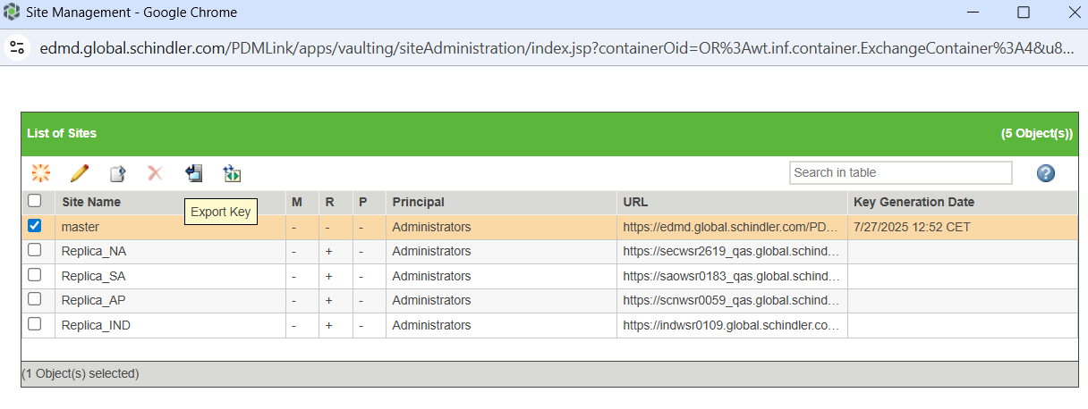

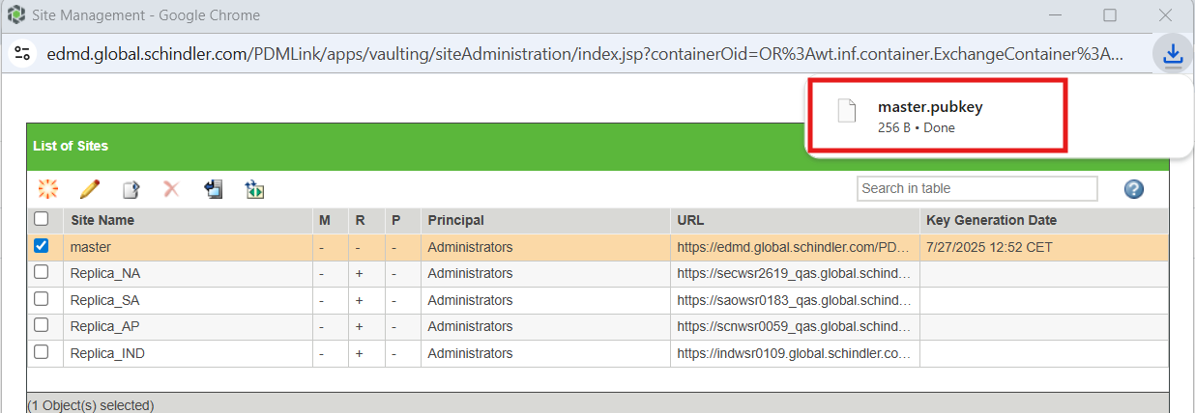

* Connect to indwsr0109 and take backup of existing .pubkey from D:\PTC folder

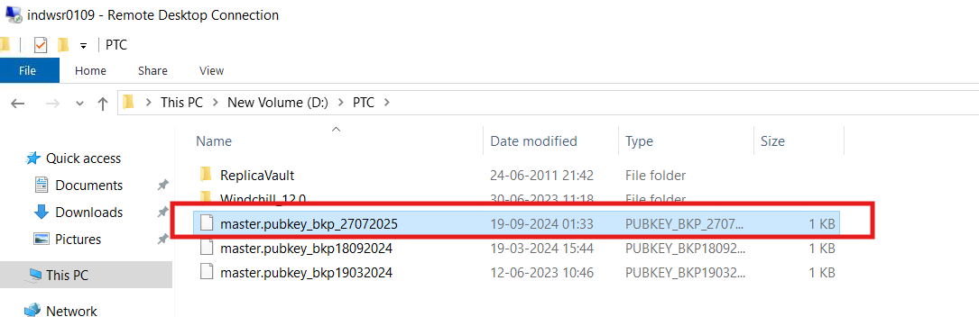

* Place downloaded master.pubkey in D:\PTC folder

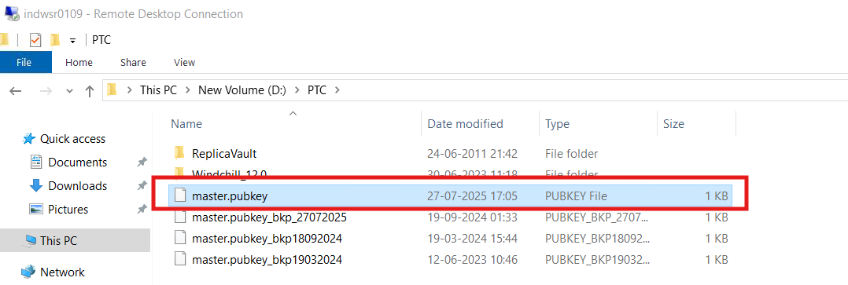

# JMS Service Update

* Navigate to Site > Utilities > Info Engine Administration

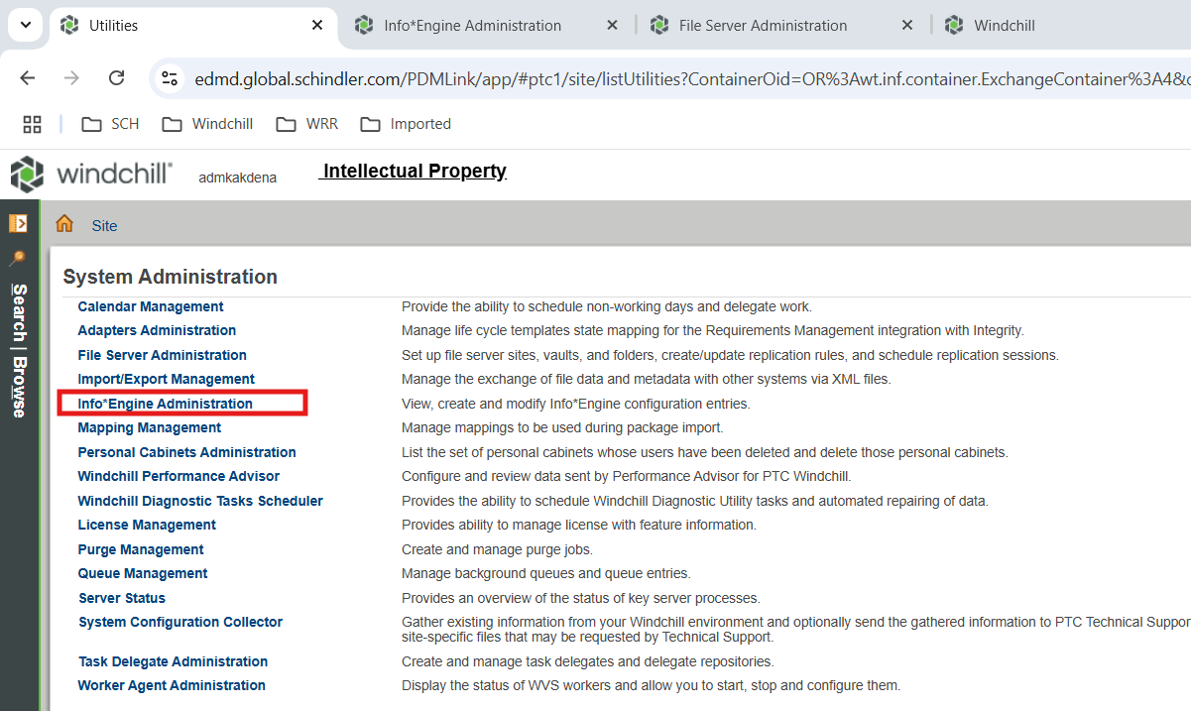

* Click on com.schindler.global.edmd.jmsService

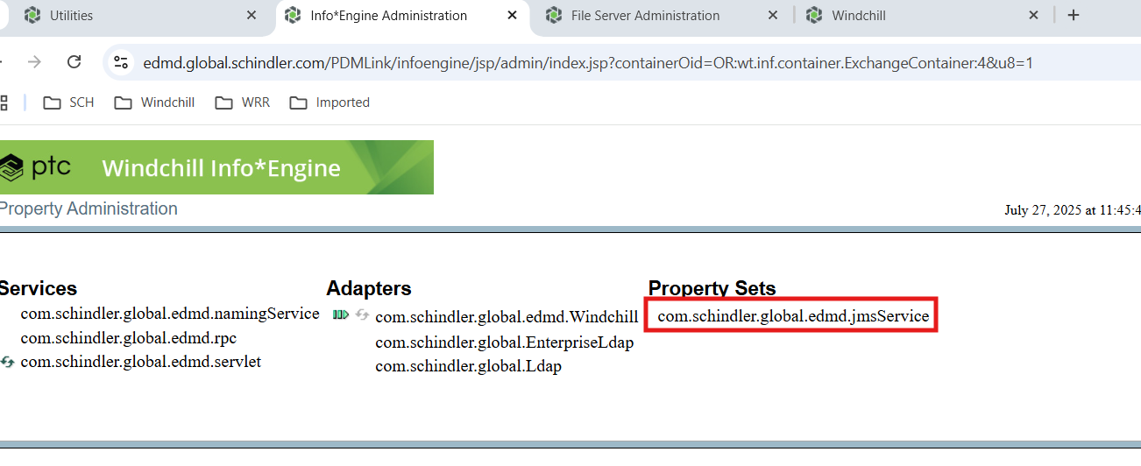

* Update JMS Base URI and Password as per QA Server

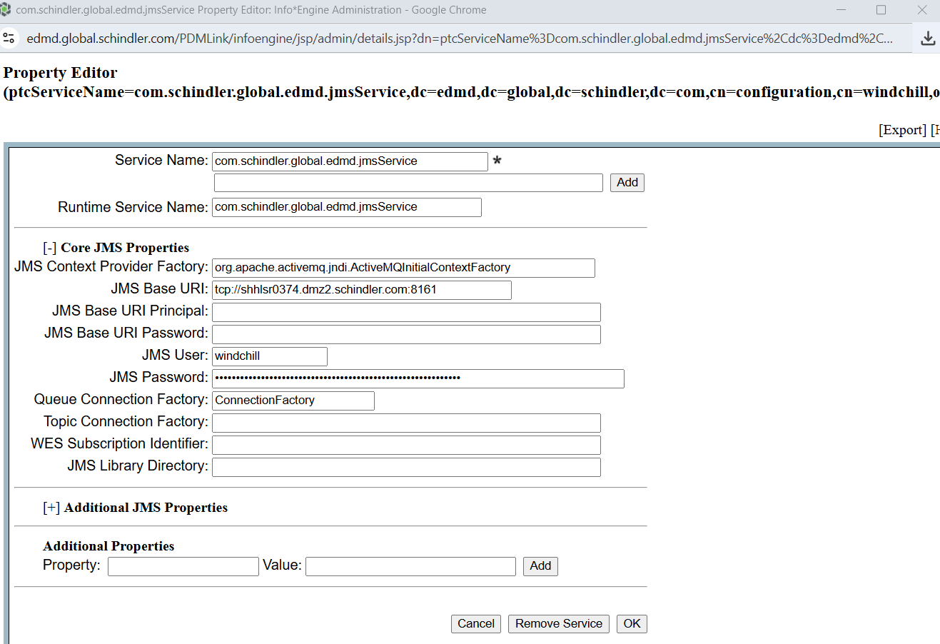

# Update Distribution Target

* Navigate to Site > Utilities > Enterprise Systems Transactions Administration

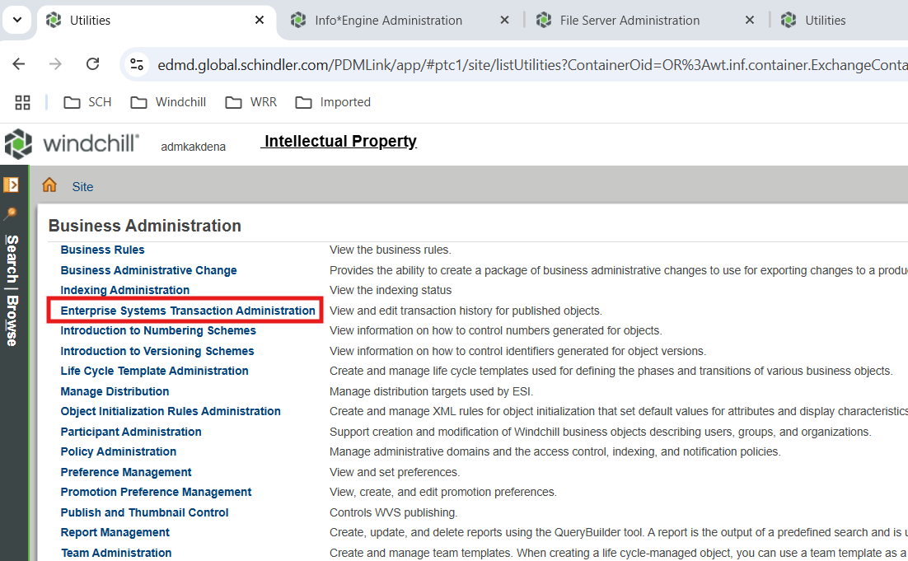

* Search Pending and Processing Transactions

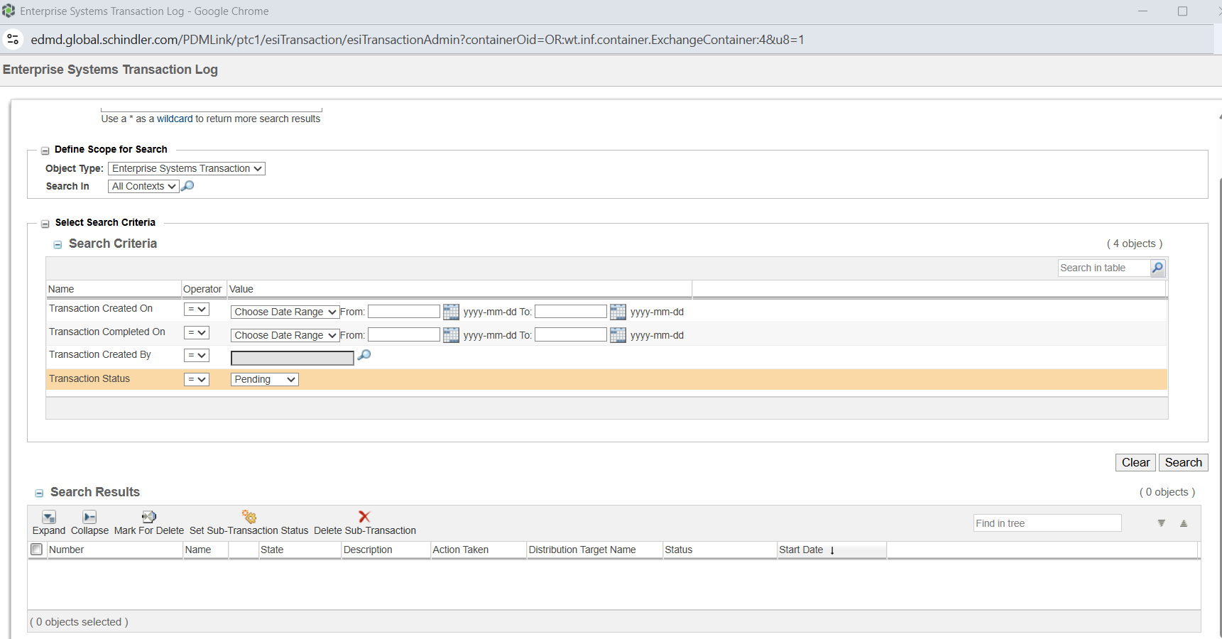

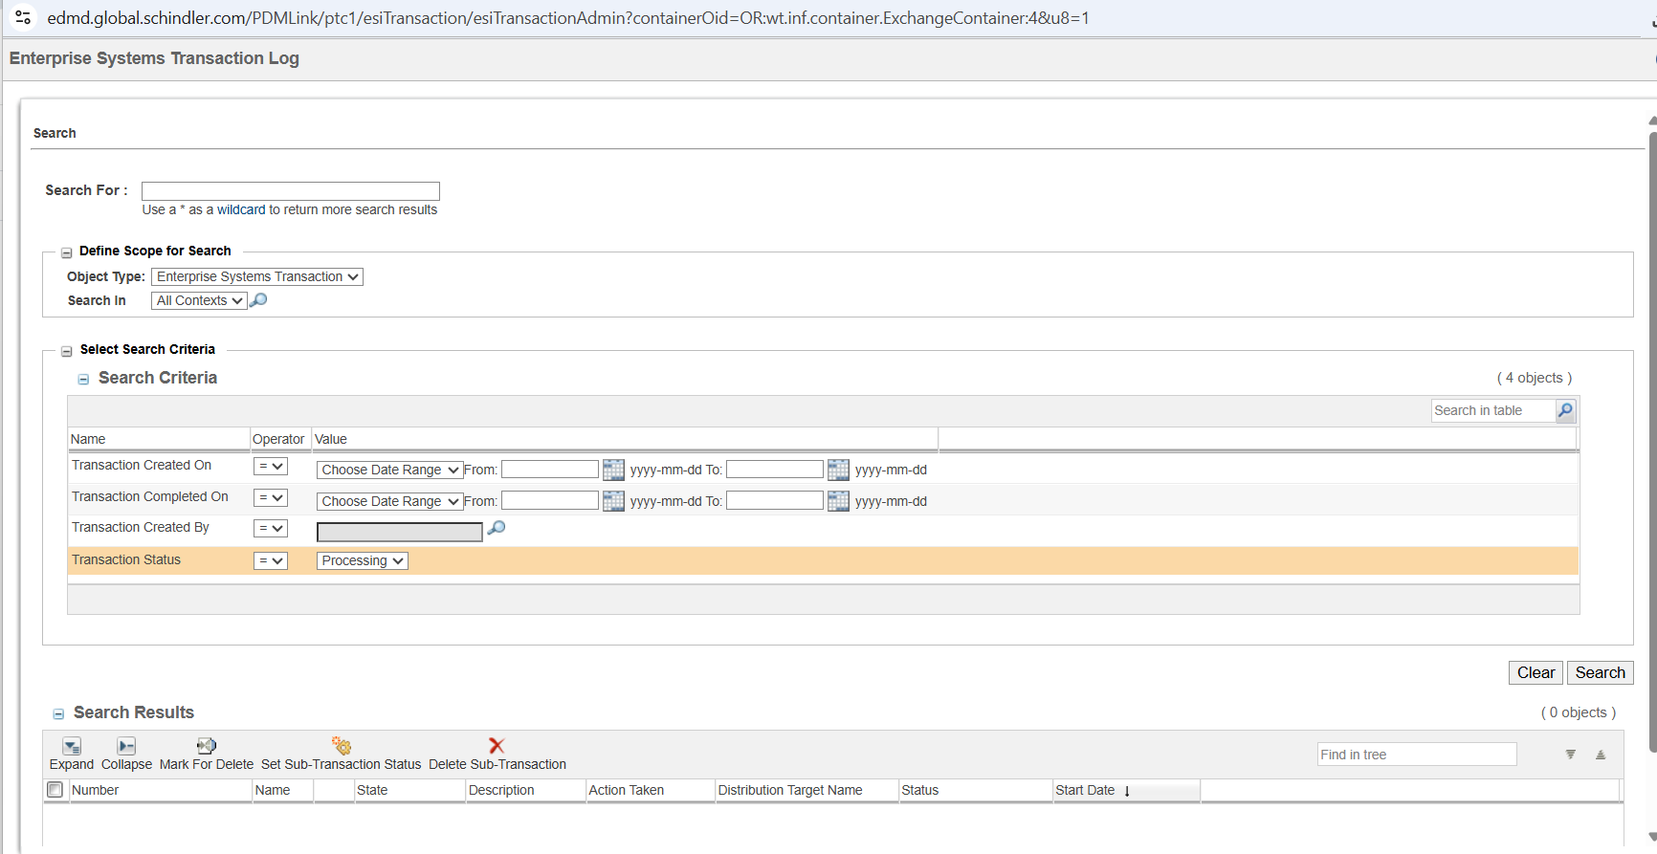

* Connect to database and run below query to take backup of ReleaseActivity table

select * into ReleaseActivity_27072025 from ReleaseActivity;

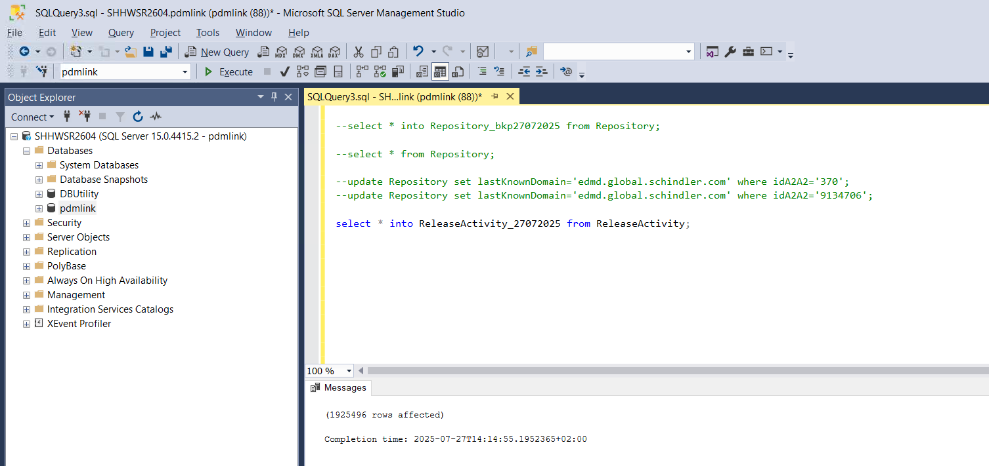

* Run below query to get the pending transactions

select * from ReleaseActivity where status='pending' and idA3A5 in(select idA2A2 from ESITarget where name='SAPPDM');

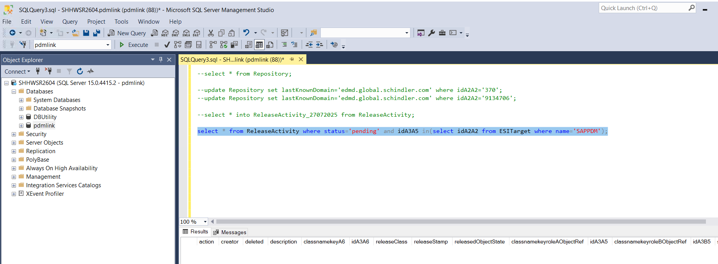

* Check if we can edit SAPPDM distribution target from Site > Utilities > Manage Distribution
* We need to set System ID as C31 and Client 670

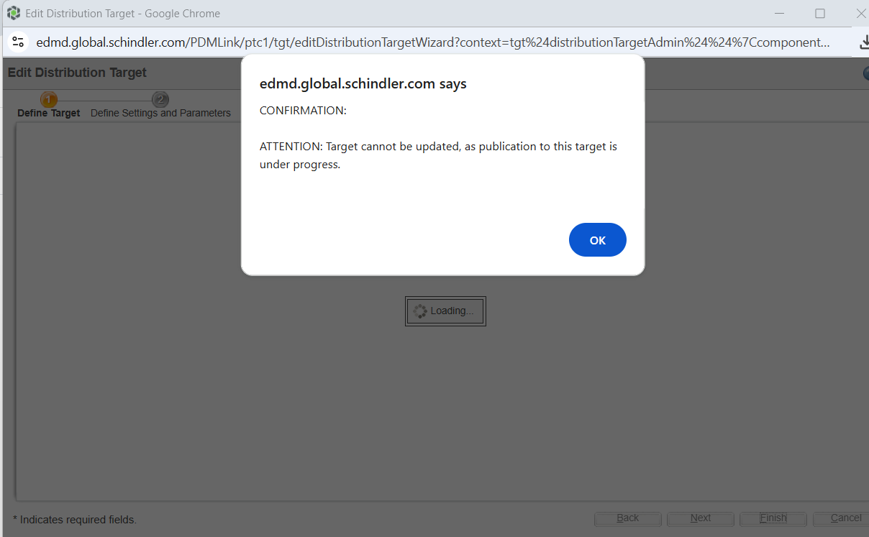

* Though there were no pending or processing transaction, we are not able to edit the DT
* Run below query to update all pending transaction to failed in ReleaseActivity table

update ReleaseActivity set status='failed' where status='pending';

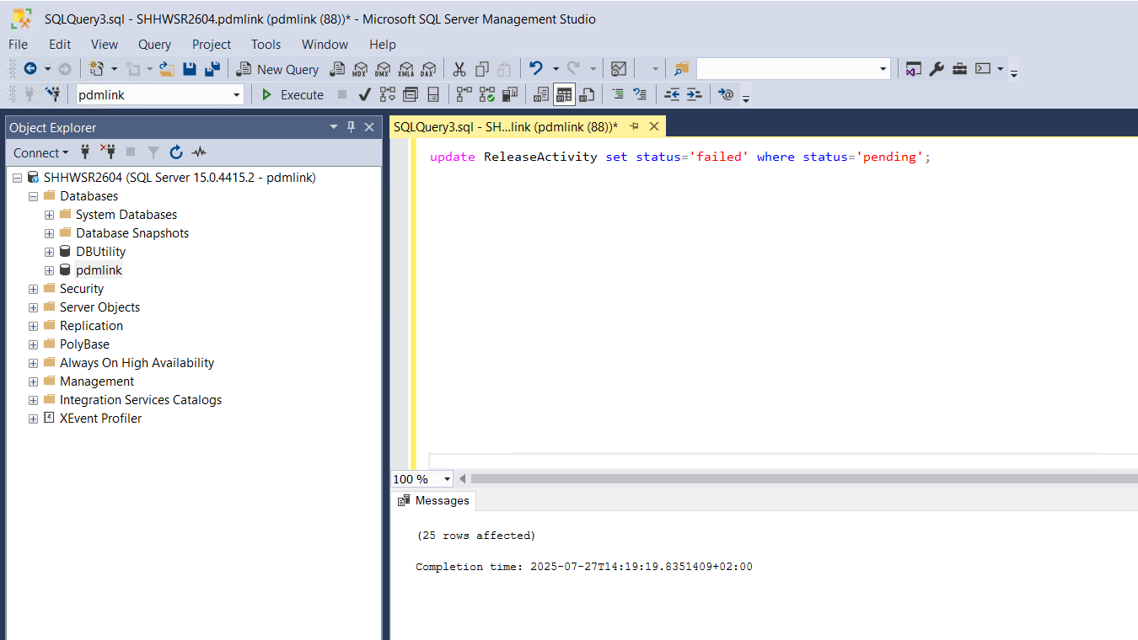

* Edit Distribution target

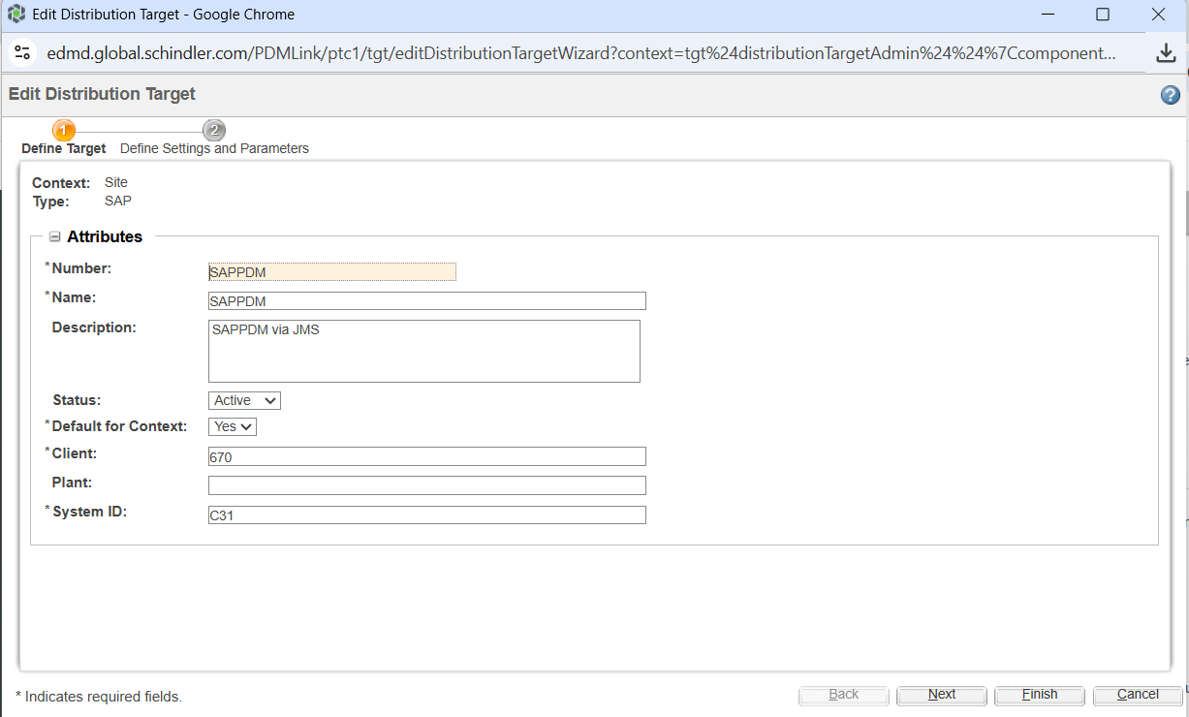

# Vault Configuration

* Navigate to Site > Utilities > File Server Administration

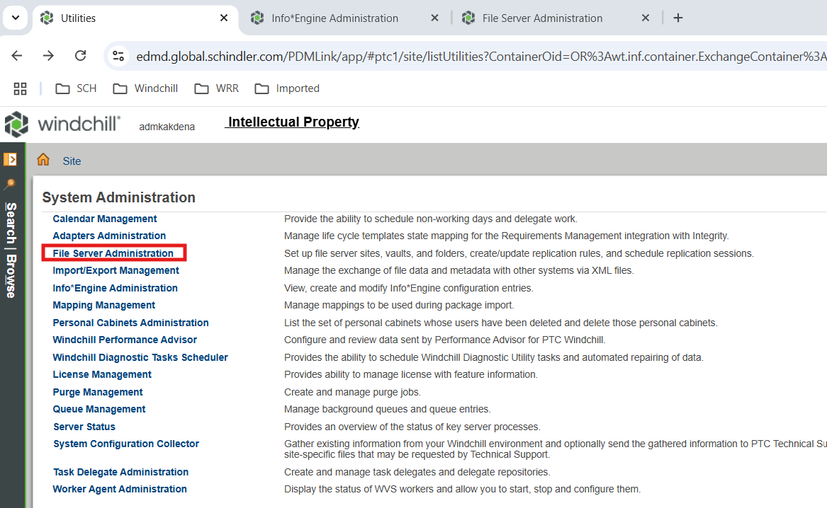

* Select Vault Configuration

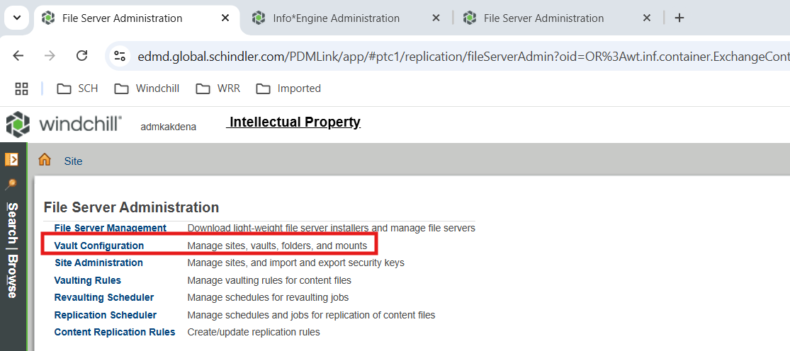

* Validate Sites > master > Hosts

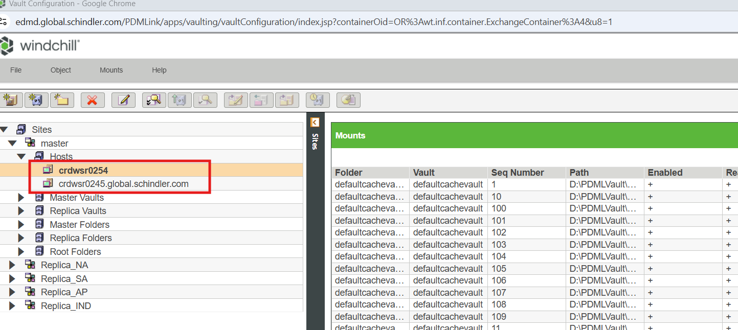

* Connect to database and take backup of fvhost table

select * into FvHost_bkp27072025_1 from FvHost;

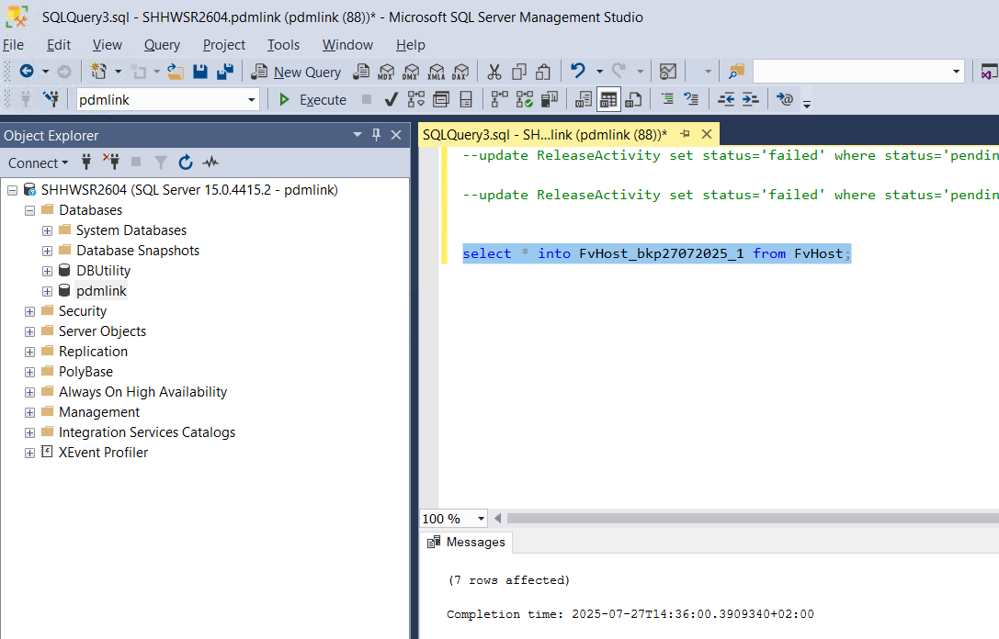

* Run below query to update hostname from crdwsr0254 to crdwsr0245 as per ida2a2 value

update FvHost set hostName='crdwsr0245' where idA2A2='14481403093';

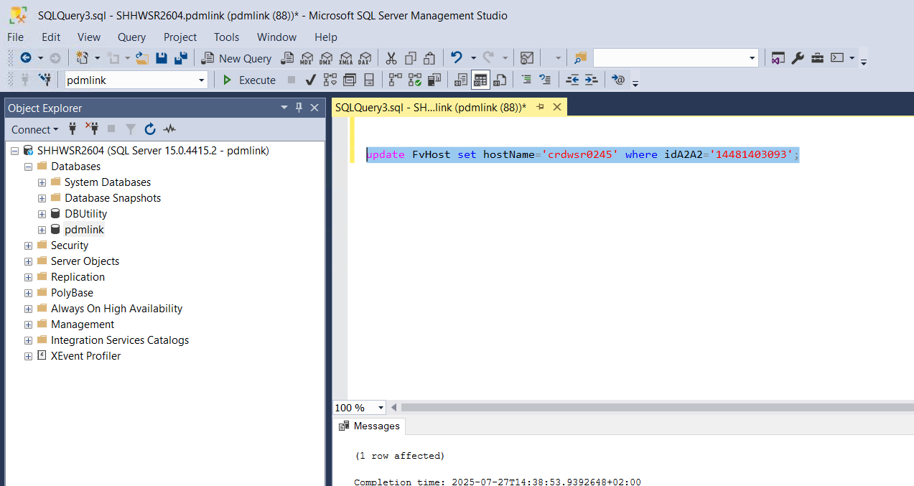

* Validate entry is updated correctly by running below query

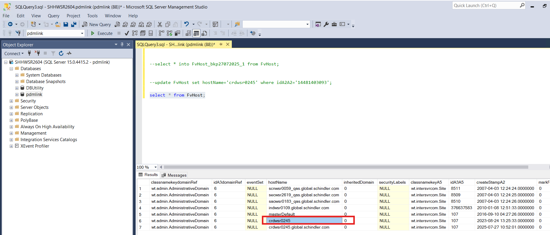

* Delete extra entry from fvhost table using below query as per ida2a2 value

Delete from FvHost where idA2A2='24517940193';

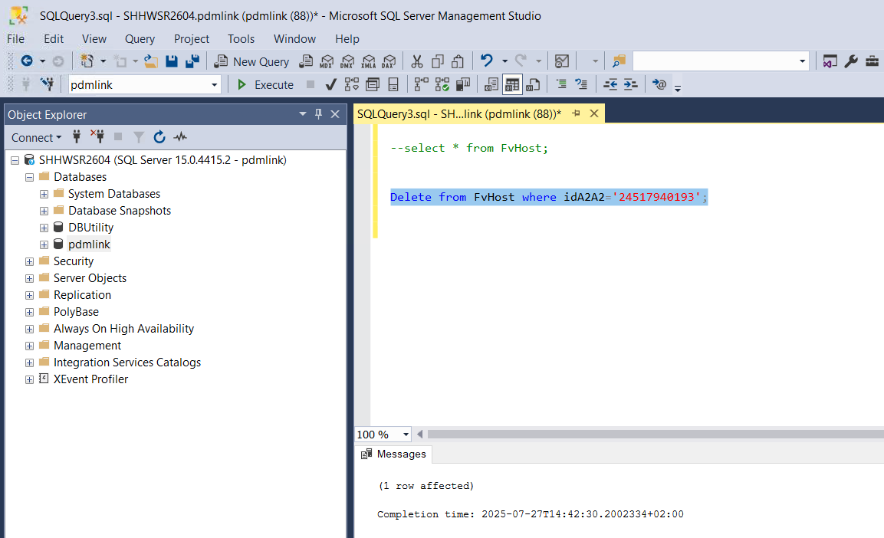

* Validate entry is deleted by running below query

select * from FvHost;

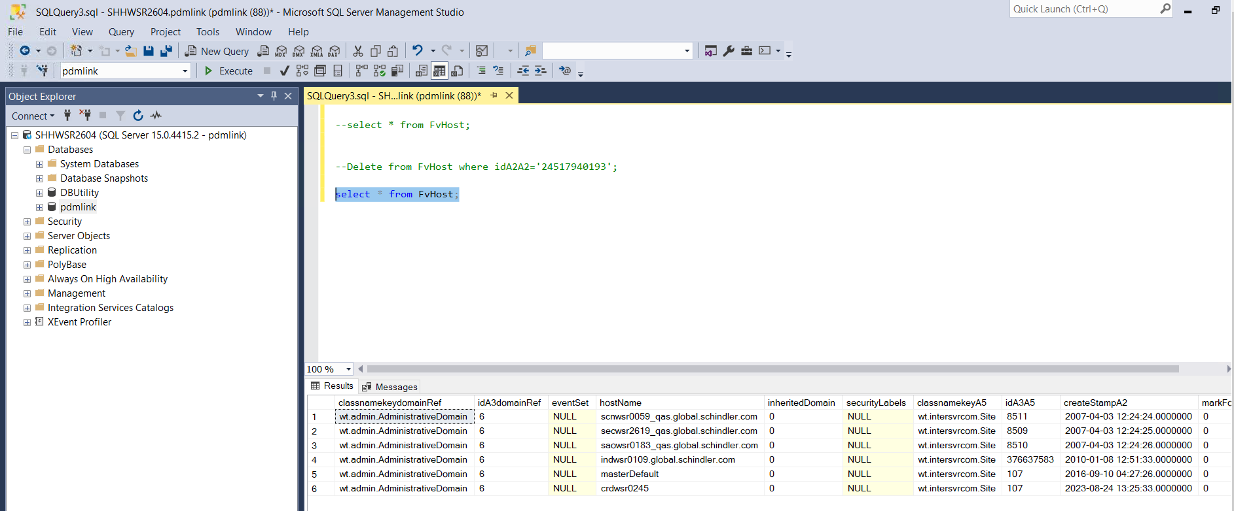

* Validate host from Vault Configuration

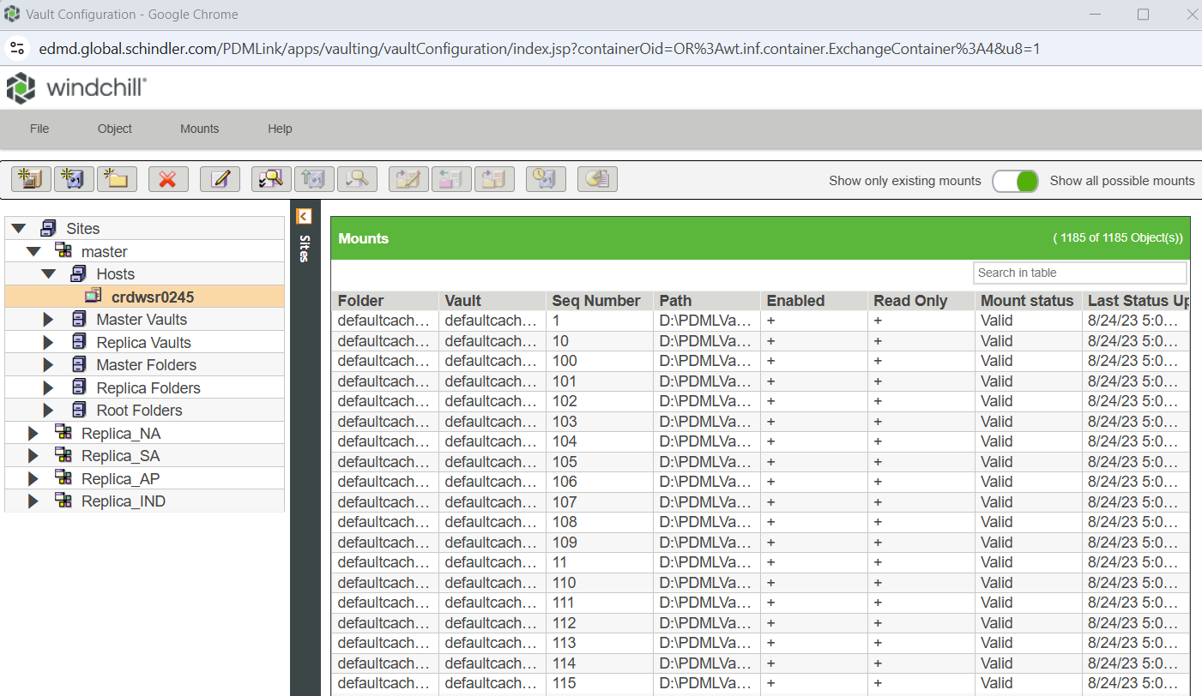

* Validated Mounts by Selecting crdwsr0245 host > Object > Validate

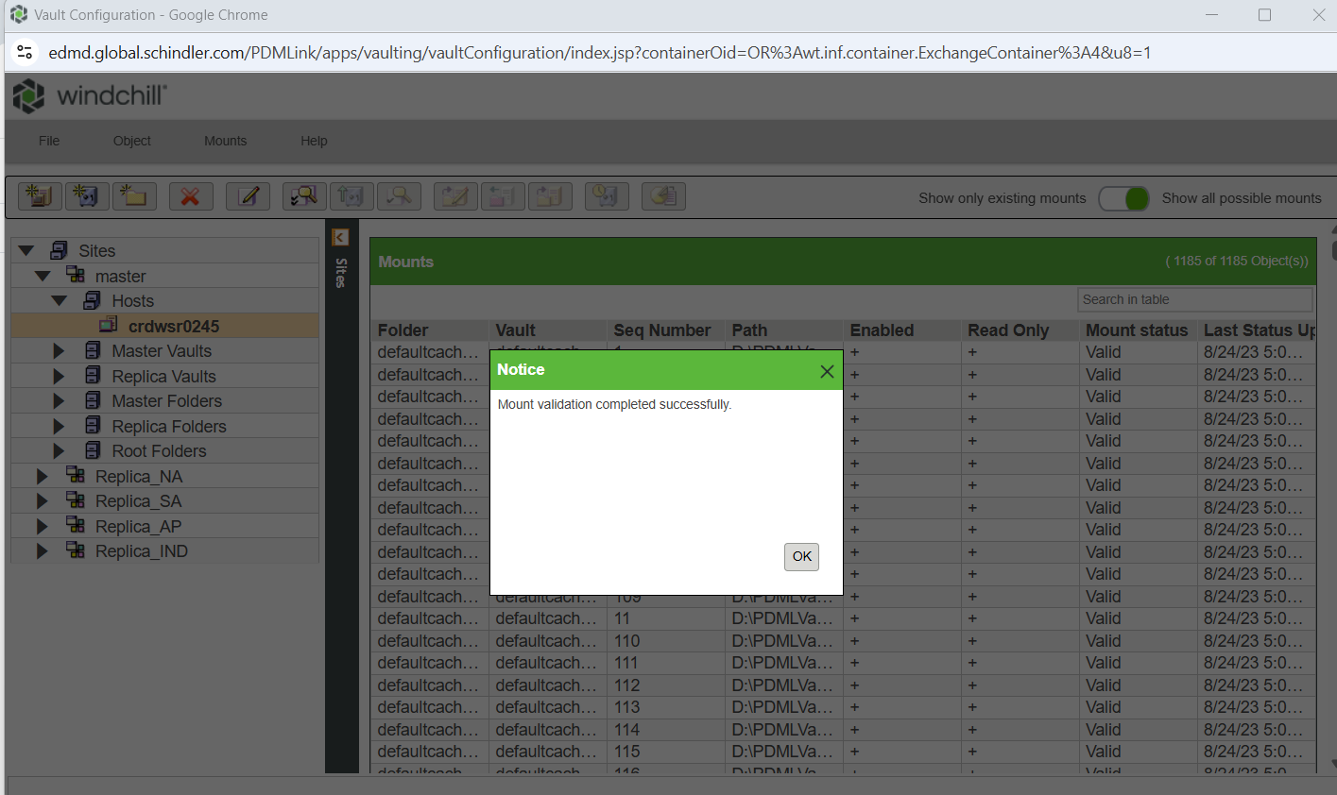

# Update GUID for WPA

* Connect to database and take backup of Repository table

select * into Repository27072025 from Repository;

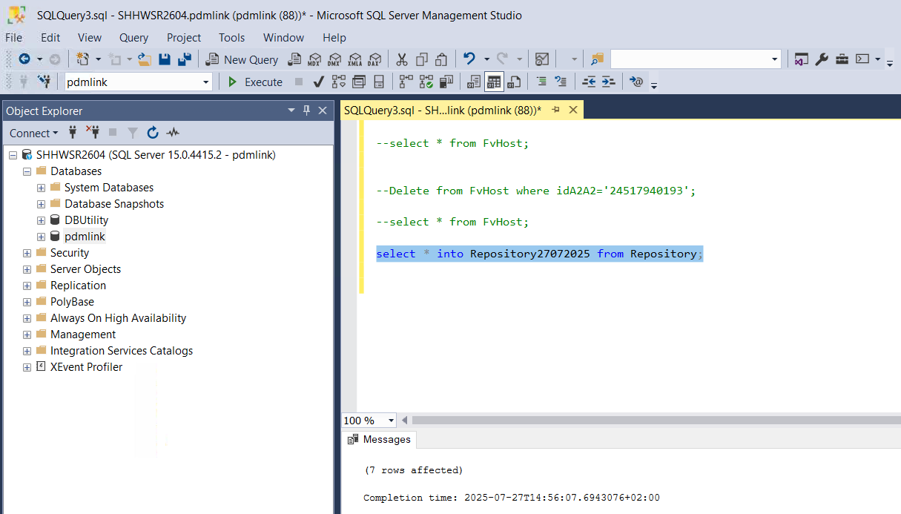

* GUID Before update

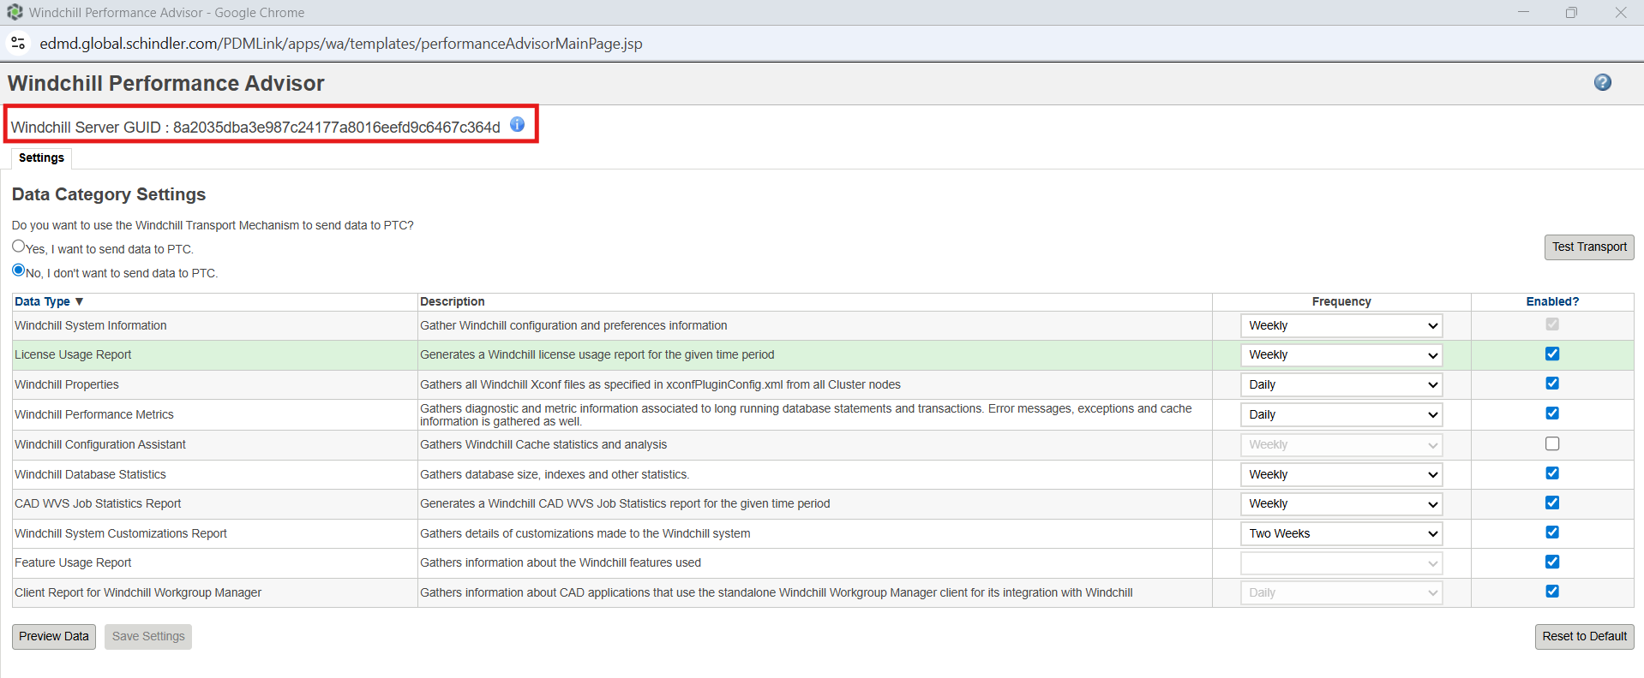

* Run below Query to check current GUID value of displayName PTC_WNC_Internal rows

select * from Repository;

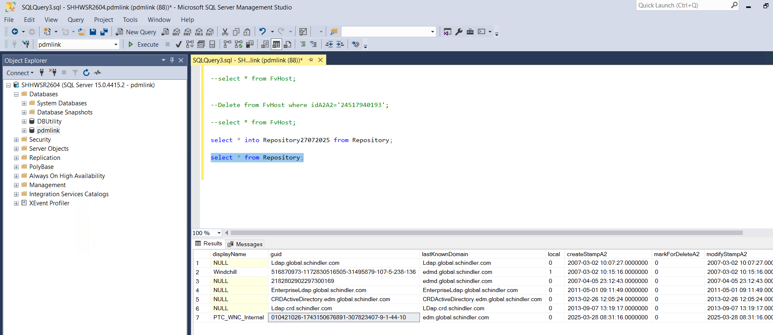

* **642486821-1744628908415-668729626-50-17-44-10**is the GUID which we have taken backup during start of rehost process
* Open Windchill Shell and run below command

windchill com.ptc.wa.WAUtility -setguid=**642486821-1744628908415-668729626-50-17-44-10** -username=wtadmin -password=<password>

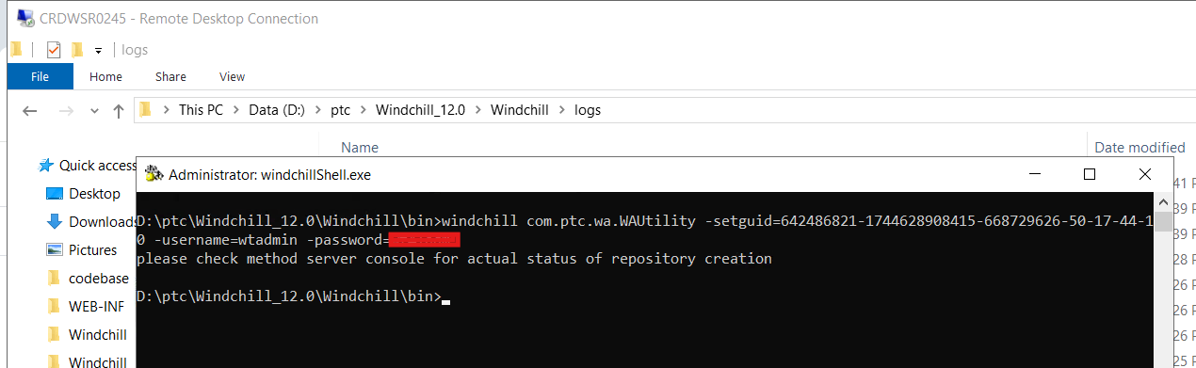

* Run below Query to check updated GUID value of displayName PTC_WNC_Internal rows

select * from Repository;

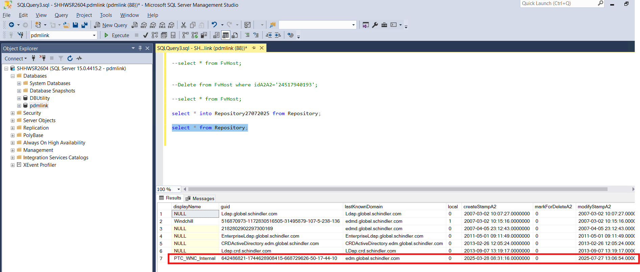

* lastKnownDomain from PTC_WNC_INTERANL row is poiting to source server so run below query to update it using its ida2a2 value

update Repository set lastKnownDomain='[edmd.global.schindler.com](http://edmd.global.schindler.com)' where idA2A2='22571814271';

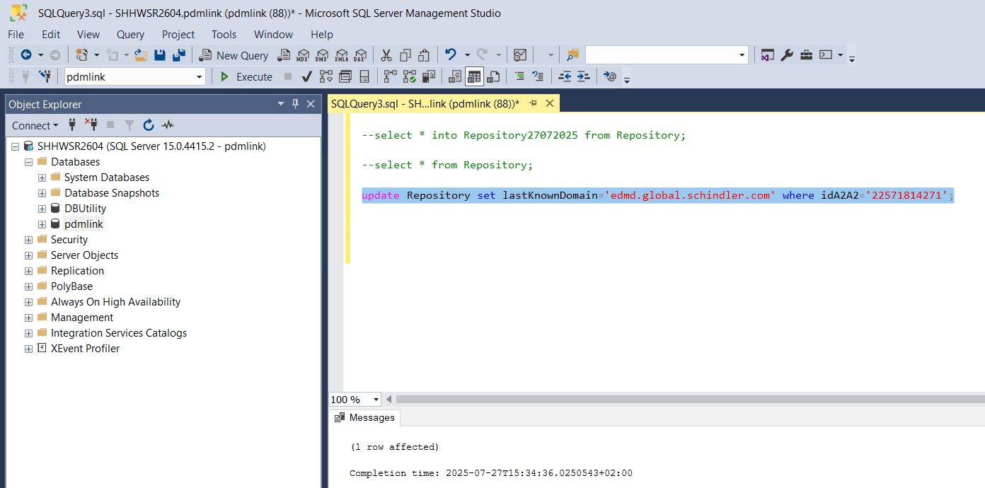

* Validate lastKnownDomain  is updated correctly

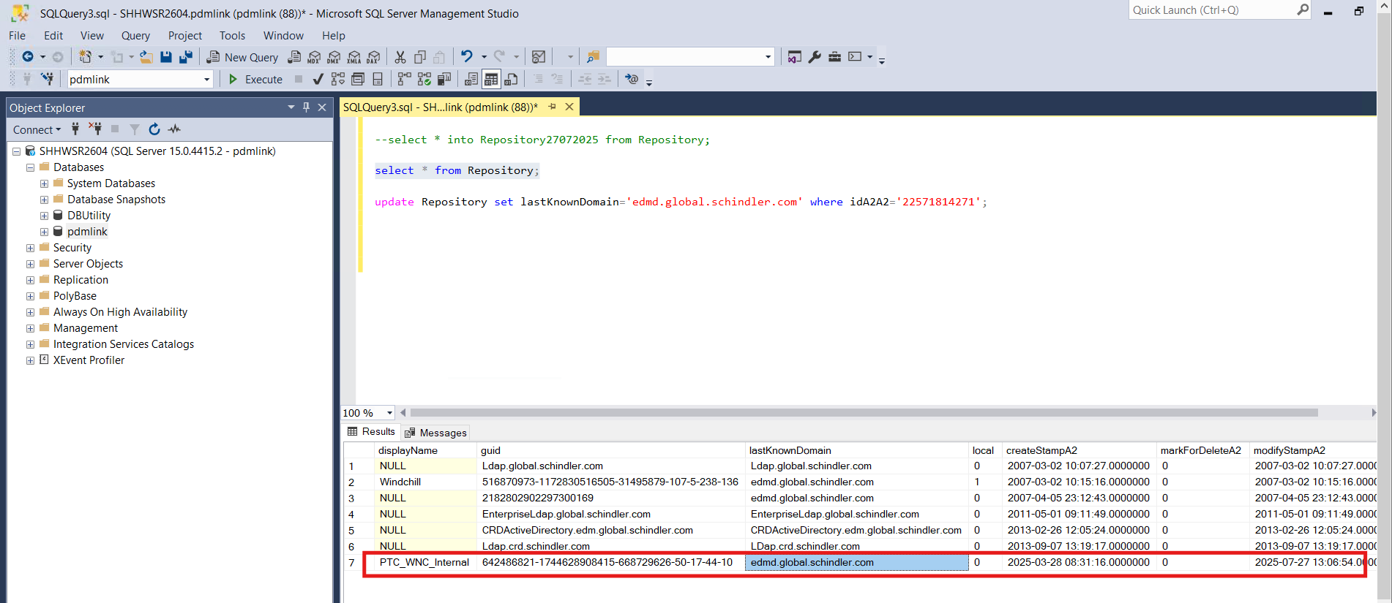

* Validate GUID from Site > Utilities > Windchill Performance Advisor Tab.
* Make sure GUID is same as per our first step **Take Backup of existing GUID**

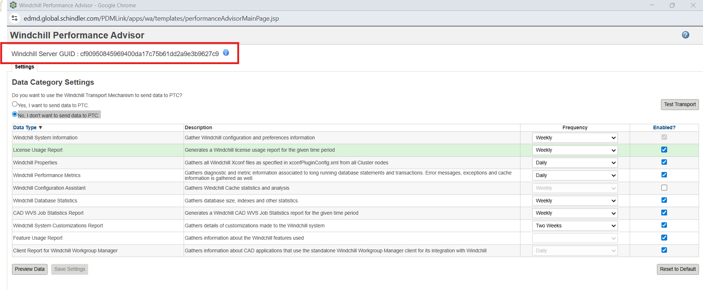

# Remove unreferenced files

* Navigate to Site > Utilities > File Server Administration > Vault Configuration
* Select defaultcachevault from Master Vaults

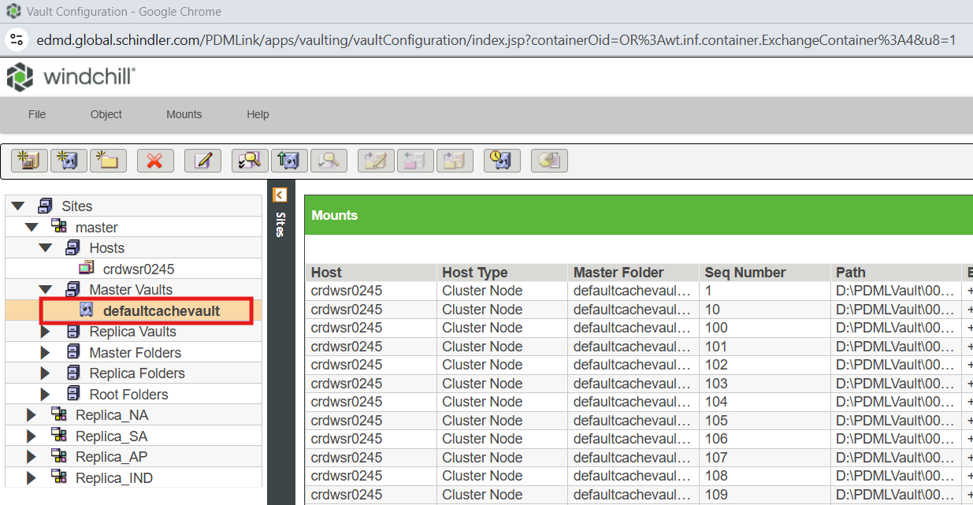

* Select Object > Remove Unreferenced Files

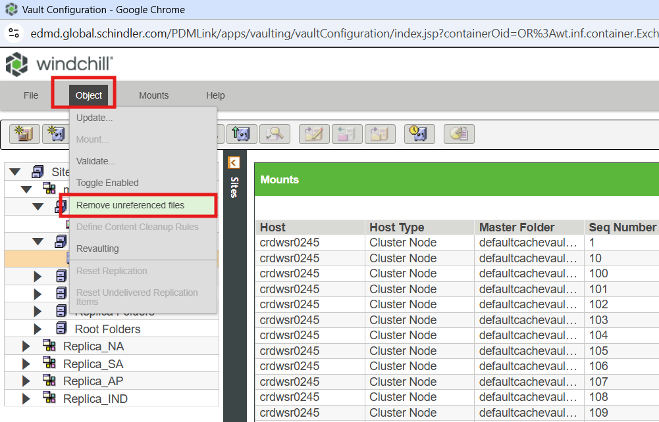

* Select Move files instead of deleting check box and click Ok

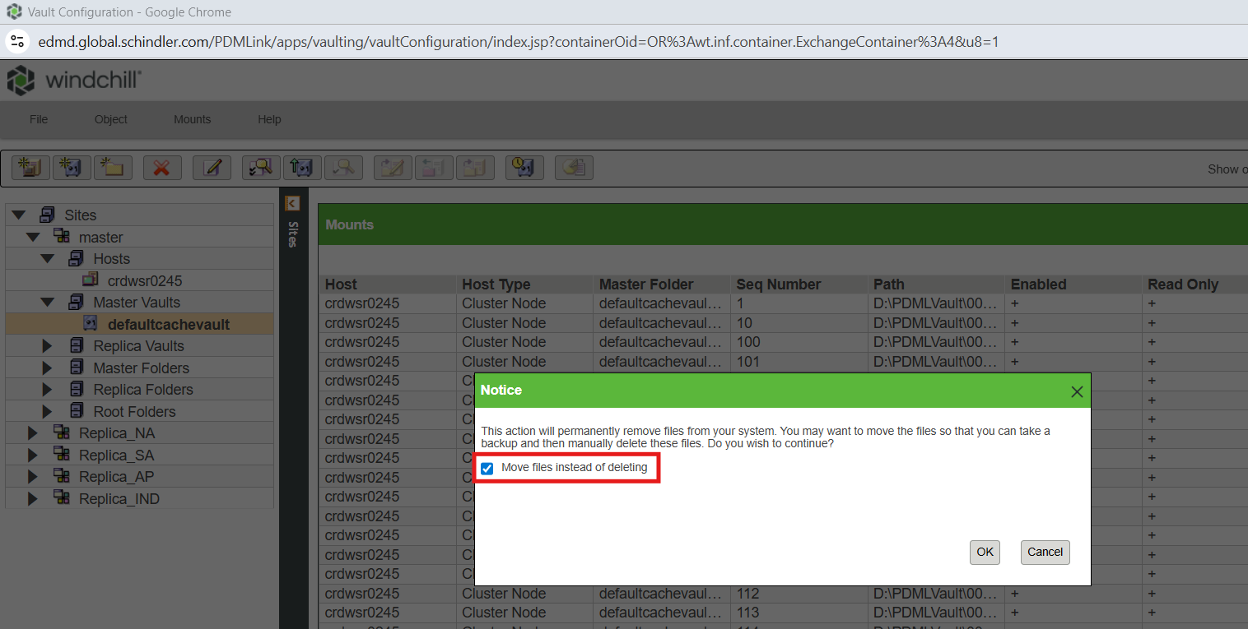

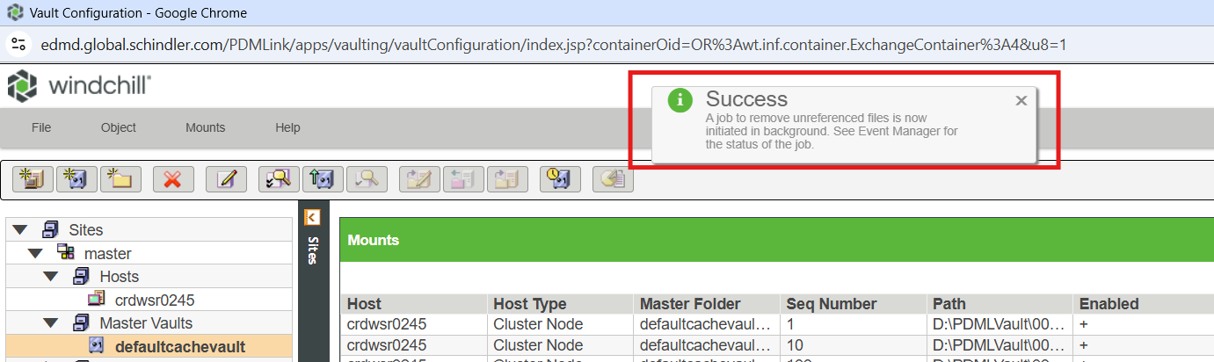

* Check status from Quick Links > Event Management

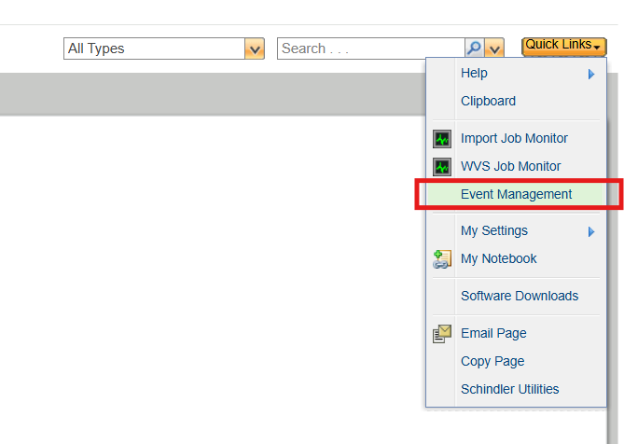

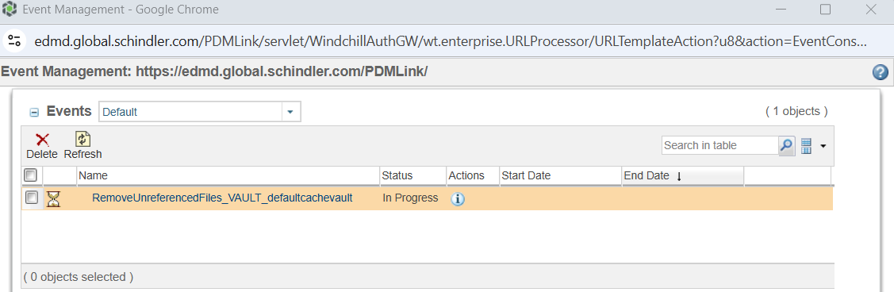

# Issues and Resolution

## Method server is not getting started due to com.ptc.wvs.server.cadagent.CadAgentServer.stop error

### Issue

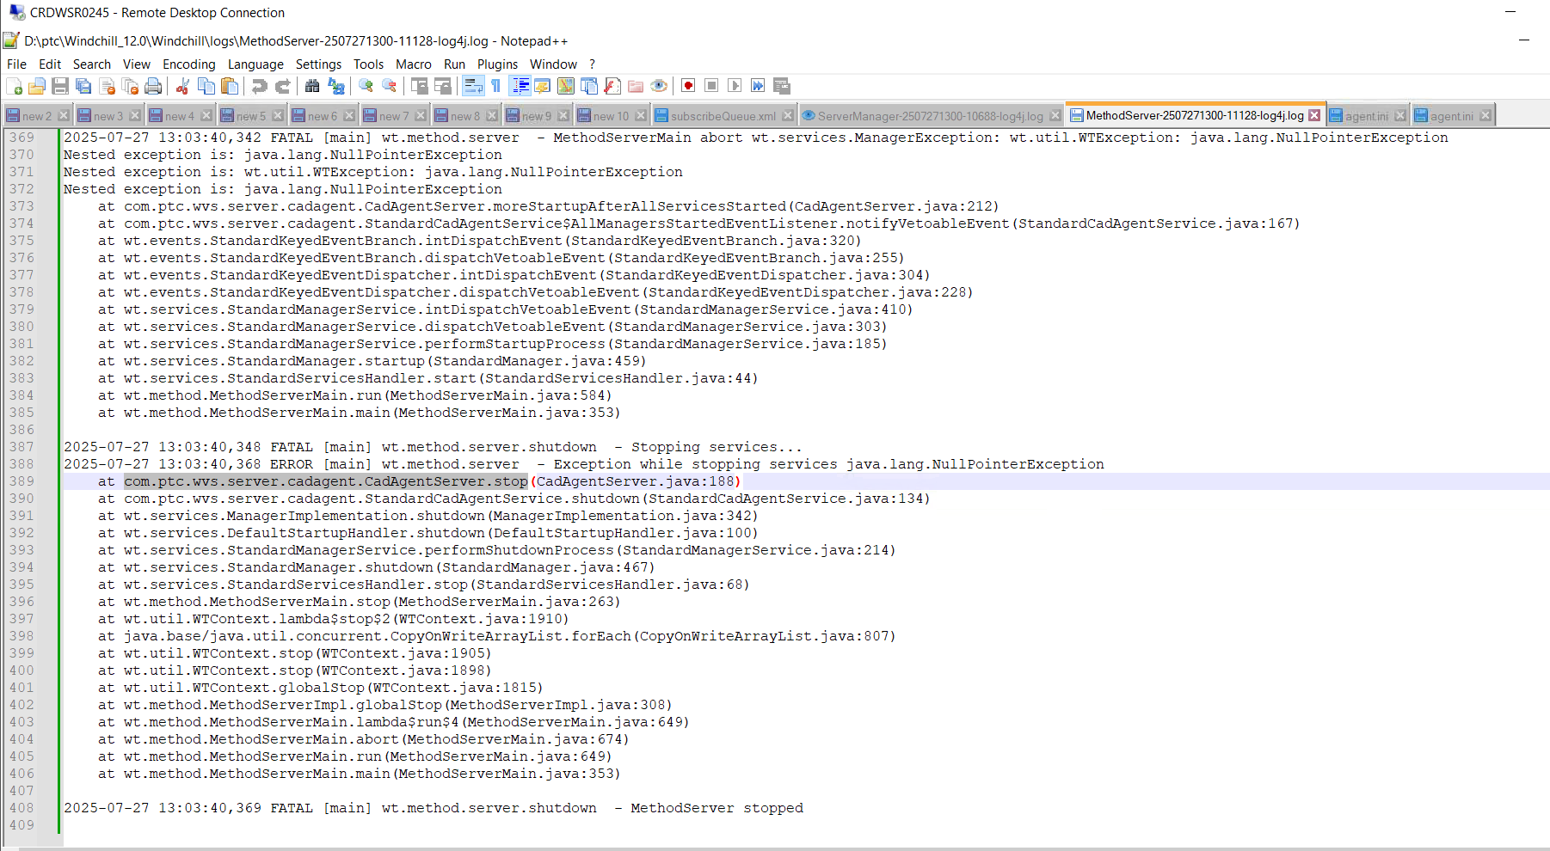

### Resolution

<https://www.ptc.com/en/support/article/CS355163>

* agent.ini file is empty
* Copy correct agent.ini file from backup

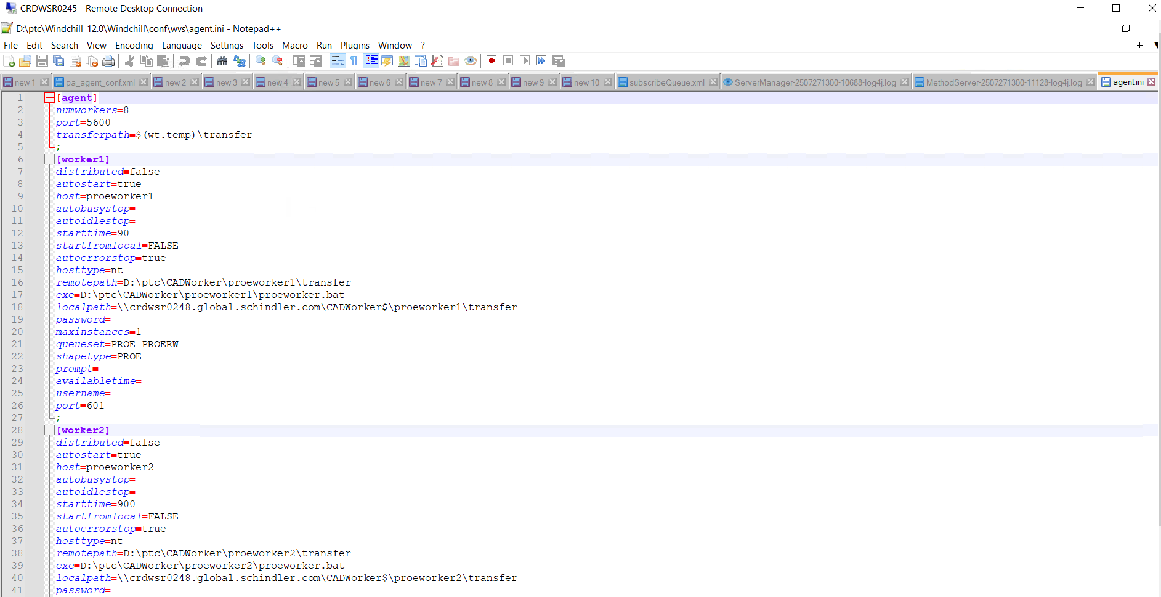

## INDWSR0109 replica server is not starting

### Issue

* Below message is thrown in windchill shell while starting the windchill

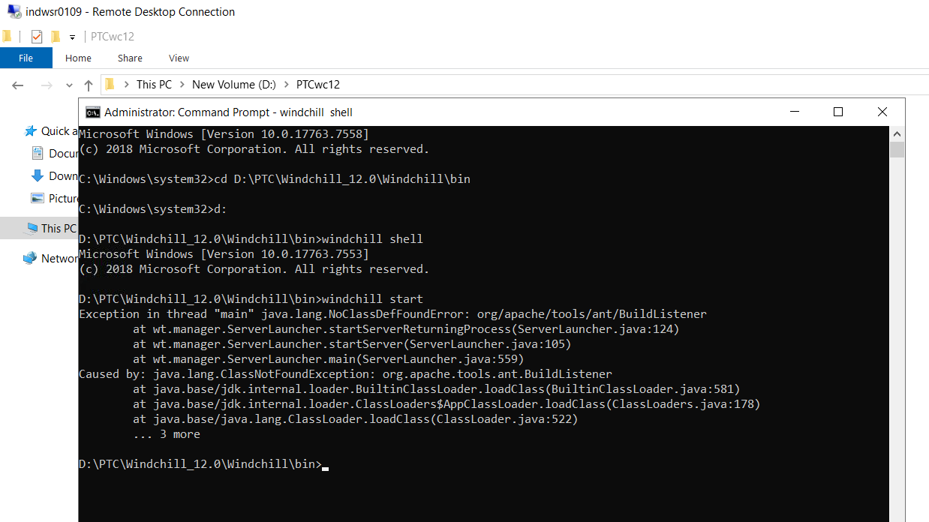

Resolution

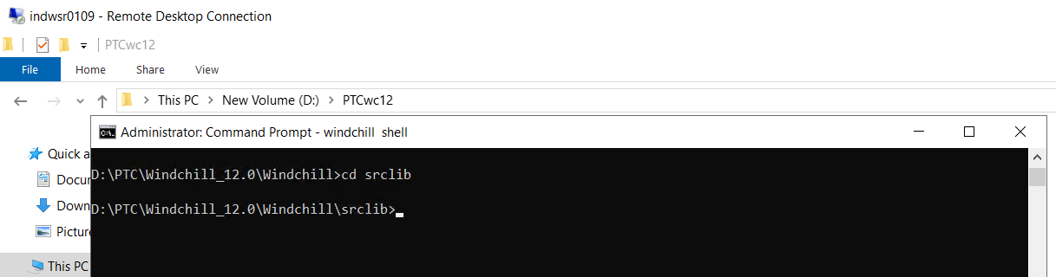

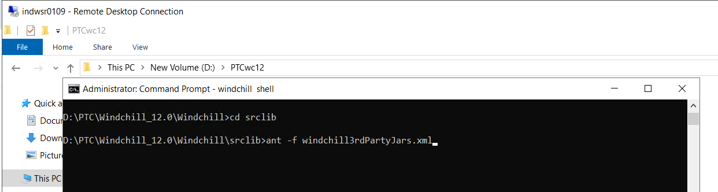

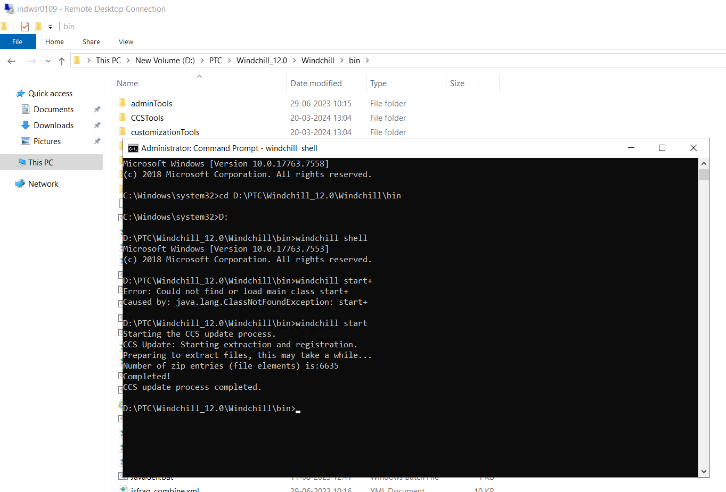

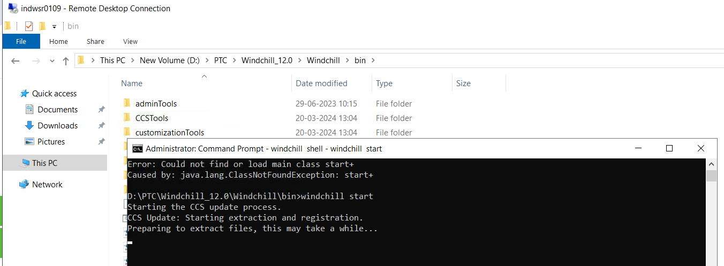

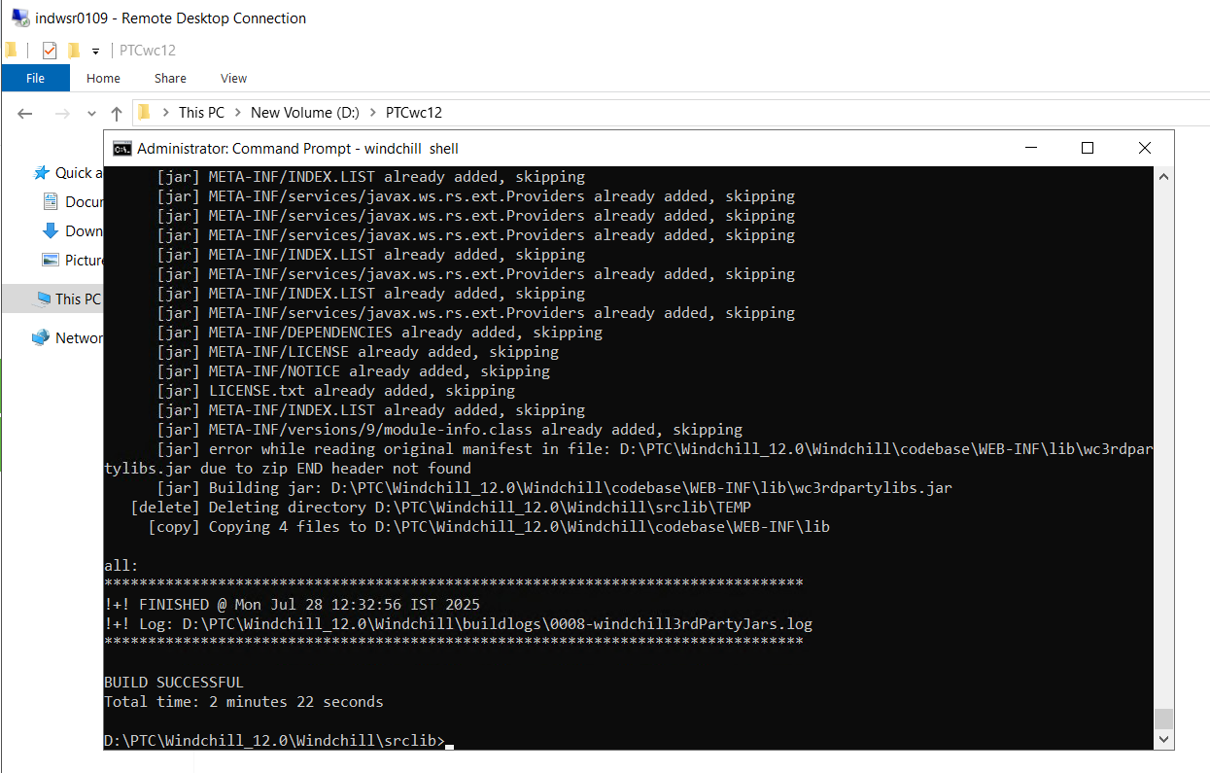

# Send ActiveMQ Certificate to SAP – PI Team

* Open cmd and navigate to D:\apache-activemq-5.19.0-bin\apache-activemq-5.19.0\bin
* Run below command to export the certificate. Enter password changeit

keytool -export -alias broker -keystore D:\apache-activemq-5.16.1-bin\apache-activemq-5.16.1\conf\amq_broker.ks -file D:\apache-activemq-5.16.1-bin\ssl\ForQASAPPI\amq_broker_cert.cer

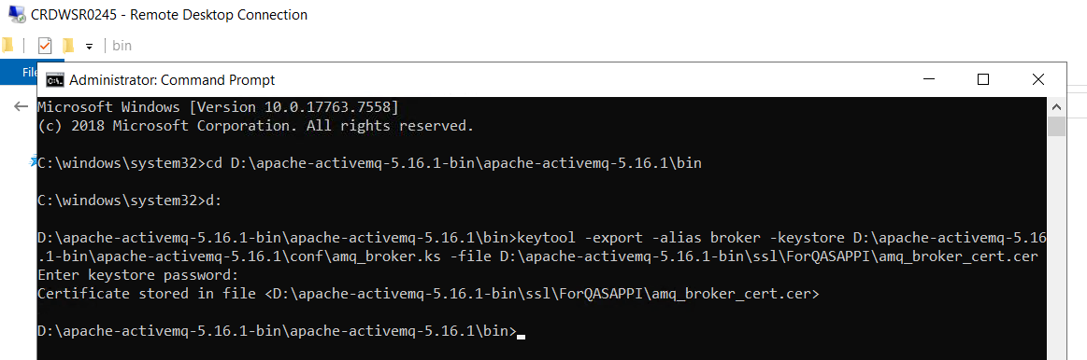

* Click on .cer file and validate start and end date of certificate. End date should be more than 2 years

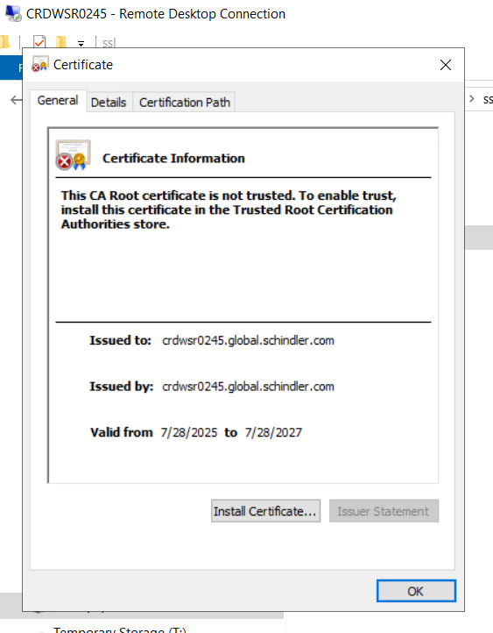

* Share this certificate with SAP PI team.
* Once SAP PI and ActiveMQ connection is setup, Connection should be successful from SAP PI to ActiveMQ. Refer below snapshot from SAP PI connector.

# References

## PTC Articles

* <https://www.ptc.com/en/support/article/CS355163>

## SQL Queries

--select * into FvHost_bkp27072025 from FvHost;

--select * from FvHost;

--update FvHost set hostName='[scnwsr0059_qas.global.schindler.com](http://scnwsr0059_qas.global.schindler.com)' where idA2A2='8703';

--update FvHost set hostName='[secwsr2619_qas.global.schindler.com](http://secwsr2619_qas.global.schindler.com)' where idA2A2='8731';

--update FvHost set hostName='[saowsr0183_qas.global.schindler.com](http://saowsr0183_qas.global.schindler.com)' where idA2A2='8753';

--update FvHost set hostName='[indwsr0109.global.schindler.com](http://indwsr0109.global.schindler.com)' where idA2A2='376639074';

--select * into RMIStubs_bkp27072025 from RMIStubs;

--Delete from RMIStubs;

--select * into Repository_bkp27072025 from Repository;

--select * from Repository;

--update Repository set lastKnownDomain='[edmd.global.schindler.com](http://edmd.global.schindler.com)' where idA2A2='370';

--update Repository set lastKnownDomain='[edmd.global.schindler.com](http://edmd.global.schindler.com)' where idA2A2='9134706';

--select * from ReleaseActivity;

--select * from ReleaseActivity where status='pending';

--SELECT DISTINCT status FROM ReleaseActivity;

--select * into ReleaseActivity_27072025 from ReleaseActivity;

--select * from ReleaseActivity where status='pending' and idA3A5 in(select idA2A2 from ESITarget where name='SAPPDM');

--update ReleaseActivity set status='failed' where status='pending' and idA3A5 in(select idA2A2 from ESITarget where name='SAPPDM');

--update ReleaseActivity set status='failed' where status='pending';

--select * into FvHost_bkp27072025_1 from FvHost;

--update FvHost set hostName='crdwsr0245' where idA2A2='14481403093';

--select * from FvHost;

--Delete from FvHost where idA2A2='24517940193';

--select * from FvHost;

--select * into Repository27072025 from Repository;

--select * from Repository;

--update Repository set lastKnownDomain='[edmd.global.schindler.com](http://edmd.global.schindler.com)' where idA2A2='22571814271';